উদ্ভাবনী বার্ষিক প্রতিবেদন
২০২০-২০২১
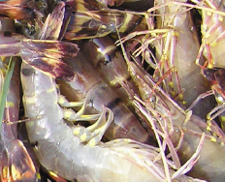
www.mofl.gov.bd
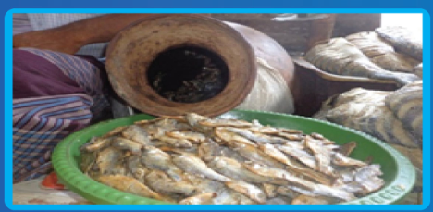
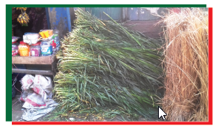
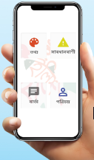
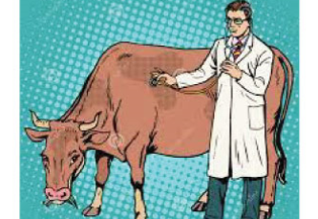

মৎস্য ও প্রাণিসম্পদ মন্ত্রণালয়
বাংলাদেশ সচিবালয়, ঢাকা-১০০০

সুচীপত্র

প্রথম অধ্যায়: মন্ত্রণালয় সম্পর্কিত 6
মন্ত্রণালয় সৃষ্টির পটভূমি 6
মৎস্য ও প্রাণিসম্পদ মন্ত্রণালয়ের ভিশন ও মিশন 6
লক্ষ্য ও উদ্দেশ্য 6
মৎস্য ও প্রাণিসম্পদ মন্ত্রণালয়ের লক্ষ্য ও উদ্দেশ্য 7
মৎস্য ও প্রাণিসম্পদ মন্ত্রণালয়ের প্রধান কার্যাবলী 7
অধিনস্ত দপ্তর/সংস্থা (৮টি) 7
সাম্প্রতিক অর্জন, চ্যালেঞ্জ এবং ভবিষ্যৎ পরিকল্পনা 8
মন্ত্রণালয়ের ইনোভেশন টিম 9
মৎস্য ও প্রাণিসম্পদ মন্ত্রণালয়ের বার্ষিক উদ্ভাবন কর্মপরিকল্পনা ২০২০-২০২১ 10
দ্বিতীয় অধ্যায়: ইনোভেশন শোকেসিং 15
ইনোভেশন শোকেসিং, ২০২১ 15
ইনোভেশন শোকেসিং-এ মন্ত্রণালয়সহ ও আওতাধীন দপ্তর/সংস্থার বিভিন্ন পর্যায়ের কর্মকর্তা কর্তৃক উদ্ভাবনসমূহ পরিদর্শনের ছবিঃ 18
শোকেসিং-এ প্রদর্শিত এবং যাচাই-বাছাই কমিটি কর্তৃক যাচাই-বাছাইকৃত উদ্ভাবনসমূহ 27
শোকেসিং-এ র‍্যাংকিংকৃত উদ্ভাবনসমূহ 29
তৃতীয় অধ্যায়: মন্ত্রণালয়ের উদ্ভাবন ও ডিজিটাল সেবা 30
সক্ষমতা বৃদ্ধির লক্ষ্যে উদ্ভাবনী প্রশিক্ষণ এবং কর্মশালা 30
মৎস্য নৌযানের লাইসেন্স প্রদান সংক্রান্ত তথ্যদি ব্যবস্থাপনা। 32
পরিদর্শন প্রতিবেদন ব্যবস্থাপনা 35
পঞ্চম অধ্যায়: সেবা সহজিকরণ 39
সেবা সহজিকরণ প্রশিক্ষণ 39
সেবার নাম - পিআরএল, লামগ্রান্ট, পেনশন ও আনুতোষিক মঞ্জুর 41
ষষ্ঠ অধ্যায়: শোকেসিং-এ প্রদর্শিত উদ্ভাবনসমূহ 48
প্রদর্শিত উদ্ভাবনসমূহ 48
চতুর্থ অধ্যায়: উদ্ভাবনী উদ্যোগের আঊটকাম স্টাডি 79
Outcome Study Report: Union Livestock Centre 79
‘Fish Advice’ Application: 93

প্রথম অধ্যায়: মন্ত্রণালয় সম্পর্কিত

মন্ত্রণালয়ের নামঃ মৎস্য ও প্রাণিসম্পদ মন্ত্রণালয়

মন্ত্রণালয় সৃষ্টির পটভূমি
- স্বাধীনতাত্তোর বন, মৎস্য ও পশুপালন নামে কৃষি মন্ত্রণালয়ের একটি বিভাগ ছিল
- প্রাণিজ আমিষের উৎপাদন বৃদ্ধির লক্ষ্যে প্রাণিজ ও মৎস্য জাতীয় সম্পদের সম্প্রসারণের জন্য ১৯৭৮ সালে কৃষি মন্ত্রণালয় থেকে আলাদা হয়ে মৎস্য ও পশুপালন মন্ত্রণালয় নামে একটি নতুন মন্ত্রণালয় গঠিত হয়
- পরবর্তীতে ১৯৮৪ সালের জানুয়ারি পর্যন্ত মৎস্য ও পশুপালন বিভাগ নামে কৃষি মন্ত্রণালয়ের আওতাধীন একটি বিভাগে পরিণত হয়
- পৃথক মন্ত্রণালয়ের মাধ্যমে কার্যক্রম পরিচালনার প্রয়োজন অনুভূত হওয়ায় ১৯৮৬ সালে পুনরায় মৎস্য ও পশুপালন মন্ত্রণালয় নামে পুণর্গঠিত হয়
- ১৯৮৯ সালে মৎস্য ও পশুপালন মন্ত্রণালয়ের নাম আংশিক সংশোধন করে নামকরণ করা হয় মৎস্য ও পশুসম্পদ মন্ত্রণালয়
- সবশেষে ২০০৯ সালে মৎস্য ও পশুসম্পদ মন্ত্রণালয়ের নাম পরিবর্তন করে মৎস্য ও প্রাণিসম্পদ মন্ত্রণালয় হিসেবে নামকরণ করা হয়

মৎস্য ও প্রাণিসম্পদ মন্ত্রণালয়ের ভিশন ও মিশন
রূপকল্প (Vision)
সকলের জন্য নিরাপদ, পর্যাপ্ত ও মানসম্মত প্রাণিজ আমিষ নিশ্চিতকরণ
অভিলক্ষ্য (Mission)
মৎস্য ও প্রাণিজ পণ্যের উৎপাদন ও উৎপাদনশীলতা বৃদ্ধি এবং মূল্য সংযোজনের মাধ্যমে প্রাণিজ আমিষের চাহিদাপূরণ

লক্ষ্য ও উদ্দেশ্য
১. মৎস্য সম্পদ ও উৎপাদন বৃদ্ধি করা;
২. প্রাণিসম্পদ এবং হাঁস-মুরগীর উৎপাদন ও উৎপাদনশীলতা বৃদ্ধি করা;
৩. মাছ, মৎস্য এবং প্রাণিসম্পদ সম্পর্কিত দ্রব্যাদির রপ্তানী তরান্বিত করা;
৪. প্রাকৃতিক ভারসাম্য রক্ষা করা, জীব-বৈচিত্র সংরক্ষণ করা এবং জনস্বাস্থ্য উন্নয়ন করা;
৫. রোগ বালাই প্রতিরোধ ও নিয়ন্ত্রণ করা; এবং৬. দারিদ্র দূরীকরণের লক্ষ্যে কর্মসংস্থান সৃষ্টি করা

মৎস্য ও প্রাণিসম্পদ মন্ত্রণালয়ের লক্ষ্য ও উদ্দেশ্য
- মৎস্যসম্পদের উৎপাদন ও উৎপাদনশীলতা বৃদ্ধি
- গবাদিপশু ও হাঁস-মুরগির উৎপাদনশীলতা বৃদ্ধি
- মানব সম্পদ উন্নয়ন ও কর্মসংস্থানের সুযোগ সৃষ্টি
- মৎস্য ও মৎস্যজাত পণ্য এবং প্রাণিজাত পণ্য রপ্তানি বৃদ্ধিতে সহায়তা
- মৎস্য ও গবাদিপশুর রোগ প্রতিরোধ ও নিয়ন্ত্রণ
- দারিদ্র্য বিমোচন ও নারীর ক্ষমতায়ন
- পুষ্টির মান উন্নয়ন

মৎস্য ও প্রাণিসম্পদ মন্ত্রণালয়ের প্রধান কার্যাবলী
- দেশের জনগণের জন্য নিরাপদ প্রাণিজ আমিষ সরবরাহ নিশ্চিতকরণ
- মৎস্য, গবাদিপশু ও হাঁস-মুরগির পুষ্টি উন্নয়ন
- মৎস্য ও প্রাণিসম্পদ সম্পর্কিত গবেষণা ও উন্নয়ন
- মৎস্য, গবাদিপশু ও হাঁস-মুরগির রোগ প্রতিরোধ ও নিয়ন্ত্রণ
- মৎস্য ও প্রাণিসম্পদের উৎপাদন, আহরণ ও এ সংক্রান্ত কার্যাবলির আধুনিকায়ন
- মৎস্য ও প্রাণিসম্পদ জরিপ ও চিড়িয়াখানা সম্পর্কিত বিষয়াদি
- সামুদ্রিক মৎস্য সম্পদ উন্নয়ন, আহরণ, সংরক্ষণ ও ব্যবস্থাপনা
- মূল্য সংযোজিত মৎস্য ও প্রাণিজাত পণ্য উৎপাদন ও রপ্তানি
- অপ্রচলিত মৎস্য (শামুক, ঝিনুক) ও কৃত্রিম মুক্তা চাষ উন্নয়ন
- নারীর দক্ষতা উন্নয়নের মাধ্যমে আর্থিক সক্ষমতা অর্জন

অধিনস্ত দপ্তর/সংস্থা (৮টি)
- মৎস্য অধিদপ্তর (DOF)
- প্রাণিসম্পদ অধিদপ্তর (DLS)
- বাংলাদেশ মৎস্য উন্নয়ন কর্পোরেশন (BFDC)
- বাংলাদেশ মৎস্য গবেষণা ইনস্টিটিউট (BFRI)
- বাংলাদেশ প্রাণিসম্পদ গবেষণা ইনস্টিটিউট (BLRI)
- মেরিন ফিশারিজ একাডেমি (MFA)
- বাংলাদেশ ভেটেরিনারি কাউন্সিল (BVC)
- মৎস্য ও প্রাণিসম্পদ তথ্য দপ্তর (FLID)

সাম্প্রতিক অর্জন, চ্যালেঞ্জ এবং ভবিষ্যৎ পরিকল্পনা

সাম্প্রতিক বছরসমূহের (৩ বছর) প্রধান অর্জনসমূহ:
২০১৯-২০ অর্থবছরে জাতীয় জিডিপিতে মৎস্য খাতের অবদান ৩.৫০%, কৃষিজ জিডিপিতে অবদান ২৫.৭২%; প্রবৃদ্ধির হার ৬.২৯% এবং জাতীয় জিডিপিতে প্রাণিসম্পদ খাতের অবদান ১.৪৩%, কৃষিজ জিডিপি’তে অবদান ১৩.৪৩% এবং প্রবৃদ্ধির হার ৩.০৪%। মৎস্য উৎপাদনে ক্রমাগত প্রবৃদ্ধির ফলে অভ্যন্তরীণ মুক্ত জলাশয়ে মাছ উৎপাদনের ক্ষেত্রে বাংলাদেশ বিশ্বে ৩য় ও বদ্ধ জলাশয়ে চাষকৃত মাছ উৎপাদনে ৫ম স্থান অধিকার করেছে। বিগত ২০১৭-১৮, ২০১১৮-১৯, ২০১৯-২০ অর্থবছরে মৎস্য উৎপাদন ছিল যথাক্রমে ৪২.৭৭, ৪৩.৮৪ ও ৪৫.০৩ লক্ষ মেট্রিক টন; মাংসের উৎপাদন ছিল ৭২.০৬, ৭৫.১৪ ও ৭৬.৭৪ লক্ষ মেট্রিক টন; দুধের উৎপাদন ছিল ৯৪.০১, ৯৯.২৩ ও ১০৬.৮০, লক্ষ মেট্রিক টন এবং ডিমের উৎপাদন ছিল ১৫৫২, ১৭১১ ও ১৭৩৬ কোটি। দৈনিক মাথাপিছু মাছ গ্রহণের পরিমাণ (৬০ গ্রাম) বৃদ্ধি পেয়ে ৬৩ গ্রাম-এ উন্নীত হয়েছে। ২০১৯-২০ অর্থবছর শেষে মাংস, দুধ ও ডিমের জন প্রতি প্রাপ্যতা বেড়ে যথাক্রমে ১২৬.২০ গ্রাম/দিন, ১৭৫.৬৩ মি.লি/দিন ও ১০৪.২৩ টি/বছর এ উন্নীত হয়েছে। মা ইলিশ রক্ষা, জাটকা সংরক্ষণ, ক্ষতিকর জাল ধ্বংসে কম্বিং অপারেশন পরিচালনা, মৎস্য আহরণ বন্ধ রাখা, মৎস্য আহরণে বিরত মৎস্যজীবী জেলেদের ভিজিএফ প্রদানের ফলে ইলিশের একক ওজন ও মোট উৎপাদন সাম্প্রতিক বছরসমূহে বৃদ্ধি পেয়েছে।

সমস্যা এবং চ্যালেঞ্জসমূহ:
মা ইলিশ ও জাটকা সংরক্ষণ করা, অবৈধ জালের ব্যবহার বন্ধ করা, গুণগত মানসম্পন্ন মৎস্য/চিংড়ির পোনা প্রাপ্তি, মৎস্য আবাসস্থল ও জীববৈচিত্র্য সংরক্ষণ, সামুদ্রিক মৎস্য সম্পদের টেকসই ব্যবস্থাপনা, কৃত্রিম প্রজননের মাধ্যমে গবাদিপশুর জাত উন্নয়ন, উন্নত জাতের সিমেন উৎপাদন এবং মানসম্পন্ন মৎস্য ও পশু খাদ্যের অপ্রতুলতা, খাদ্যের উচ্চমূল্য, জলবায়ু পরিবর্তনের প্রভাব ইত্যাদি মৎস্য ও প্রাণিসম্পদ উন্নয়নে প্রধান প্রধান প্রতিবন্ধক। তাছাড়া বন্যা ও কোভিড-১৯ মহামারিসহ অন্যান্য মহামারি চ্যালেঞ্জ হিসেবে কাজ করে।

ভবিষ্যৎ পরিকল্পনা:
অষ্টম পঞ্চবার্ষিক পরিকল্পনা অনুযায়ী জনপ্রতি মাছ, মাংস, দুধ ও ডিমের চাহিদা যথাক্রমে ৬০ গ্রাম/দিন, ১৩০.০০ গ্রাম/দিন ২৫০.০০ মি.লি/দিন ও ১২০টি/বছর পূরণের লক্ষ্যে এ মন্ত্রণালয় কাজ করছে। গুণগত মানসম্পন্ন মৎস্য/চিংড়ির পোনা উৎপাদন ও সরবরাহ, সামুদ্রিক মৎস্যসম্পদের মজুদ নিরুপণ, মাংস ও দুগ্ধ উৎপাদন বৃদ্ধির জন্য কৃত্রিম প্রজনন কার্যক্রম সম্প্রসারণের মাধ্যমে গরু-মহিষের জাত উন্নয়ন, পশুখাদ্যের এবং প্রাণিজাত খাদ্যের মান নিয়ন্ত্রন করা হবে। মৎস্য ও প্রাণিজাত পণ্যের বহুমুখীকরণ, ফুড সেফটি নিশ্চিতকরণ এবং ক্যাটেল ইনসুরেন্স ব্যবস্থা প্রবর্তন। বন্যা ও মহামারির সময়ে মৎস্য ও প্রাণিজাত পণ্যের উৎপাদন ও বাজারজাতকরণ এবং বিভিন্ন প্রণোদনা প্রদানের উদ্যোগ গ্রহণ করা হবে।

২০২১-২২ অর্থবছরের সম্ভাব্য প্রধান অর্জনসমূহ:
- মৎস্য ও মৎস্যজাত পণ্যের ‍উৎপাদন ও উৎপাদনশীলতা বৃদ্ধিতে বিভিন্ন প্রযুক্তি প্যাকেজের ১২০০০টি প্রদর্শনী খামার স্থাপন, উন্মুক্ত জলাশয়ে ২০০ মে:টন পোনা অবমুক্তকরণ, ১৬০ টি বিল নার্সারি স্থাপন এবং ২০০টি অভয়াশ্রম রক্ষণাবেক্ষণ করা
- গবাদি পশুর জাত উন্নয়নে ৪৪ লক্ষ মাত্রা সিমেন উৎপাদন, রোগ নিয়ন্ত্রণে ৩২ কোটি মাত্রা টিকা উৎপাদন;
- মানবসম্পদ উন্নয়ন ও বিকল্প কর্মসংস্থান সৃষ্টিতে প্রায় তিন লক্ষ মৎস্যচাষি/মৎস্যজীবী/সুফলভোগীকে এবং খামারি ও মাংস প্রক্রিয়াকারীকে প্রশিক্ষণ প্রদান;
- মন্ত্রণালয় কর্তৃক উপরোক্ত কাজসমূহ পরিদর্শন/তদারকি এবং
- উপরোক্ত কার্যক্রমসমূহ বাস্তবায়নের মাধ্যমে বছর শেষে যথাক্রমে ৪৬.৭৭ লক্ষ মে:টন মাছ, ৮১.৮০ লক্ষ মে:টন মাংস, ১১৭.৭৫ লক্ষ মে:টন দুধ এবং ২০৩৭ কোটি ডিম উৎপাদন সম্ভব হবে।

মন্ত্রণালয়ের ইনোভেশন টিম

ক্রমিক নং | নাম ও পদবী | পদবী / ইমেইল / মোবাইল নং
১. | জনাব মোঃ তৌফিকুল আরিফ  অতিরিক্ত সচিব (পরিকল্পনা) | চিফ ইনোভেশন অফিসার  addlsec_be@mofl.gov.bd  towfiqularif@yahoo.com  01711-643813
২. | জনাব সুব্রত ভৌমিক  উপসচিব (প্রশাসন-৩) | ইনোভেশন অফিসার  administration-3@mofl.gov.bd  subrata1964@gmail.com  ০১৭১১৩৭৫৮৫৯
৩ | বেগম হাফছা বেগম  উপসচিব (মৎস্য-১ অধিশাখা) | ইনোভেশন অফিসার  fisheries-1@mofl.gov.bd  hafsabegum20@gmail.com  01711-310077
৪. | জনাব মোহাম্মদ হাবীবুর রহমান উপসচিব (প্রাণিসম্পদ পরিকল্পনা-২) | ইনোভেশন অফিসার  livestockplanning-2@mofl.gov.bd  habib.edu.msdm@gmail.com  ০১৭৫৮৫৪৫৩৮৮
৫. | জনাব অমিতাভ চক্রবর্তী, উপসচিব (প্রাণিসম্পদ -৪ অধিশাখা) | ইনোভেশন অফিসার  livestock-4@mofl.gov.bd  amitavodvm@gmail.com  ০১৭১২২০৬৬৪৪
৬. | জনাব মোঃ ইলিয়াস হোসেন  সিস্টেম এনালিস্ট, আইসিটি সেল | ইনোভেশন অফিসার (সদস্য সচিব)  sa@mofl.gov.bd  elias.cse01@gmail.com  ০১৫১৭২৬৮২৭৩

মৎস্য ও প্রাণিসম্পদ মন্ত্রণালয়ের বার্ষিক উদ্ভাবন কর্মপরিকল্পনা ২০২০-২০২১
ক্রম | উদ্দেশ্য  (Objectives) | বিষয়ের মান  (Weight of Objectives) | কার্যক্রম  (Activities) | কর্মসম্পাদন  সূচক  (Performance  Indicators) | একক  (Unit) | কর্মসম্পাদন  সূচকের মান  (Weight of Performance  Indicators) | লক্ষ্যমাত্রা/নির্ণায়ক ২০20-২০২1  (Target /Criteria Value for 2020-2021)
 |  |  |  |  |  |  | অসাধারণ | অতি উত্তম | উত্তম | চলতি মান | চলতি মানের নিম্নে
 |  |  |  |  |  |  | ১০০% | ৯০% | ৮০% | ৭০% | ৬০%
 | ১ | ২ | ৩ | ৪ | ৫ | ৬ | 7 | ৮ | ৯ | ১০ | ১১
১ | উদ্ভাবন কর্মপরিকল্পনা প্রণয়ন | 10 | ১.১ বার্ষিক উদ্ভাবন কর্মপরিকল্পনা প্রণয়ন | ১.১.১কর্মপরিকল্পনা প্রণীত | তারিখ | 4 | ৩০-7-২০20 | ৪-8-২০20 | 8-8-২০20 | ১1-8-২০20 | ১6-8-২০20
 |  |  | 1.২ উদ্ভাবন কর্মপরিকল্পনা মহামারী/আপদকাল মোকাবেলার সাথে সম্পৃক্ততা | ১.২.১ প্রণীত কর্মপরিকল্পনায় মহামারী/আপদকাল মোকাবেলায় বিশেষ পদক্ষেপের রুপরেখা প্রকাশ | তারিখ | 3 | ৩০-৭-২০২০ | ৪-৮-২০২০ | ৮-৮-২০২০ | ১১-৮-২০২০ | ১৬-৮-২০২০
 |  |  | ১.৩ বার্ষিক উদ্ভাবন কর্মপরিকল্পনা মন্ত্রিপরিষদ বিভাগে প্রেরণ | ১.৩.১ মন্ত্রিপরিষদ বিভাগে প্রেরিত | তারিখ | ১ | 4-8- ২০20 | ১1-8- ২০20 | ১6-8- ২০20 | ২২-8- ২০20 | ২৮-8-২০20
 |  |  | ১.৪ বার্ষিক উদ্ভাবন কর্মপরিকল্পনা তথ্য বাতায়নে প্রকাশ | ১.৪.১ তথ্য বাতায়নে প্রকাশিত | তারিখ | ২ | ১0-8- ২০20 | ১4-8- ২০20 | 18-8- ২০20 | ২2-8-২০20 | 28-8-  ২০20
২ | ইনোভেশন টিমের সভা | ৬ | ২.১ ইনোভেশন টিমের সভা অনুষ্ঠান | ২.১.১ সভা অনুষ্ঠিত | সংখ্যা | ৪ | ৬ | ৫ | ৪ | ৩ | ২
 |  |  | ২.২ ইনোভেশন টিমের সভার সিদ্ধান্ত বাস্তবায়ন | ২.২.১ সিদ্ধান্ত বাস্তবায়িত | % | 2 | ৯৫ | ৮০ | ৭৫ | ৭০ | ৬৫
৩ | উদ্ভাবন খাতে (কোড নম্বর-3257105) বরাদ্দ | ৪ | ৩.১ উদ্ভাবন-সংক্রান্ত কার্যক্রম বাস্তবায়নে বাজেট বরাদ্দ | ৩.১.১ বাজেট বরাদ্দকৃত | টাকা | ২ | ১০ লক্ষ | ১০ লক্ষ | ১০ লক্ষ | ১০ লক্ষ | ১০ লক্ষ
 |  |  | ৩.২ উদ্ভাবন-সংক্রান্ত কার্যক্রম বাস্তবায়নে বরাদ্দকৃত অর্থ ব্যয় | ৩.২.১ উদ্ভাবন-সংক্রান্ত কার্যক্রম বাস্তবায়নে বরাদ্দকৃত অর্থ ব্যয়িত | % | ২ | ৯০ | ৮৫ | ৮০ | ৭৫ | ৭০
৪ | সক্ষমতা বৃদ্ধি | 8 | ৪.১ উদ্ভাবন ও সেবা সহজিকরণ বিষয়ে এক দিনের কর্মশালা/ সেমিনার | ৪.১.১ কর্মশালা/ সেমিনার অনুষ্ঠিত | সংখ্যা | ৩ | ১ | - | - | - | -
 |  |  | ৪.২ উদ্ভাবনে সক্ষমতা বৃদ্ধির লক্ষ্যে দুই দিনের প্রশিক্ষণ আয়োজন | ৪.২.১ প্রশিক্ষণ আয়োজিত | সংখ্যা  (জন) | ৩ | ২০ | ১৫ | ১২ | ১০ | ৮
 |  |  | ৪.৩ সেবা সহজিকরণে সক্ষমতা বৃদ্ধির লক্ষ্যে দুই দিনের প্রশিক্ষণ আয়োজন | ৪.৩.১ প্রশিক্ষণ আয়োজিত | সংখ্যা  (জন) | 2 | ১০ | ৮ | ৬ | ৫ | 3
৫ | স্বীয় দপ্তরের সেবায় উদ্ভাবনী ধারণা/ উদ্যোগ আহবান, যাচাই-বাছাই-সংক্রান্ত কার্যক্রম | 4 | ৫.১ উদ্ভাবনী উদ্যোগ/ধারণা আহবান এবং প্রাপ্ত উদ্ভাবনী ধরণাগুলো যাচাই-বাছাইপূর্বক তালিকা তথ্য বাতায়নে প্রকাশ | ৫.১.১ উদ্ভাবনী উদ্যোগের তালিকা তথ্য বাতায়নে প্রকাশিত | তারিখ | 4 | ৩-1১-২০20 | ৫-11-২০20 | ১০-11-২০20 | ১7-11-২০20 | ২০-11-২০20
৬ | উদ্ভাবনী উদ্যোগের পাইলটিং বাস্তবায়ন | 6 | ৬.১ ন্যূনতম একটি উদ্ভাবনী উদ্যোগের পাইলটিং বাস্তবায়নের সরকারি আদেশ জারি | ৬.১.১ পাইলটিং বাস্তবায়নের আদেশ জারিকৃত | তারিখ | 3 | ১৯-1২-২০20 | ২৪-1২-২০20 | ৩০-11-২০20 | 5-১-২০২1 | ১০-১-২০২1
 |  |  | ৬.২ উদ্ভাবনী উদ্যোগের পাইলটিং বাস্তবায়ন মূল্যায়ন | ৬.২.১ পাইলটিং বাস্তবায়ন মূল্যায়িত | তারিখ | ৩ | ১-০৩- ২০২1 | ৫-৩- ২০২1 | ১০-৩- ২০২1 | ১৫-৩- ২০২1 | ১৯-৩- ২০২1
৭ | উদ্ভাবন প্রদর্শনী (শোকেসিং) | ৮ | ৭.১ ন্যূনতম একটি উদ্ভাবন প্রদর্শনীর (শোকেসিং) আয়োজন | ৭.১.১ আয়োজিত উদ্ভাবন প্রদর্শনী | তারিখ | ৬ | ১৫-০৫-২০২1 | ২২-৫-২০২1 | ২৯-৫-২০২1 | ১০-৬-২০২1 | ১৫-৬-২০২1
 |  |  | ৭.২ প্রদর্শনীর মাধ্যমে শ্রেষ্ঠ উদ্ভাবনী উদ্যোগ নির্বাচন | ৭.২.১ শ্রেষ্ঠ উদ্ভাবনী উদ্যোগ নির্বাচিত | সংখ্যা | ২ | ৩ | ২ | ১ | - | -
৮ | উদ্ভাবনী উদ্যোগ আঞ্চলিক ও জাতীয় পর্যায়ে বাস্তবায়ন | 7 | ৮.১ ন্যূনতম একটি উদ্ভাবনী উদ্যোগ আঞ্চলিক/ জাতীয় পর্যায়ে বাস্তবায়ন | ৮.১.১ বাস্তবায়নের জন্য অফিস আদেশ জারিকৃত | তারিখ | 7 | ১০-৬-২০21 | ১৬-৬-২০21 | ২০-৬-২০21 | ২৫-৬-২০21 | ৩০-6-২০21
৯ | স্বীকৃতি বা প্রণোদনা প্রদান | 5 | ৯.১ উদ্ভাবকগণকে প্রশংসাসূচক উপ-আনুষ্ঠানিক পত্র/সনদপত্র /ক্রেস্ট/ পুরস্কার প্রদান | ৯.১.১ প্রশংসাসূচক উপ-আনুষ্ঠানিক পত্র/ সনদপত্র /ক্রেস্ট/ পুরস্কার প্রদানকৃত | সংখ্যা  (জন) | 3 | 4 | 3 | 2 | 1 | -
 |  |  | ৯.২ উদ্ভাবকগণকে দেশে শিক্ষা সফর/প্রশিক্ষণ /নলেজ শেয়ারিং প্রোগ্রামে প্রেরণ | ৯.২.১ শিক্ষা সফর/ প্রশিক্ষণ/নলেজ শেয়ারিং প্রোগ্রামে প্রেরিত | সংখ্যা  (জন) | 2 | ৫ | ৪ | ৩ | ২ | ১
১০ | তথ্য বাতায়নহালনাগাদকরণ | 8 | ১০.১ ইনোভেশন টিমের পূর্ণাঙ্গ তথ্যসহ বছরভিত্তিক উদ্ভাবনের সকল তথ্য আপলোড/ হালনাগাদকরণ | ১০.১.১ উদ্ভাবনের তথ্য আপলোডকৃত/ হালনাগাদকৃত | নিয়মিত  (%) | ৪ | 100 | 90 | 80 | 70 | ৬০
 |  |  | ১০.২ বছরভিত্তিক পাইলট ও বাস্তবায়িত সেবা সহজিকরণের তথ্য আপলোড/ হালনাগাদকরণ | ১০.২.১ সেবা সহজিকরণের তথ্য আপলোড/ হালনাগাদকৃত | % | ২ | 100 | 90 | 80 | 70 | ৬০
 |  |  | ১০.৩ বাস্তবায়িত ডিজিটাল-সেবার তথ্য আপলোড/ হালনাগাদকরণ | ১০.৩.১ ডিজিটাল-সেবার তথ্য আপলোড/ হালনাগাদকৃত | % | 2 | 100 | 90 | 80 | 70 | ৬০
১১ | ডিজিটাল সেবা তৈরি ও বাস্তবায়ন | ৪ | ১১.১ ন্যূনতম একটি ডিজিটাল সেবা তৈরি ও বাস্তবায়ন করা | ১১.১.১ একটি ডিজিটাল সেবা বাস্তবায়িত | তারিখ | ৪ | ১৫-২-২০২1 | ১৫-৩-২০২1 | ৩১-৩-২০২1 | ৩০-৪-২০২1 | ৩০-৫-২০২1
১২ | সেবা সহজিকরণ | ৮ | ১২.১ ন্যূনতম একটি সেবা পদ্ধতি সহজিকরণের পাইলটিং বাস্তবায়ন | ১২.১.১ সহজিকরণের পাইলটিং বাস্তবায়নের অফিস আদেশ জারিকৃত | তারিখ | 4 | ১৫-১০- ২০20 | ২০-১০- ২০20 | ২৪-১০- ২০20 | ২৮-১০- ২০20 | ৩০-১০- ২০20
 |  |  | ১২.২ ন্যূনতম একটি সেবা পদ্ধতি সহজিকরণ সারাদেশে সম্প্রসারণ/ রেপ্লিকেশন | ১২.২.১ সেবা সহজিকরণ বাস্তবায়নে চুড়ান্ত অফিস আদেশ জারিকৃত | তারিখ | 4 | ১৫-০৪-২০২1 | ৩০-৪-২০২1 | ১৫-৫-২০২1 | ৩০-৫-২০২1 | ১৫-৬-২০২1
১৩ | পরিবীক্ষণ | ৭ | ১৩.১ আওতাধীন অধিদপ্তর/ সংস্থার উদ্ভাবন কর্মপরিকল্পনা প্রণয়ন কার্যক্রম পরিবীক্ষণ | ১৩.১.১ আওতাধীন দপ্তর/ সংস্থার বার্ষিক কর্মপরিকল্পনা প্রণীত | তারিখ | ৩ | ৩০-7-২০20 | ৪-8-২০20 | 8-8-২০20 | ১1-8-২০20 | ১6-8-২০20
 |  |  | ১৩.২ স্বীয় দপ্তরসহ আওতাধীন অধিদপ্তর/ দপ্তর সংস্থার উদ্ভাবন কর্মপরিকল্পনা বাস্তবায়ন অগ্রগতি পরিবীক্ষণ | ১৩.২.১ আওতাধীন অধিদপ্তর/ দপ্তর সংস্থার সঙ্গে ইনোভেশন টিমের সভা আয়োজিত | সংখ্যা | ২ | ৩ | ২ | ১ | - | -
 |  |  | ১৩.৩ মাঠ পর্যায়ে চলমান উদ্ভাবনী প্রকল্পসমূহ সরেজমিন পরিদর্শন ও প্রয়োজনীয় সহায়তা প্রদান | ১৩.৩.১ প্রকল্প পরিদর্শনকৃত এবং সহায়তা প্রদানকৃত | সংখ্যা (কয়টি) | ২ | 4 | 3 | 2 | 1
১৪ | ডকুমেন্টেশন প্রকাশনা | 7 | ১৪.১ বাস্তবায়িত উদ্ভাবনী উদ্যোগের ডকুমেন্টেশন তৈরি ও প্রকাশনা (পাইলট ও সম্প্রসারিত) | ১৪.১.১ ডকুমেন্টেশন প্রকাশিত | তারিখ | ৪ | ২০-০৫-২০২1 | ২৫-৫-২০২1 | ৩১-৫-২০২1 | ১০-৬-২০২1 | ১৫-৬-২০২1
 |  |  | ১৪.২ সেবা সহজিকরণের ডকুমেন্টেশন তৈরি ও প্রকাশনা | ১৪.২.১ ডকুমেন্টেশন প্রকাশিত | তারিখ | ৩ | ২০-০৫-২০২1 | ২৫-৫-২০২1 | ৩১-৫-২০২1 | ১০-৬-২০২1 | ১৫-৬-২০২1
1৫ | উদ্ভাবন কর্মপরিকল্পনা মূল্যায়ন | ৮ | ১৫.১ উদ্ভাবন পরিকল্পনার অর্ধ-বাষিক স্ব-মূল্যায়ন | ১৫.১.১ অর্ধ- বার্ষিক প্রতিবেদন স্ব-মূল্যায়িত | তারিখ | ৩ | ৩০-1-২০২1 | ৫-২-২০২1 | ১০-২-২০২1 | ১৭-২-২০২1 | ২০-২-২০২1
 |  |  | ১৫.২ উদ্ভাবন কর্মপরিকল্পনার অর্ধ- বার্ষিক মূল্যায়ন প্রতিবেদন মন্ত্রিপরিষদ বিভাগে প্রেরণ | ১৫.২.১ অর্ধ- বার্ষিক মূ্ল্যায়ন প্রতিবেদন প্রেরিত | তারিখ | ১ | ৫-২-২০২1 | ১০-২-২০২1 | ১৭-২-২০২1 | ২০-২-২০২1 | ২৫-২-২০২1
 |  |  | ১৫.৩ উদ্ভাবন কর্মপরিকল্পনার বাষিক স্ব-মূল্যায়ন | ১৫.৩.১ বার্ষিক মূল্যায়ন প্রতিবেদন প্রস্তুতকৃত | তারিখ | ৩ | ১৫-৭-২০২1 | ২০-৭-২০২1 | ২৩-৭-২০২1 | ২৬-৭-২০২1 | ৩০-7-২০২1
 |  |  | ১৫.৪ উদ্ভাবন কর্মপরিকল্পনার বাষিক স্ব-মূল্যায়ন প্রতিবেদন মন্ত্রিপরিষদ বিভাগে প্রেরণ | ১৫.৪.১ মূল্যায়ন প্রতিবেদন প্রেরিত | তারিখ | ১ | ২০-৭-২০২1 | ২৩-৭-২০২1 | ২৬-৭-২০২1 | ৩০-7-২০২1 | ৫-৮-২০২1

দ্বিতীয় অধ্যায়: ইনোভেশন শোকেসিং

ইনোভেশন শোকেসিং, ২০২১
গত ৩১/০৩/২০২১ তারিখে ওসমানী স্মৃতি মিলনায়তনে মৎস্য ও প্রাণিসম্পদ মন্ত্রণালয়ের ইনোভেশন শোকেসিং অনুষ্ঠান অনুষ্ঠিত হয়। উক্ত অনুষ্ঠানে প্রধান অতিথি হিসেবে অত্র মন্ত্রণালয়ের মাননীয় মন্ত্রী, জনাব শ ম রেজাউল করিম, এমপি এবং বিশেষ অতিথি হিসেবে জনাব রওনক মাহমুদ, সচিব, মৎস্য ও প্রাণিসম্পদ মন্ত্রণালয় উপস্থিত ছিলেন। শোকেসিং অনুষ্ঠানে সভাপতিত্ব করেন জনাব মোঃ তৌফিকুল আরিফ, অতিরিক্ত সচিব ও চীফ ইনোভেশন অফিসার, মৎস্য ও প্রাণিসম্পদ মন্ত্রণালয়। এছাড়া মন্ত্রণালয়ের অধীনস্থ ০৮ (আট) টি দপ্তর/সংস্থার প্রধানগণ তাদের দপ্তর/সংস্থার ইনোভেশন টিমসহ উক্ত শোকেসিং অনুষ্ঠানে উপস্থিত ছিলেন। শোকেসিং অনুষ্ঠানে ৩৪ জন উদ্ভাবক উপস্থিত থেকে তাদের উদ্ভাবনসমূহ উপস্থাপন করেন। শোকেসিং অনুষ্ঠানে ৩১ টি নতুন আইডিয়া এবং ১ টি রেপ্লিকেবল আইডিয়া উপস্থাপন করা হয়। প্রধান অতিথি, বিশেষ অতিথি, সভাপতি, দপ্তর/সংস্থার প্রধানগণ ও মন্ত্রণালয়ের ঊর্ধ্বতন কর্মকর্তাগণ সকলেই ৩২টি প্রদর্শনী সরজমিনে পরিদর্শন করেন। পরিদর্শন শেষে একটি আলোচনা সভা অনুষ্ঠিত হয়। আলোচনা সভার শুরুতেই চীফ ইনোভেশন অফিসার স্বাগত বক্তব্য প্রদান করেন। অতঃপর, আলোচনা সভায় ২ জন সফল উদ্ভাবক তাদের নিজেদের অনুভূতিসমূহ সভায় ব্যক্ত করেন। এছাড়াও সভায় বিশেষ অতিথি ও প্রধান অতিথি গুরুত্বপূর্ণ দিক নির্দেশনামূলক বক্তব্য রাখেন।
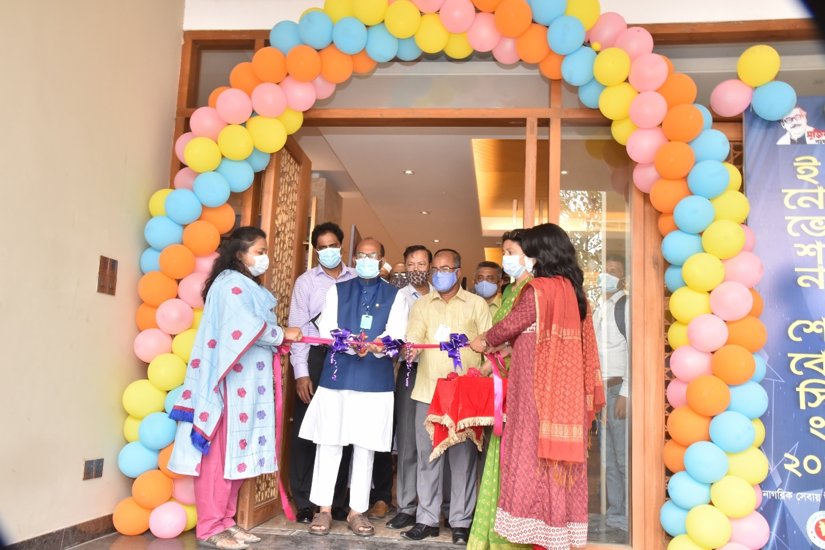
ছবি-১: প্রধান অতিথি মাননীয় মন্ত্রী, মৎস্য ও প্রাণিসম্পদ কর্তৃক ইনোভেশন শোকেসিং উদ্বোধন।
প্রধান অতিথি বলেন, খুব সহজে এবং দ্রুততম সময়ে জনগণের নিকট সেবা পৌঁছে দেয়ার জন্য উদ্ভাবন কার্যক্রম বেশ গুরুত্বের সাথে বিবেচিত হচ্ছে। এ চর্চা মন্ত্রণালয় ও অধীনস্থ দপ্তর/সংস্থার কাজকে গতিশীল করবে এবং জনগণের ভোগান্তি কমবে।
বিশেষ অতিথি বলেন, সরকার উদ্ভাবনকে এপিএ-এর সাথে সমন্বিত করেছেন। তাছাড়া মন্ত্রীপরিষদ বিভাগ হতে অনুমোদিত বার্ষিক উদ্ভাবন কর্মপরিকল্পনাও রয়েছে। কর্মপরিকল্পনা বাস্তবায়নে এ শোকেসিং গুরুত্বপূর্ণ ভূমিকা রাখবে বলে তিনি আশাবাদ ব্যক্ত করেন।
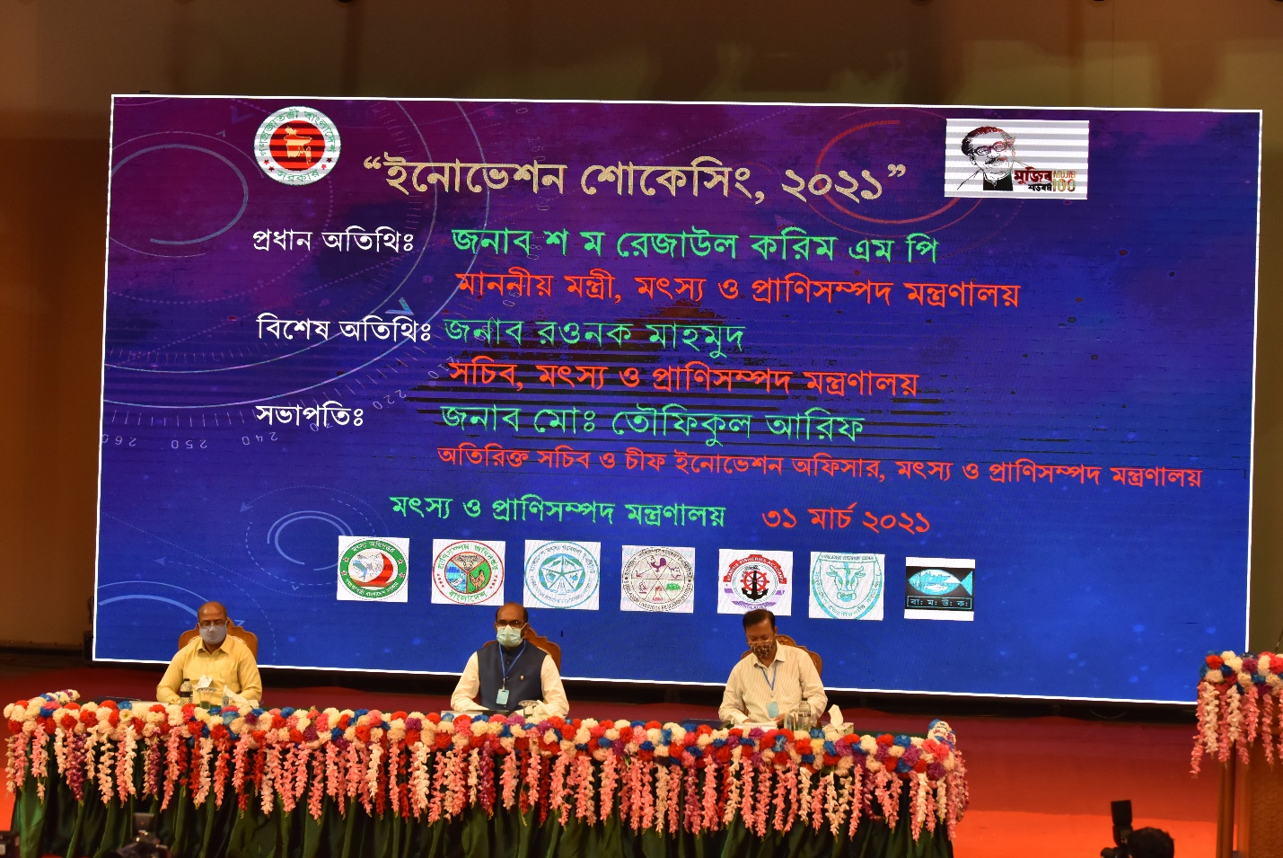
ছবি-২: মৎস্য ও প্রাণিসম্পদ মন্ত্রণালয়য় কর্তৃক আয়োজিত ৪র্থ ইনোভেশন শোকেসিং উদ্বোধন।
ইনোভেশন শোকেসিং অনুষ্ঠানে প্রধান অতিথি অত্র মন্ত্রণালয়ের মাননীয় মন্ত্রী, জনাব শ ম রেজাউল করিম, এমপি বক্তব্যের শুরুতেই বর্তমান করোনা পরিস্থিতির মধ্যে স্বাস্থ্য বিধি অনুসরণ করে শোকেসিং অনুষ্ঠান আয়োজনের জন্য সংশ্লিষ্ট সকলকে ধন্যবাদ জানান। তিনি উল্লেখ করেন যে, করোনা মোকাবেলায় মাননীয় প্রধানমন্ত্রী শেখ হাসিনার দূরদৃষ্টিসম্পন্ন সিদ্ধান্ত ও নেতৃত্বের মাধ্যমে বাংলাদেশের সার্বিক উন্নয়নের অগ্রযাত্রা অব্যাহত রয়েছে বিধায় তিনি প্রশংসার দাবিদার। এছাড়াও মাননীয় প্রধানমন্ত্রীর কার্যালয় থেকে ইতিমধ্যে যে নির্দেশনা দেয়া হয়েছে তা অনুসরণ করার জন্য তিনি আহ্বান জানান। তিনি বলেন, আমি ধন্যবাদ জানায় আজকে যারা এই শোকেসিং অনুষ্ঠানে অংশগ্রহণ করেছেন, বিভিন্ন ক্রিয়েটিভ আইটেম যারা সামনে নিয়ে আসছেন তাদের সবাইকে ধন্যবাদ জানায়। আসুন আমরা সকলে মিলে অতি আধুনিক রাষ্ট্রব্যবস্থার জন্য আমাদের এই সেক্টরকে ডেভেলপ করি। এটা হবে আজকের দিনে আপনাদের কাছে আমাদের প্রত্যাশা। মৎস্য ও প্রাণিসম্পদ সেক্টরকে সর্বাধিক গুরুত্ব দেয়া হচ্ছে, এটাকে আধুনিকীকরণ করা হবে, বিজ্ঞানসম্মত করা হবে, পুষ্টি এবং আমিষের পরিসরকে বৃদ্ধি করা হবে। সে ব্যাপারে সকলকে একসাথে কাজ করার জন্য নির্দেশনা প্রদান করেন। তিনি উদ্ভাবনী উদ্যোগের সাথে সংশ্লিষ্ট সকলকে আরও বুদ্ধিমত্তা প্রয়োগ করে এই সেক্টরকে এগিয়ে নেওয়ার বিষয়ে উল্লেখ করেন।
শোকেসিং অনুষ্ঠানে বিশেষ অতিথি জনাব রওনক মাহমুদ, সচিব, মৎস্য ও প্রাণিসম্পদ মন্ত্রণালয় উল্লেখ করেন, মাননীয় মন্ত্রী আজকের ইনোভেশন শোকেসিং এর এত গুরুত্ব দিয়েছেন যে এই করোনাকালেও আমাদের মাঝে তিনি প্রধান অতিথি হিসেবে উপস্থিত হয়েছেন। ইনোভেশন আইডিয়াগুলোতে যারা শোকেসিং করেছেন এমন ৩২ টি আইটেম দেখা হয়েছে মাননীয় মন্ত্রী মহোদয়ের সাথে। আমাদের এক একজন অফিসার তারা যদি চিন্তা করার ও কাজ করার সুযোগ পান তাহলে তারা যে অসাধ্য সাধন করতে পারে, আজকে যে ইনোভেশন আইডিয়াগুলো দেখলাম এটি আসলে তারই উৎকৃষ্ট বড় প্রমাণ। তিনি আরো উল্লেখ করেন যে, আমরা এখন উৎপাদন করবো না; আমাদেরকে সরবরাহ এবং বিপণন ব্যবস্থার বিষয়ে চিন্তা করতে হবে। সেখানেও আপনাদেরকে ভাবতে হবে আমরা কিভাবে জিনিসটা সহজে মানুষের কাছে পৌঁছে দেবো।

ইনোভেশন শোকেসিং অনুষ্ঠানে সভাপতি জনাব মোঃ তৌফিকুল আরিফ, অতিরিক্ত সচিব (পরিকল্পনা) ও চীফ ইনোভেশন অফিসার, মৎস্য ও প্রাণিসম্পদ মন্ত্রণালয় জানান যে, ২০১৬ সন হতে এই শোকেসিং এর প্রচলন হয়। এখন আমাদের বার্ষিক ইনোভেশন কর্মপরিকল্পনায় এই শোকেসিং এবং শোকেসিং থেকে বাছাইকৃত প্রকল্পসমূহে ০৮ নম্বর সংযুক্ত আছে। গত বছর করোনার কারণে শোকেসিং আয়োজন করতে না পারায় গত বছর মূল্যায়নে ৫২টি মন্ত্রণালয় বিভাগের মধ্যে এই মন্ত্রণালয়য় ৭ম স্থান অধিকার করেছিল এবং নম্বর পেয়েছিলাম ৮৮.২০। অর্থাৎ আমরা যদি গত অর্থবছরে শোকেসিং কার্যক্রম ও বাজেট খরচের মোট ১০ নম্বর অর্জন করতে পারতাম তাহলে আমরা সকল মন্ত্রণালয় বিভাগের মধ্যে ১ম হতাম অর্থাৎ ৯৮.২০ পয়েন্ট অর্জন করতাম। সেকারণেই আমরা এবার আগেভাগে এই শোকেসিং অনুষ্ঠানটি করার উদ্যোগ নিয়েছি। তদুপরি আমরা এই করোনাকালেও এটি করছি আমাদের যে কর্মপরিকল্পনা সেটি বাস্তবায়নের জন্য। শোকেসিং অনুষ্ঠানের প্রথম পর্বে অত্র মন্ত্রণালয়ের সচিব এবং মন্ত্রী মহোদয় ইনোভেশন আইডিয়াগুলো পরিদর্শন করেছেন। উনারা কিছু পরামর্শ / নির্দেশনা প্রদান করেছেন। মৎস্য সেক্টরের জন্য এবং প্রাণিসম্পদ সেক্টরের জন্য আমাদের দুইটি যাচাই কমিটি করা হয়েছে। কমিটিসমূহ বাছাই করবে যে কতগুলো পাইলটিং দরকার, কতগুলো পুনঃপাইলটিং দরকার, কতগুলো রেপ্লিকেটিং দরকার।

ইনোভেশন শোকেসিং-এ মন্ত্রণালয়সহ ও আওতাধীন দপ্তর/সংস্থার বিভিন্ন পর্যায়ের কর্মকর্তা কর্তৃক উদ্ভাবনসমূহ পরিদর্শনের ছবিঃ
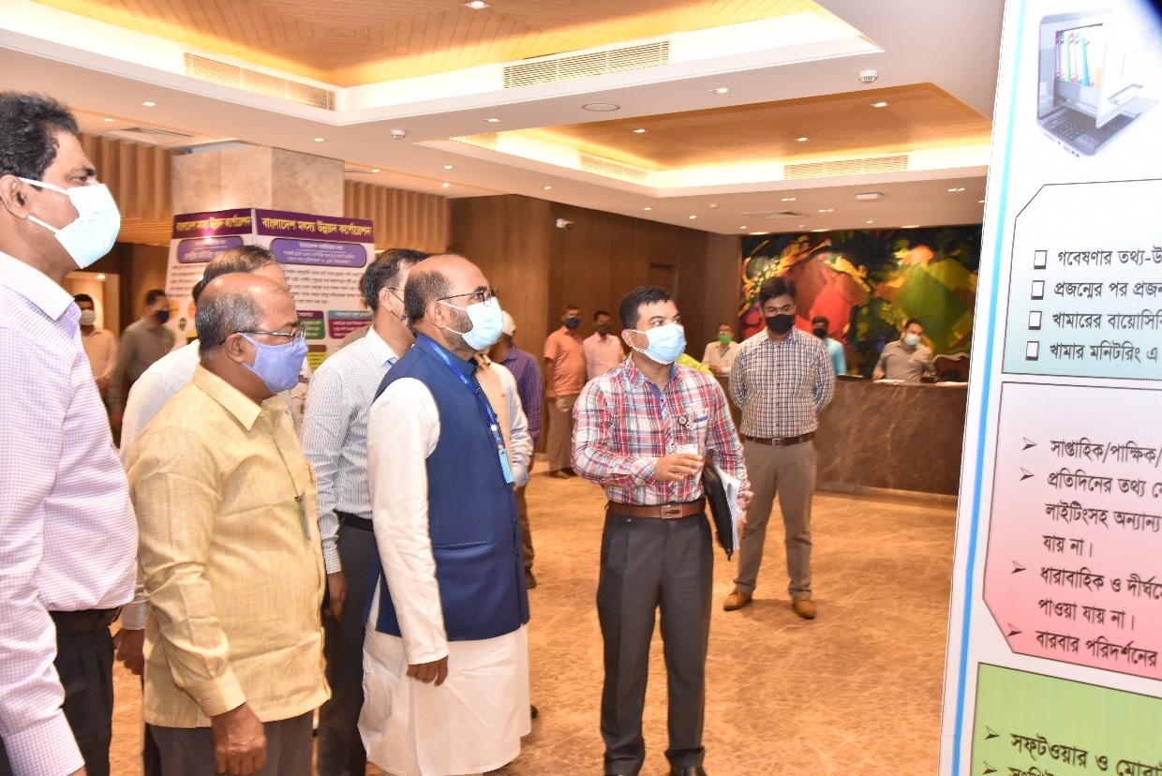
ছবি-৩: প্রধান অতিথি, বিশেষ অতিথি ও সভাপতিসহ মন্ত্রণালয় ও আওতাধীন দপ্তর/সংস্থার বিভিন্ন পর্যায়ের কর্মকর্তা কর্তৃক ইনোভেশন শোকেসিং-এ প্রদর্শিত মৎস্য ও প্রাণিসম্পদ মন্ত্রণালয়ের উদ্ভাবনসমূহ পরিদর্শন।

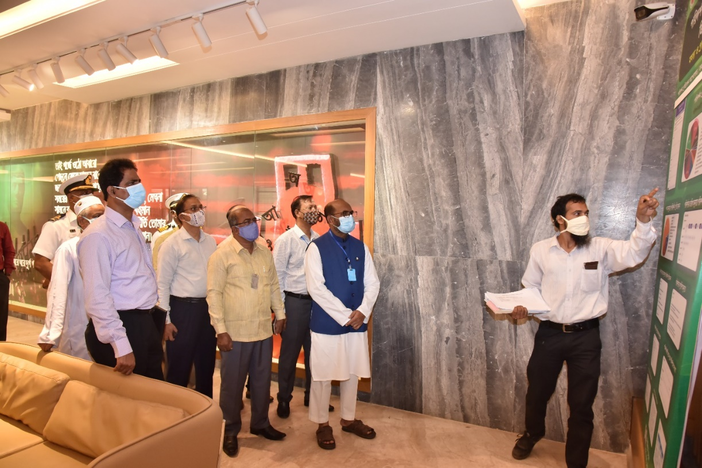
ছবি-৪: প্রধান অতিথি, বিশেষ অতিথি ও সভাপতিসহ মন্ত্রণালয় ও আওতাধীন দপ্তর/সংস্থার বিভিন্ন পর্যায়ের কর্মকর্তা কর্তৃক ইনোভেশন শোকেসিং-এ প্রদর্শিত মৎস্য ও প্রাণিসম্পদ মন্ত্রণালয়ের উদ্ভাবনসমূহ পরিদর্শন।
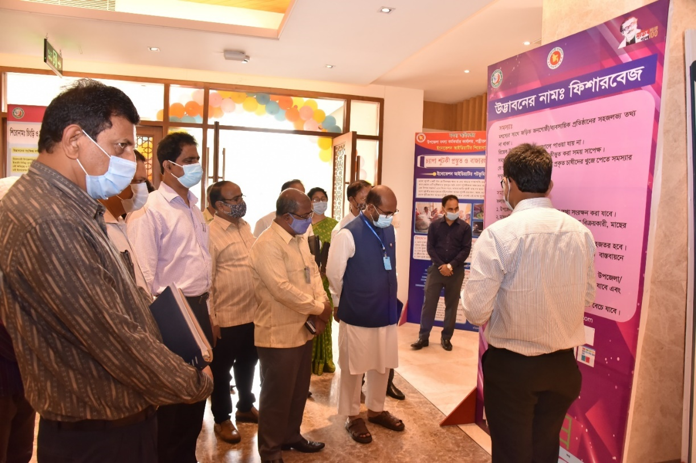
ছবি-৫: প্রধান অতিথি, বিশেষ অতিথি ও সভাপতিসহ মন্ত্রণালয় ও আওতাধীন দপ্তর/সংস্থার বিভিন্ন পর্যায়ের কর্মকর্তা ও আওতাধীন দপ্তর / সংস্থা প্রধান কর্তৃক ইনোভেশন শোকেসিং-এ প্রদর্শিত মৎস্য অধিদপ্তরের উদ্ভাবনসমূহ পরিদর্শন।

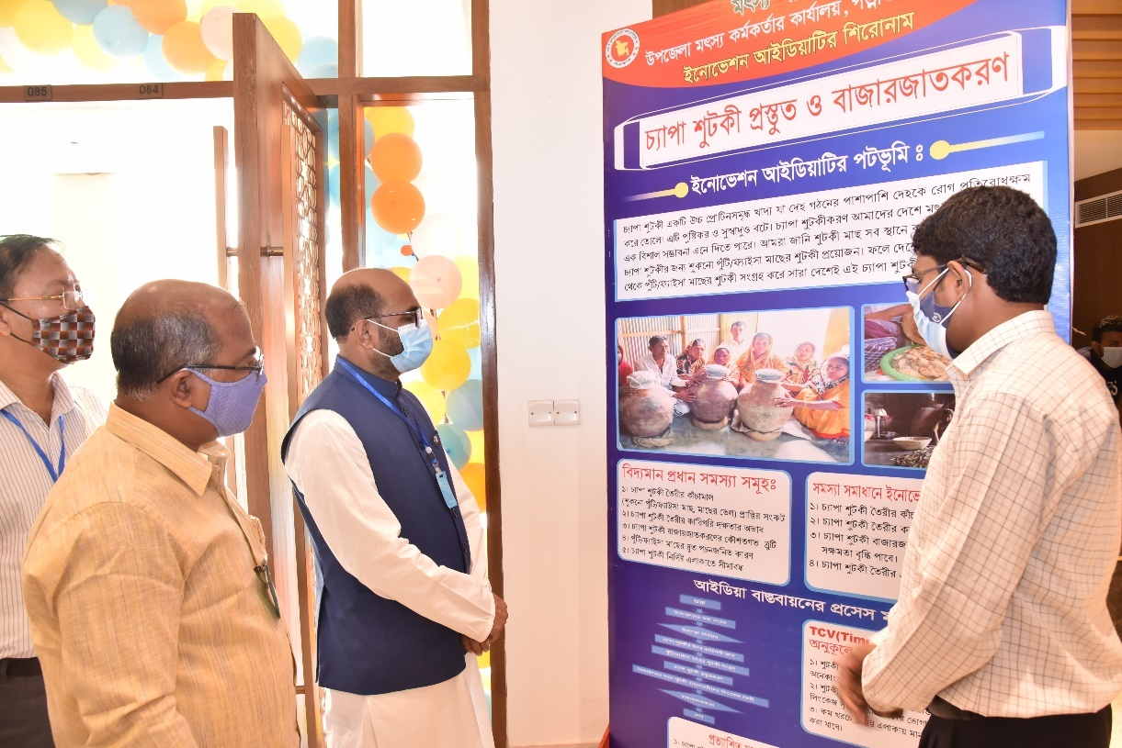
ছবি-৬: প্রধান অতিথি, বিশেষ অতিথি ও সভাপতিসহ মন্ত্রণালয় ও আওতাধীন দপ্তর/সংস্থার বিভিন্ন পর্যায়ের কর্মকর্তা ও আওতাধীন দপ্তর / সংস্থা প্রধান কর্তৃক ইনোভেশন শোকেসিং-এ প্রদর্শিত মৎস্য অধিদপ্তরের উদ্ভাবনসমূহ পরিদর্শন।
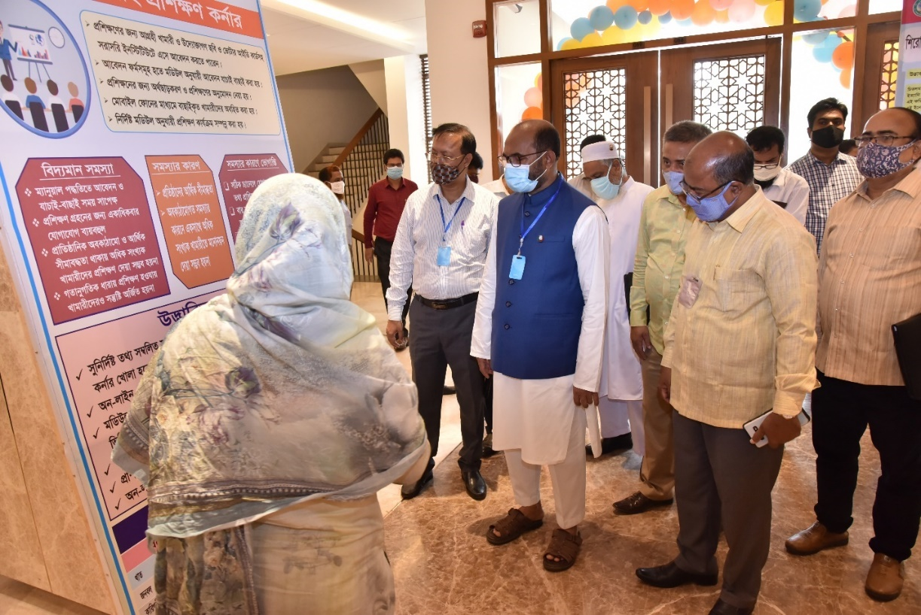
ছবি-৭: প্রধান অতিথি, বিশেষ অতিথি ও সভাপতিসহ মন্ত্রণালয় ও আওতাধীন দপ্তর/সংস্থার বিভিন্ন পর্যায়ের কর্মকর্তা ও আওতাধীন দপ্তর / সংস্থা প্রধান কর্তৃক ইনোভেশন শোকেসিং-এ প্রদর্শিত প্রাণিসম্পদ অধিদপ্তরের উদ্ভাবনসমূহ পরিদর্শন।

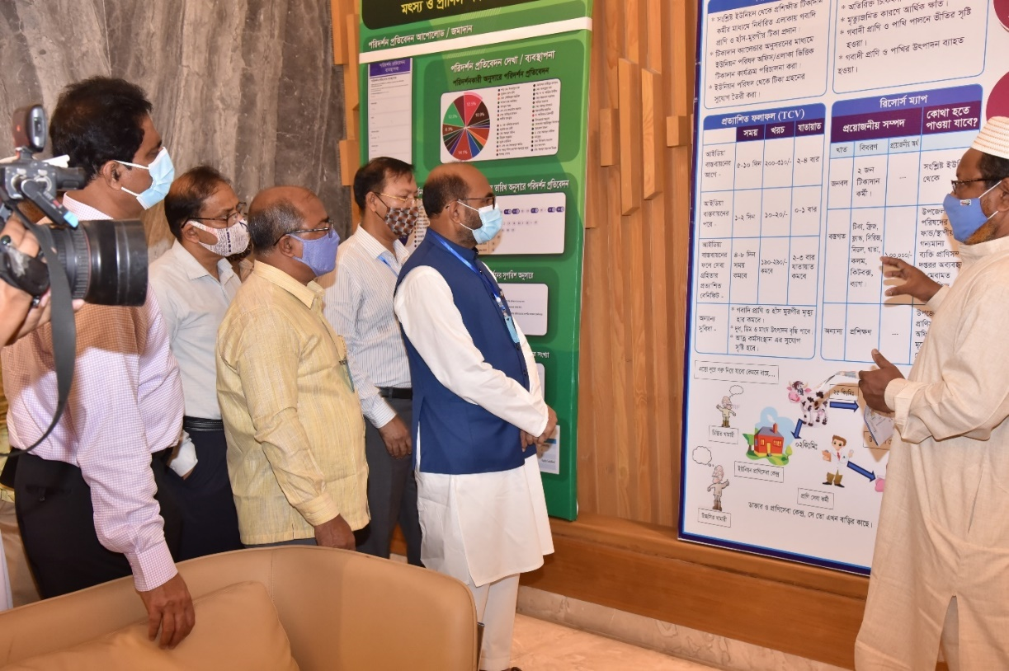
ছবি-৮: প্রধান অতিথি, বিশেষ অতিথি ও সভাপতিসহ মন্ত্রণালয় ও আওতাধীন দপ্তর/সংস্থার বিভিন্ন পর্যায়ের কর্মকর্তা কর্তৃক ইনোভেশন শোকেসিং-এ প্রদর্শিত প্রাণিসম্পদ অধিদপ্তরের উদ্ভাবনসমূহ পরিদর্শন।
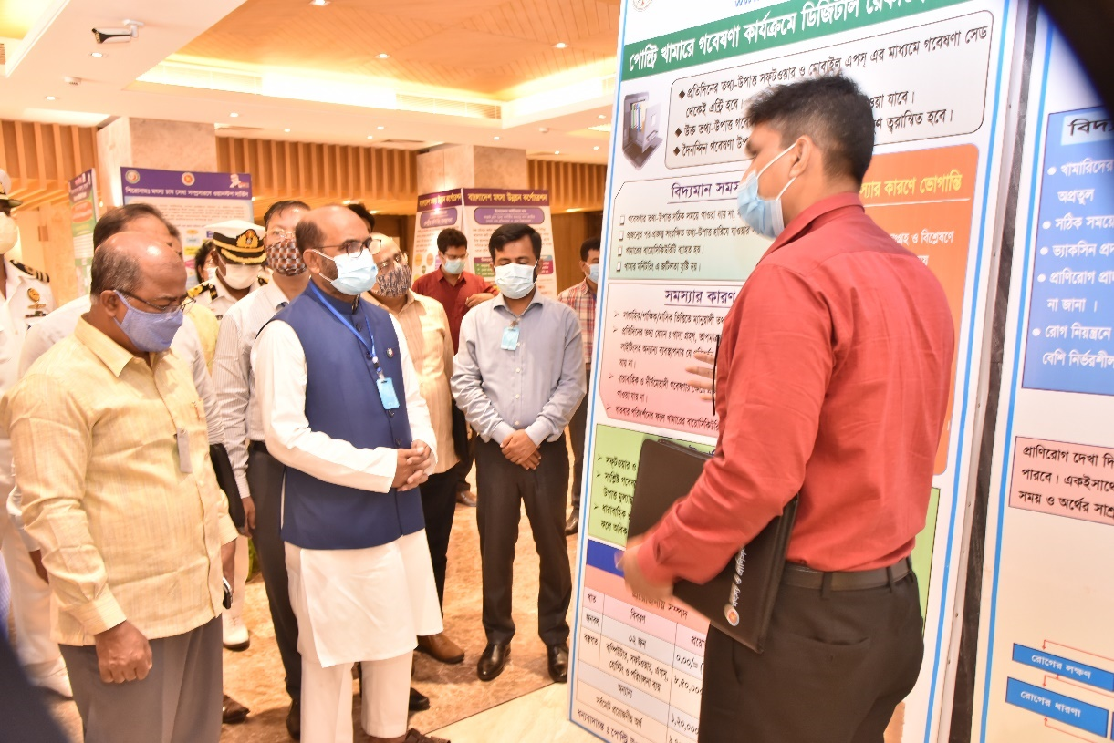
ছবি-৯: প্রধান অতিথি, বিশেষ অতিথি ও সভাপতিসহ মন্ত্রণালয় ও আওতাধীন দপ্তর/সংস্থার বিভিন্ন পর্যায়ের কর্মকর্তা কর্তৃক ইনোভেশন শোকেসিং-এ প্রদর্শিত বাংলাদেশ প্রাণিসম্পদ গবেষণা ইন্সটিটিউট-এর উদ্ভাবনসমূহ পরিদর্শন।

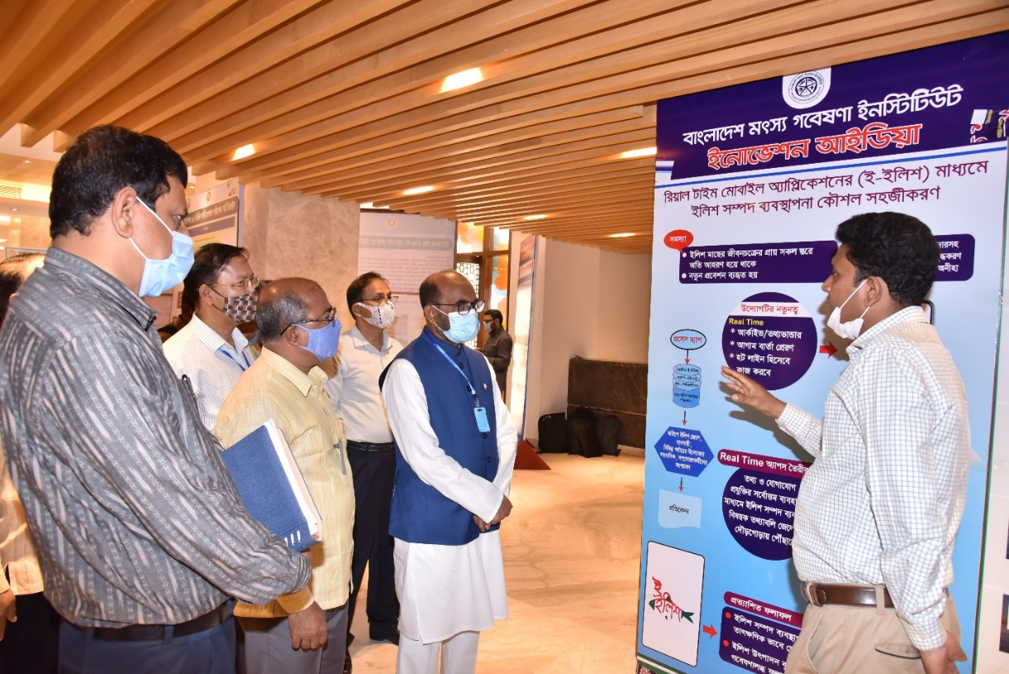
ছবি-১০: প্রধান অতিথি, বিশেষ অতিথি ও সভাপতিসহ মন্ত্রণালয় ও আওতাধীন দপ্তর/সংস্থার বিভিন্ন পর্যায়ের কর্মকর্তা কর্তৃক ইনোভেশন শোকেসিং-এ প্রদর্শিত বাংলাদেশ মৎস্য গবেষণা ইন্সটিটিউট-এর উদ্ভাবনসমূহ পরিদর্শন।
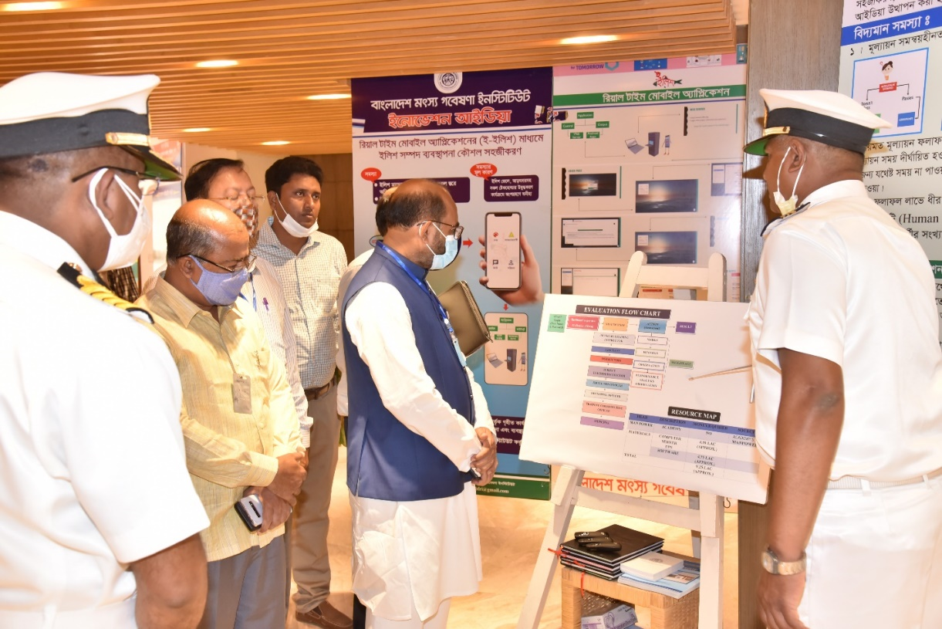
ছবি-১১: প্রধান অতিথি, বিশেষ অতিথি ও সভাপতিসহ মন্ত্রণালয় ও আওতাধীন দপ্তর/সংস্থার বিভিন্ন পর্যায়ের কর্মকর্তা কর্তৃক ইনোভেশন শোকেসিং-এ প্রদর্শিত মেরিন ফিশারিজ একাডেমী-এর উদ্ভাবনসমূহ পরিদর্শন।

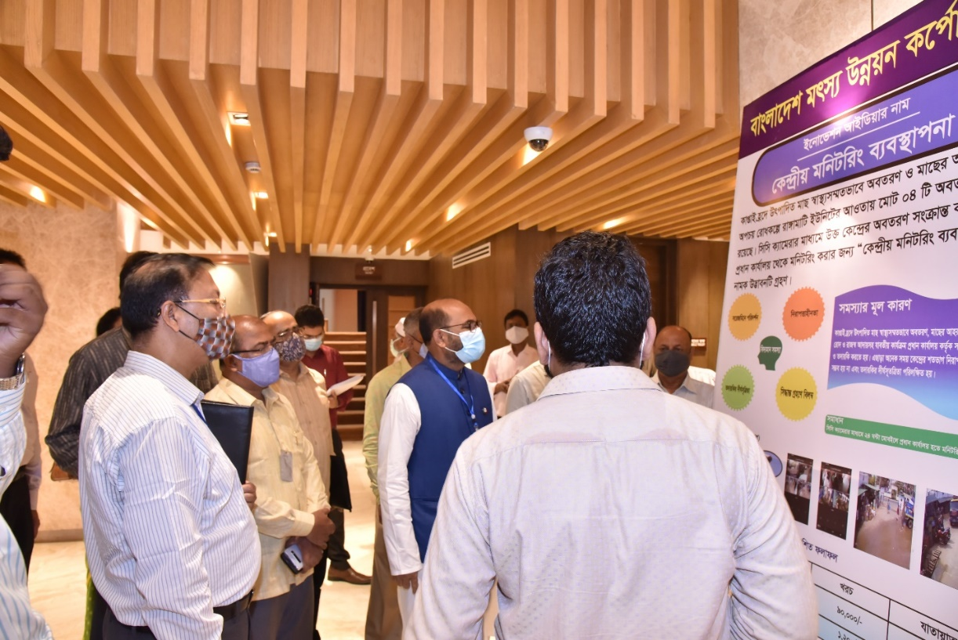
ছবি-১২: প্রধান অতিথি, বিশেষ অতিথি ও সভাপতিসহ মন্ত্রণালয় ও আওতাধীন দপ্তর/সংস্থার বিভিন্ন পর্যায়ের কর্মকর্তা কর্তৃক ইনোভেশন শোকেসিং-এ প্রদর্শিত বাংলাদেশ মৎস্য উন্নয়ন কর্পোরেশন-এর উদ্ভাবনসমূহ পরিদর্শন।
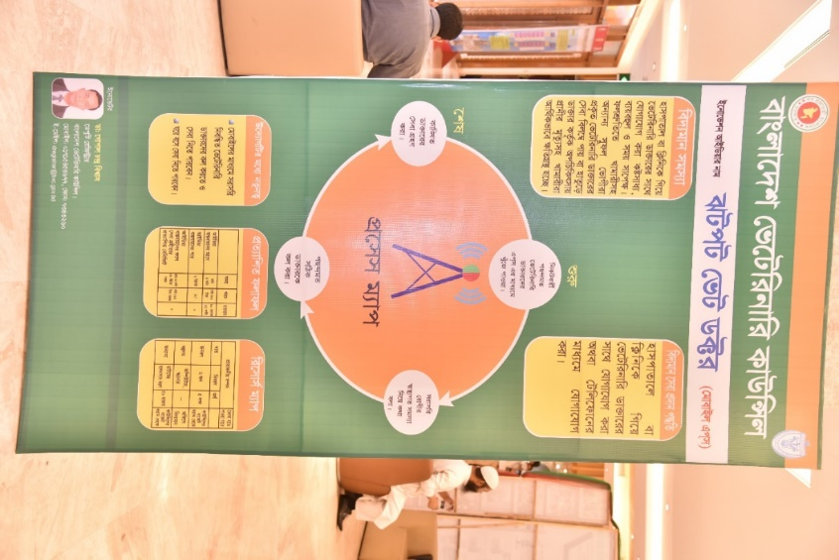
ছবি-১৩: প্রধান অতিথি, বিশেষ অতিথি ও সভাপতিসহ মন্ত্রণালয় ও আওতাধীন দপ্তর/সংস্থার বিভিন্ন পর্যায়ের কর্মকর্তা কর্তৃক ইনোভেশন শোকেসিং-এ প্রদর্শিত বাংলাদেশ ভেটেরিনারি কাউন্সিল-এর উদ্ভাবনসমূহ পরিদর্শন।

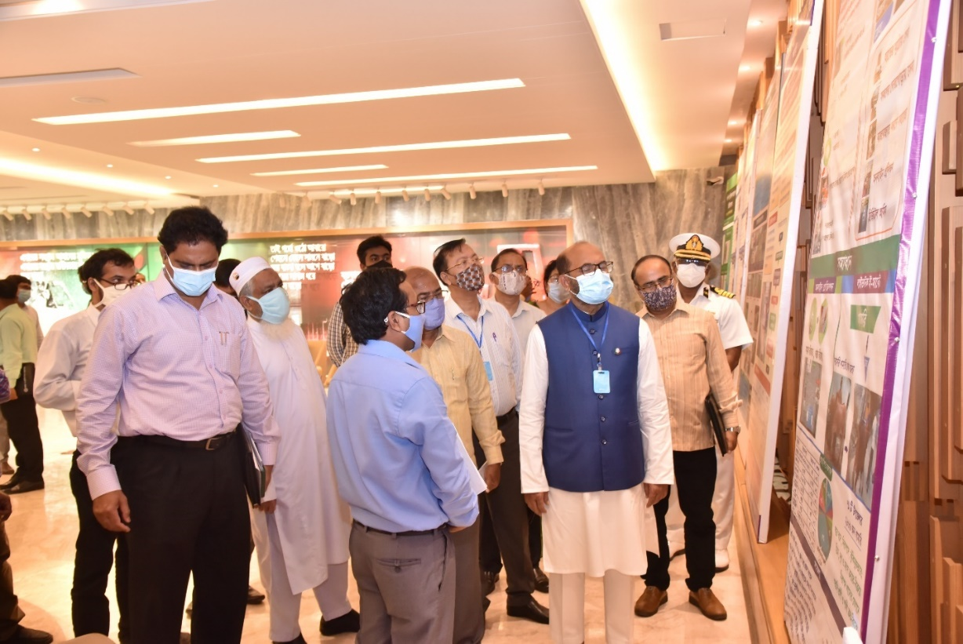
ছবি-১৪: প্রধান অতিথি, বিশেষ অতিথি ও সভাপতিসহ মন্ত্রণালয় ও আওতাধীন দপ্তর/সংস্থার বিভিন্ন পর্যায়ের কর্মকর্তা ও আওতাধীন দপ্তর / সংস্থা প্রধান কর্তৃক ইনোভেশন শোকেসিং-এ প্রদর্শিত উদ্ভাবনসমূহ পরিদর্শন।
শোকেসিং অনুষ্ঠানে উপস্থাপিত উদ্ভাবনসমূহ যাচাই বাছাই এর লক্ষ্যে ০২ টি কমিটি গঠন করা হয় যথাক্রমে মৎস্য সেক্টরের আইডিয়া যাচাই বাছাই কমিটি এবং প্রাণিসম্পদ সেক্টরের যাচাই বাছাই কমিটি। এছাড়াও গঠিত কমিটি কর্তৃক যাচাই বাছাইকৃত উদ্ভাবনসমূহ মূল্যায়নের নিমিত্ত ০১ টি মূল্যায়ন কমিটি গঠন করা হয়। কমিটিসমূহ নিম্নরূপঃ
ক) মৎস্য সেক্টরের উদ্ভাবনসমূহ যাচাই-বাছাই সংক্রান্ত কমিটিঃ
ক্রমিক নং | নাম ও পদবী | মন্তব্য
১। | মোঃ হামিদুর রহমান, যুগ্নসচিব (আইন), মৎস্য ও প্রাণিসম্পদ মন্ত্রণালয়। | আহ্বায়ক
২। | সুব্রত ভৌমিক, উপসচিব (প্রশাসন-৩), মৎস্য ও প্রাণিসম্পদ মন্ত্রণালয়। | সদস্য
৩। | হাফছা বেগম, উপসচিব (মৎস্য-১), মৎস্য ও প্রাণিসম্পদ মন্ত্রণালয়। | সদস্য
৪। | মোঃ ইলিয়াস হোসেন, সিস্টেম এনালিস্ট, মৎস্য ও প্রাণিসম্পদ মন্ত্রণালয়। | সদস্য
খ) প্রাণিসম্পদ সেক্টরের উদ্ভাবনসমূহ যাচাই-বাছাই সংক্রান্ত কমিটিঃ
ক্রমিক নং | নাম ও পদবী | মন্তব্য
১। | এস এম ফেরদৌস আলম, যুগ্ম সচিব (প্রাণিসম্পদ-১)  মৎস্য ও প্রাণিসম্পদ মন্ত্রণালয়। | আহ্বায়ক
২। | ড. আবু নঈম মুহাম্মদ আবদুছ ছবুর, মাননীয় মন্ত্রীর একান্ত সচিব (উপসচিব)  মৎস্য ও প্রাণিসম্পদ মন্ত্রণালয়। | সদস্য
৩। | দিলওয়ারা আলো, উপসচিব (প্রাণিসম্পদ-৩)  মৎস্য ও প্রাণিসম্পদ মন্ত্রণালয়। | সদস্য
৪। | নূর মোহাম্মদ, প্রোগ্রামার  মৎস্য ও প্রাণিসম্পদ মন্ত্রণালয়। | সদস্য

গ) মৎস্য ও প্রাণিসম্পদ সেক্টরের বিভিন্ন উদ্ভাবনসমূহ সংশ্লিষ্ট কমিটি কর্তৃক যাচাই-বাছাইয়ান্তে মূল্যায়নের নিমিত্ত নিন্মোক্ত মূল্যায়ন কমিটি গঠন করা হয়।
ক্রমিক নং | নাম ও পদবী | মন্তব্য
১। | শাহ্ মোঃ ইমদাদুল হক, অতিরিক্ত সচিব (প্রাণিসম্পদ-২)  মৎস্য ও প্রাণিসম্পদ মন্ত্রণালয়। | আহ্বায়ক
২। | মোঃ তৌফিকুল আরিফ, অতিরিক্ত সচিব (পরিকল্পনা)  মৎস্য ও প্রাণিসম্পদ মন্ত্রণালয়। | সদস্য
৩। | শ্যামল চন্দ্র কর্মকার, অতিরিক্ত সচিব (মৎস্য)  মৎস্য ও প্রাণিসম্পদ মন্ত্রণালয়। | সদস্য

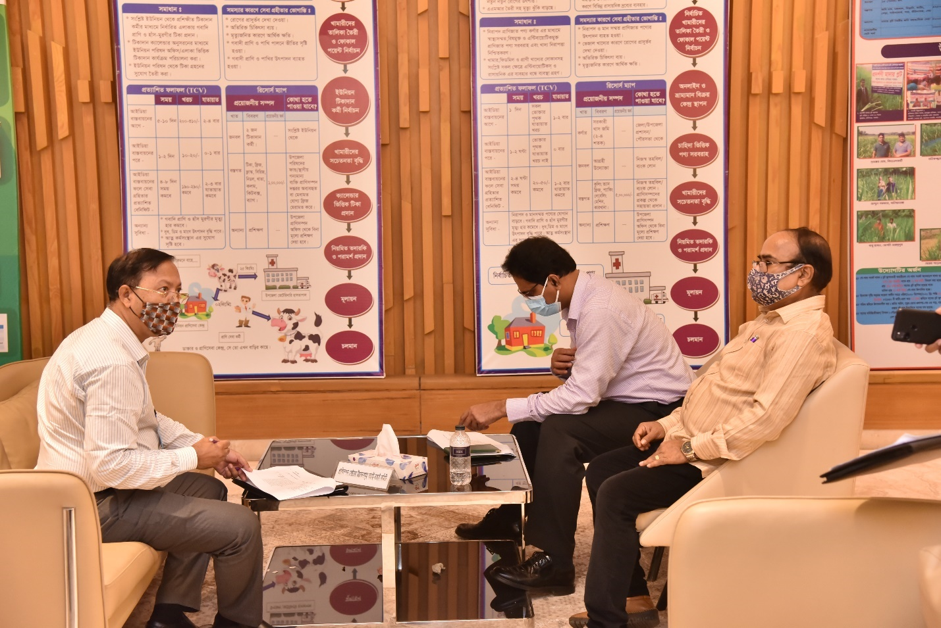
ছবি-১৫: শোকেসিং অনুষ্ঠানে গঠিত মূল্যায়ন কমিটি কর্তৃক যাচাই-বাছাইকৃত উদ্ভাবনসমূহ মূল্যায়ন।
শোকেসিং অনুষ্ঠানে গঠিত যাচাই-বাছাই কমিটি কর্তৃক ৩২ টি উদ্ভাবন পুঙ্খানুপুঙ্খরূপে যাচাই-বাছাই করা হয়। যাচাই-বাছাই কমিটি যাচাই-বাছাই কার্যক্রম শেষে উদ্ভাবনসমূহ পাইলটিংযোগ্য, পুনঃপাইলটিং, রেপ্লিকেশনযোগ্য ইত্যাদি শ্রেণিতে নিম্নক্তভাবে শ্রেণিবিন্যাস করেন এবং যাচাই-বাছাই কমিটি শ্রেণিবিন্যাসকৃত উদ্ভাবনসমূহ মূল্যায়ন কমিটির নিকট প্রদান করেন।

শোকেসিং-এ প্রদর্শিত এবং যাচাই-বাছাই কমিটি কর্তৃক যাচাই-বাছাইকৃত উদ্ভাবনসমূহ
ক্রম | উদ্ভাবনের নাম | উদ্ভাবকের নাম ও পদবী | মন্ত্রণালয়/দপ্তর/সংস্থা
পাইলটিংযোগ্য
১ | মৎস্য নৌযানের লাইসেন্স প্রদান সংক্রান্ত তথ্যাদি ব্যবস্থাপনা। | ড. মোঃ আবদুল লতিফ, উপসচিব | মৎস্য ও প্রাণিসম্পদ মন্ত্রণালয়
২ | পরিদর্শন প্রতিবেদন ব্যবস্থাপনা | মোঃ ইলিয়াস হোসেন, সিস্টেম এনালিস্ট | মৎস্য ও প্রাণিসম্পদ মন্ত্রণালয়
৩ | পার্বত্য এলাকায় নদী ও ছড়ায় দেশীয় প্রজাতির ছোট মাছের উৎপাদন ও প্রাপ্যতা বৃদ্ধি | বিজয় কুমার দাস, উপজেলা মৎস্য কর্মকর্তা | মৎস্য অধিদপ্তর
৪ | চিংড়ি চাষিদের কল্যাণে উপজেলা মৎস্য অফিসের উদ্যোগে গ্রামে গ্রামে মিনি প্রশিক্ষণ | সোহেল মোঃ জিল্লুর রহমান রিগান, সিনিয়র উপজেলা মৎস্য কর্মকর্তা | মৎস্য অধিদপ্তর
৫ | চ্যাপা শুটকি প্ৰস্তুত ও বাজারজাতকরণ | মোঃ আবু সাঈদ,  উপজেলা মৎস্য কর্মকর্তা | মৎস্য অধিদপ্তর
৬ | মৎস্য ডেটাবেজ | পলাশ বালা,  উপজেলা মৎস্য কর্মকর্তা, বাঘারপাড়া | মৎস্য অধিদপ্তর
৭ | রাসায়নিক পরীক্ষার মাধ্যমে গাভীর গর্ভ পরীক্ষা। | ডা: আ,জ,ম, সালাহ্ উদ্দীন, ভেটেরিনারি সার্জন | প্রাণিসম্পদ অধিদপ্তর
৮ | পোল্ট্রি খামারে গবেষণা কার্যক্রমে ডিজিটাল রেকর্ডিং সিস্টেম | ড. মোঃ রাকিবুল হাসান  প্রধান বৈজ্ঞানিক কর্মকর্তা | বাংলাদেশ প্রাণিসম্পদ গবেষণা ইনস্টিটিউট
৯ | বিএলআরআই প্রশিক্ষণ কর্নার | কামরুন নাহার মনিরা  ঊর্ধতন প্রশিক্ষণ কর্মকর্তা | বাংলাদেশ প্রাণিসম্পদ গবেষণা ইনস্টিটিউট
১০ | ডিজিজ এন্ড ভ্যাকসিন ক্যালেন্ডার | ডা: মোঃ জুলফিকার আলী,  বৈজ্ঞানিক কর্মকর্তা | বাংলাদেশ প্রাণিসম্পদ গবেষণা ইনস্টিটিউট
১১ | ডেবা নার্সারি | মোঃ ইসমাইল হোসেন  ফিস কালচারিস্ট | বাংলাদেশ মৎস্য উন্নয়ন কর্পোরেশন
আইডিয়া পরিবীক্ষণপূর্বক পাইলটিংযোগ্য
১ | মৎস্য চাষ সেবা সম্প্রসারণে ওয়ানস্টপ সার্ভিস | মোঃ শামসুল আলম পাটওয়ারী  উপজেলা মৎস্য কর্মকর্তা | মৎস্য অধিদপ্তর
২ | IoT ভিত্তিক পানির গুনাগুণ পরিমাপক স্মার্ট ডিভাইস | মোঃ আলমগীর হোসেন,  সিনিয়র উপজেলা মৎস্য অফিসার (নিজ বেতনে) | মৎস্য অধিদপ্তর
৩ | আধুনিক কৃত্রিম প্রজনন সেবার মাধ্যমে গর্ভধারণের হার বৃদ্ধি, মান সম্মত বাছুর এবং অধিক দুধ উৎপাদন নিশ্চিতকরণ | ডা: এ এস এম সাদেকুর রহমান  উপজেলা প্রাণিসম্পদ কর্মকর্তা | প্রাণিসম্পদ অধিদপ্তর
৪ | তৃণমূল পর্যায়ে গবাদিপশু পালন, গরু হৃষ্টপুষ্টকরণ প্রশিক্ষণ ও ঔষধ সরবরাহ | ডা: ফারহানা জাহান, ভেটেরিনারি সার্জন | প্রাণিসম্পদ অধিদপ্তর
৫ | রিয়াল টাইম মোবাইল অ্যাপ্লিকেশনের (ই-ইলিশ) মাধ্যমে ইলিশ সম্পদ ব্যবস্থাপনা কৌশল সহজিকরণ | মোঃ আবুল বাশার  উর্ধ্বতন বৈজ্ঞানিক কর্মকর্তা ও  প্রকল্প পরিচালক | বাংলাদেশ মৎস্য গবেষণা ইনস্টিটিউট
৬ | ই-কার্প ব্রিডিং মোবাইল এ্যাপস | ড. মোঃ শাহা আলী  মুখ্য বৈজ্ঞানিক কর্মকর্তা এবং মোঃ আশিকুর রহমান, ঊর্ধ্বতন বৈজ্ঞানিক কর্মকর্তা | বাংলাদেশ মৎস্য গবেষণা ইনস্টিটিউট
৭ | চিংড়ির রোগ বাতায়ন | শাহ্‌নূর জাহেদুল হাসান  উর্ধ্বতন বৈজ্ঞানিক কর্মকর্তা ও  প্রকল্প পরিচালক | বাংলাদেশ মৎস্য গবেষণা ইনস্টিটিউট
আইডিয়া পুনঃপরিবীক্ষণ প্রয়োজন
১ | FTMS (FISHING TRAWLWR MONITORING SYSTEM) | সুদীপ ভট্টাচার্য,  সিনিয়র উপজেলা মৎস্য কর্মকর্তা | মৎস্য অধিদপ্তর
২ | উত্তম মৎস্য বাজার ব্যবস্থাপনা।  Good Fish Market Management (GFMM) | মোঃ মহিদুল ইসলাম,  উপজেলা মৎস্য কর্মকর্তা | মৎস্য অধিদপ্তর
৩ | একটি খামার একটি ঘাসের প্লট। (কেশবপুর মডেল) | ডা: অলোকেশ কুমার সরকার,  ভেটেরিনারি সার্জন | প্রাণিসম্পদ অধিদপ্তর
৪ | জনগণের দোরগোড়ায় প্রাণিসম্পদের সেবা পৌঁছানো। | ডা. এবিএম সাইফুজ্জামান, জেলা প্রাণিসম্পদ কর্মকর্তা | প্রাণিসম্পদ অধিদপ্তর
৫ | জনসচেতনতা বৃদ্ধির মাধ্যমে প্রাণীর সংক্রামক রোগ প্রতিরোধ ও নিয়ন্ত্রণ | ডা: মোসাঃ শামীম নাহার, উপজেলা প্রাণিসম্পদ কর্মকর্তা | প্রাণিসম্পদ অধিদপ্তর
৬ | তৃণমূল পর্যায়ে টিকা প্রদান কর্মীর মাধ্যমে গবাদিপ্রাণি ও হাঁস-মুরগীর টিকাদান সেবা সহজীকরণ | ডা: নুরুল্লাহ মোঃ আহসান, জেলা প্রাণিসম্পদ কর্মকর্তা | প্রাণিসম্পদ অধিদপ্তর
৭ | গ্রামভিত্তিক গবাদিপশু ও হাস-মুরগীর রোগ প্রতিরোধ ও চিকিৎসা সেবায় প্রাণিসম্পদের ক্যাম্প স্থাপন। | ডা: মোঃ আব্দুল মজিদ,  জেলা প্রাণিসম্পদ কর্মকর্তা | প্রাণিসম্পদ অধিদপ্তর
৮ | গ্রীনওয়ে অ্যাপস্ | ডা: সোনিয়া আক্তার  বৈজ্ঞানিক কর্মকর্তা | বাংলাদেশ প্রাণিসম্পদ গবেষণা ইনস্টিটিউট
৯ | কেন্দ্রীয় মনিটরিং ব্যবস্থাপনা | মোঃ রাজিবুল আলম  হিসাব নিয়ন্ত্রক | বাংলাদেশ মৎস্য উন্নয়ন কর্পোরেশন
১০ | মেরিটাইম প্রশিক্ষণ মূল্যায়ন প্রক্রিয়া | লেঃ কমাঃ মোঃ নজরুল ইসলাম, উর্দ্ধতন ইন্সট্রাক্টর (নেভিগেশন) এবং মোঃ এমদাদ উল্লাহ্, জুঃ ইন্সট্রাক্টর (মেরিন) | মেরিন ফিশারিজ একাডেমি
১১ | ঝটপট ভেট ডক্টর | ডা: গোপাল চন্দ্র বিশ্বাস, ডেপুটি রেজিস্ট্রার | বাংলাদেশ ভেটেরিনারি কাউন্সিল
রেপ্লিকেশনযোগ্য
১ | “হাতের মুঠোয়, ঘরে বসে অনলাইন ডিজিটাল প্রাণিসম্পদ সেবা” (কাগজবিহীন অফিস ব্যবস্থাপনা) | ডা: মিঠুন সরকার  ভেটেরিনারি সার্জন | প্রাণিসম্পদ অধিদপ্তর
২ | “স্বপ্ন ছোঁয়ার সিঁড়ি, বাণিজ্যিক ভিত্তিক দেশি মুরগির (অরগানিক) খামার” | ডা: মোঃ রায়হান পিএএ, ভেটেরিনারি সার্জন | প্রাণিসম্পদ অধিদপ্তর
৩ | প্রাণীর টেলিমেডিসিন সেবা | ড. মোঃ শাহীন আলম  ঊর্ধ্বতন বৈজ্ঞানিক কর্মকর্তা  প্রাণিস্বাস্থ্য গবেষণা বিভাগ | বাংলাদেশ প্রাণিসম্পদ গবেষণা ইনস্টিটিউট

মূল্যায়ন কমিটি শ্রেণিবিন্যাসকৃত ৩২ টি উদ্ভাবন মূল্যায়ন শেষে মৎস্য সেক্টর ও প্রাণিসম্পদ সেক্টরের ৬ টি উদ্ভাবনকে র‍্যাংকিং করেন এবং মৎস্য ও প্রাণিসম্পদ মন্ত্রণালয়ের ২ টি উদ্ভাবন বিশেষ র‌্যাংকিং করেন যা নিম্নরূপ:

শোকেসিং-এ র‍্যাংকিংকৃত উদ্ভাবনসমূহ

খ) র‍্যাংকিংকৃত মৎস্য সেক্টরের উদ্ভাবনসমূহ
র‌্যাংকিং | আইডিয়ার নাম | উদ্ভাবকের নাম ও পদবী | দপ্তর/সংস্থা
১ম | IoT ভিত্তিক পানির গুনাগুণ পরিমাপক স্মার্ট ডিভাইস | মোঃ আলমগীর হোসেন,  সিনিয়র উপজেলা মৎস্য অফিসার | মৎস্য অধিদপ্তর
২য় | চ্যাপা শুটকি প্ৰস্তুত ও বাজারজাতকরণ | মোঃ আবু সাঈদ,  উপজেলা মৎস্য কর্মকর্তা | মৎস্য অধিদপ্তর
৩য় | ডেবা নার্সারি | মোঃ ইসমাইল হোসেন  ফিস কালচারিস্ট | বাংলাদেশ মৎস্য উন্নয়ন কর্পোরেশন

গ) র‌্যাংকিংকৃত প্রাণিসম্পদ সেক্টরের উদ্ভাবনসমূহ
র‌্যাংকিং | আইডিয়ার নাম | উদ্ভাবকের নাম ও পদবী | দপ্তর/সংস্থা
১ম | “হাতের মুঠোয়, ঘরে বসে অনলাইন ডিজিটাল প্রাণিসম্পদ সেবা” (কাগজবিহীন অফিস ব্যবস্থাপনা) | ডা: মিঠুন সরকার, ভেটেরিনারি সার্জন | প্রাণিসম্পদ অধিদপ্তর
২য় | রাসায়নিক পরীক্ষার মাধ্যমে গর্ভ পরীক্ষা | ডা: আ,জ,ম, সালাহ্ উদ্দীন, ভেটেরিনারি সার্জন | প্রাণিসম্পদ অধিদপ্তর
৩য় | ডিজিজ এন্ড ভ্যাকসিন ক্যালেন্ডার | ডা: মোঃ জুলফিকার আলী, বৈজ্ঞানিক কর্মকর্তা, প্রাণিস্বাস্থ্য গবেষণা বিভাগ,  বাংলাদেশ প্রাণিসম্পদ গবেষণা ইনস্টিটিউট | বিএলআরআই

গ) বিশেষ র‌্যাংকিংকৃত মৎস্য ও প্রাণিসম্পদ মন্ত্রণালয়ের উদ্ভাবনসমূহ
ক্রম | আইডিয়ার নাম | উদ্ভাবকের নাম ও পদবী
১ | মৎস্য নৌযানের লাইসেন্স প্রদান সংক্রান্ত তথ্যাদি ব্যবস্থাপনা। | ড. মোঃ আবদুল লতিফ, উপসচিব  মৎস্য ও প্রাণিসম্পদ মন্ত্রণালয়
২ | পরিদর্শন প্রতিবেদন ব্যবস্থাপনা | মোঃ ইলিয়াস হোসেন, সিস্টেম এনালিস্ট  মৎস্য ও প্রাণিসম্পদ মন্ত্রণালয়

র‌্যাংকিংকৃত মোট আটটির উদ্ভাবকগণকে ক্রেস্টসহ সার্টিফিকেট এবং অন্যান্য উদ্ভাবকগণকে শোকেসিং কর্মশালা অনুষ্ঠানে অংশগ্রহণ ও তাঁর উদ্ভাবনী বিষয়ক কার্যক্রমের নিমিত্ত সার্টিফিকেট দেয়ার সিদ্ধান্ত গৃহীত হয়।
অতঃপর সভাপতি মহোদয় সকলকে ধন্যবাদ জানিয়ে শোকেসিং কর্মশালা সমাপ্ত ঘোষণা করেন।

তৃতীয় অধ্যায়: মন্ত্রণালয়ের উদ্ভাবন ও ডিজিটাল সেবা

সক্ষমতা বৃদ্ধির লক্ষ্যে উদ্ভাবনী প্রশিক্ষণ এবং কর্মশালা
প্রশিক্ষণের তারিখঃ ১৭-১৮ ফেব্রুয়ারি, ২০২১ ইং
প্রশিক্ষণের অংশগ্রহণকারীঃ মৎস্য ও প্রাণিসম্পদ মন্ত্রণালয়ের ৩২জন কর্মকর্তা
প্রশিক্ষণের ছবিঃ-১
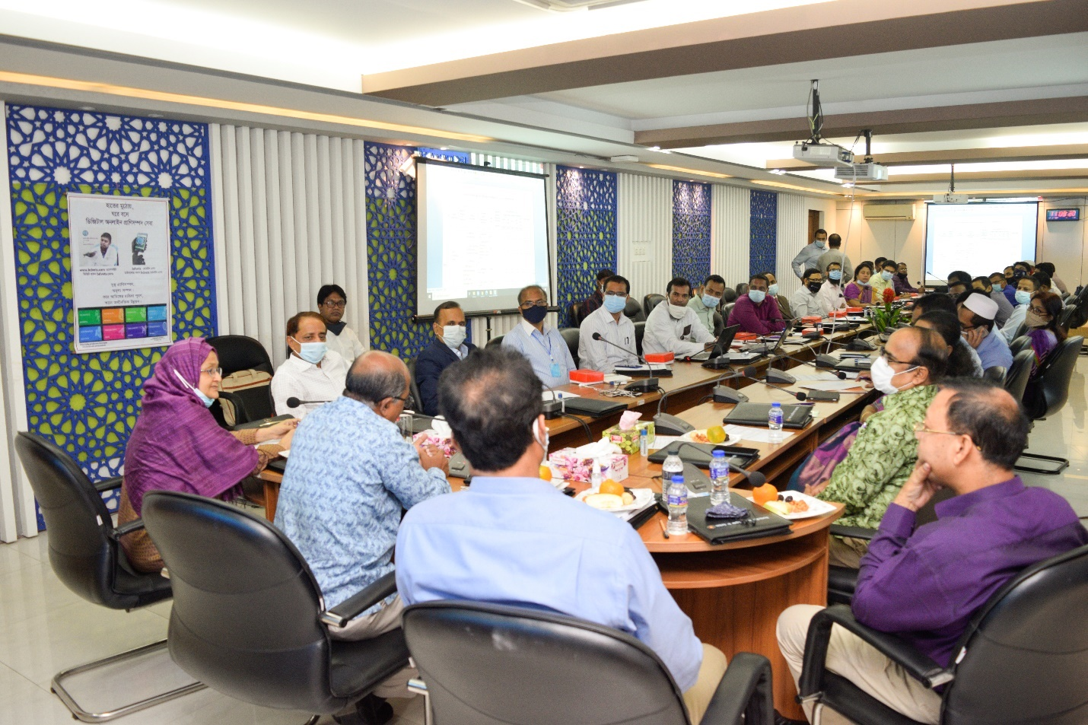

প্রশিক্ষণের ছবিঃ-২
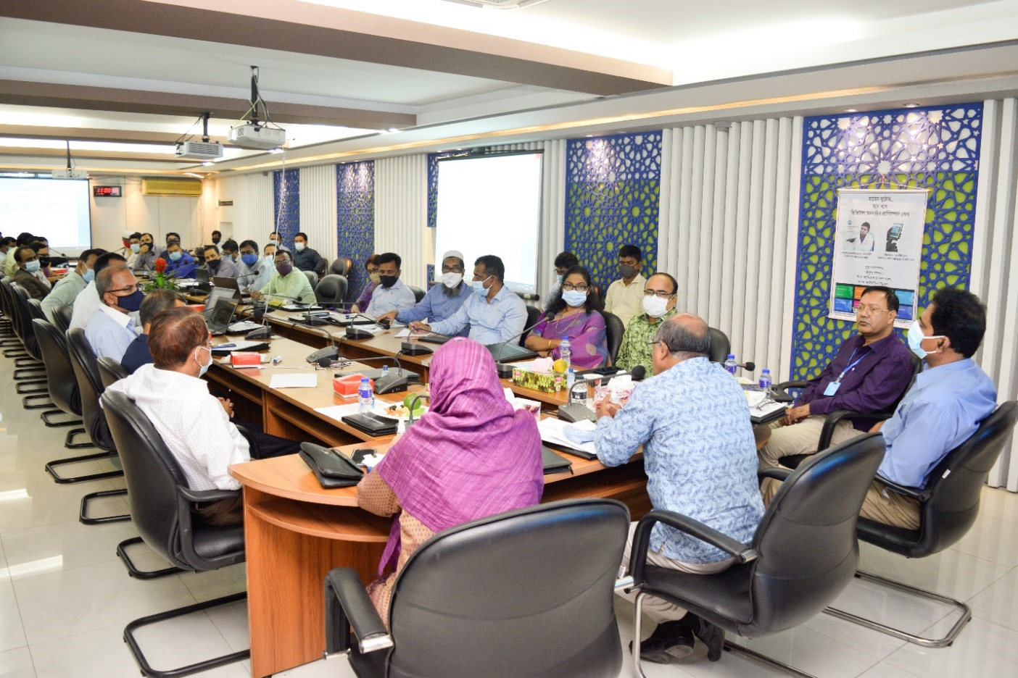
প্রশিক্ষণের ছবিঃ-৩
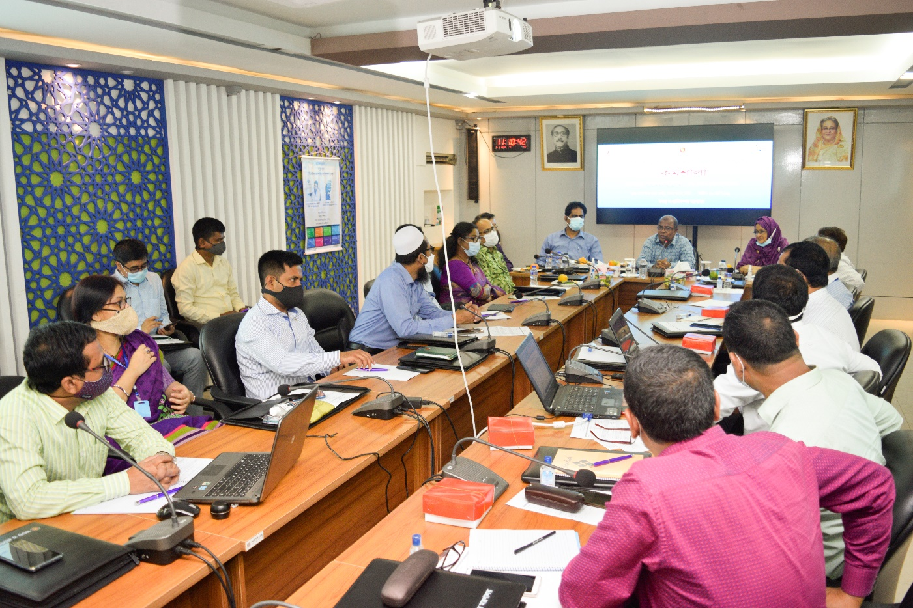
১। উদ্ভাবনের নামঃ

মৎস্য নৌযানের লাইসেন্স প্রদান সংক্রান্ত তথ্যদি ব্যবস্থাপনা।

২। সমস্যার / বর্তমান ফ্লো-চার্টঃ

সেবার সমস্যা | সমস্যার কারণ | সেবা গ্রহিতা বা জনগণের ভোগান্তি
ক. লাইসেন্স প্রদানে বেশী সময় ক্ষেপন হওয়া;  খ. শ্রমের অপচয়;  গ. অর্থের অপচয়;  গ. নৌযান ক্রয় ও বিক্রয়কারী এর প্রয়োজনীয় তথ্যাবলির ঘাটতি; | বর্তমানে ম্যানুয়াল পদ্ধতিতে লাইসেন্সের জন্য আবেদন করতে হয় ফলে আবেদনকারীর লাইসেন্স পেতে দীর্ঘসময় (৬০ দিন) প্রয়োজন হয়। এতে আবেদনকারীর সময়, শ্রম ও অর্থের অপচয় হয়। অপরদিকে আবেদনকারীর আবেদনের সাথে প্রয়োজনীয় তথ্যাদি (ডিজিটাল ডাটাবেজ) না থাকায় সিদ্ধান্ত গ্রহণে দীর্ঘসূত্রীতা সৃষ্টি হয়। আবেদনকারী আবেদনের সাথে প্রয়োজনীয় তথ্যাদি কি কি দিতে হবে সে সম্পর্কে অবগত না থাকায় আবেদন অসম্পন্ন রয়ে যায়।  নৌযানের মালিকানা, নৌযানের Category, নবায়ন, নৌযানের Fitness, মাছ ধরার অনুমোদিত এলাকা, মৎস্য ধারণ ক্ষমতা, নৌযানে লোকবল, IUU Reporting, মৎস্য সংরক্ষণ ব্যবস্থা ইত্যাদি বিষয়য়ে তথ্য একত্র না থাকা। | সেবা গ্রহিতার সময়, শ্রম ও অর্থের অপচয় হয়।  নৌযান সম্পর্কিত প্রয়োজনীয় তথ্যাদি এবং সিদ্ধান্ত গ্রহনে প্রক্রিয়া সম্পর্কে জানা না থাকায় ক্রয়-বিক্রয় পরবর্তী সমস্যার সম্মুখীন হওয়া।

সমস্যা সম্পর্কিত বিবৃতিঃ পরিচালক, সামুদ্রিক মৎস্য দপ্তর হতে মৎস্য নৌযানের মৎস্য লাইসেন্স সংক্রান্ত তথ্যাদি প্রাপ্তিতে জটিলতা এবং আবেদনের ফরম্যাট, প্রয়োজনীয় কাগজপত্রাদি সম্পর্কের ধারণা না থাকা।
৩। ইনোভেশনঃ মৎস্য নৌযান এর ক্রয়-বিক্রয় তথ্যাদি ও মৎস্য লাইসেন্স প্রদানের জন্য প্রয়োজনীয় তথ্যাদি ব্যবস্থাপনা সহজীকরনের মাধ্যমে ইলেক্ট্রনিক পদ্ধতির প্রবর্তন।
৪। নতুন প্রাকটিসঃ ইলেক্ট্রনিক পদ্ধতেতি মৎস্য লাইসেন্স-এর তথ্যাদি ও ক্রয়-বিক্রয় সংক্রান্ত তথ্য সহজে প্রাপ্তি।
৫। নতুন প্রাকটিস চালু করার জন্য গ্রহীত পদক্ষেপসমূহঃ
ক) নৌযান লাইসেন্স সংক্রান্ত তথ্যাদির ডাটাবেজের প্রবর্তন (ওয়েবসাইটে সংরক্ষণ)
খ) নৌযান লাইসেন্স অথবা নবায়নের জন্য ছক / ফরম্যাট ওয়েবসাইটে সংরক্ষণ
গ) নৌযান লাইসেন্স অথবা নবায়নের জন্য প্রয়োজনীয় কাগজ-পত্র সংম্পর্কিত তথ্য ওয়েবসাইটে সংরক্ষণ
ঘ) ক্রয়-বিক্রয় সংক্রান্ত প্রয়োজনীয় তথ্যদির ডাটাবেজের প্রবর্তন (ওয়েবসাইটে সংরক্ষণ)

৭। পরবর্তীত ফ্লো-চার্টঃ

৭। ইনোভেশনটির শিরোনাম: মৎস্য নৌযানের লাইসেন্স প্রদান সংক্রান্ত তথ্যদি ব্যবস্থাপনা।
৮। প্রত্যাশিত ফলাফল (TCV):
 | সময় (দিন) | খরচ (টাকা) | যাতায়াত
আইডিয়া বাস্তবায়নের পূর্বে | ৬০ | ২০০০০.০০ | ৩
আইডিয়া বাস্তবায়নের পরে | ৩০ | ৫০০০.০০ | ১
মোট পার্থক্য | ৩০ | ১৫০০০.০০ | ২
অন্যান্য (TCV কমেনি, কিন্তু গুনগত মান বৃদ্ধি কিংবা অন্যান্য সুবিধা বেড়েছে) । | TCV ও গুনগত মান বৃদ্ধি

ডিজিটাল সেবার নামঃ

পরিদর্শন প্রতিবেদন ব্যবস্থাপনা
ডিজিটাল সেবার লিংকঃ
http://t.ly/znVY
ডিজিটাল সেবার সংক্ষিপ্ত বিবরণঃ
মন্ত্রণালয়ের সকল পরিদর্শনের তথ্য সংশ্লিষ্ট ডেস্ক অফিসারের নিকট অনেক প্রতিবেদন যায় না। ফলে এপিএ কার্যক্রম বাস্তবায়নের নিমিত্ত পরিদর্শন অর্জনের বাস্তব সংখ্যা ও প্রাপ্ত পরিদর্শন প্রতিবেদনের সংখ্যার গরমিল হয়। এছাড়া, সংশ্লিষ্ট কর্মকর্তা প্রাপ্ত পরিদর্শন প্রতিবেদনের হার্ডকপি সংরক্ষণ করে এবং অনেক সময় পরিদর্শন প্রতিবেদন খুঁজে পেতে সমস্যা হয় – যা অর্থ ও সময়ের অপচয় হয়।
“পরিদর্শন প্রতিবেদন ব্যবস্থাপনা” পদ্ধতি পরিদর্শনকারী কর্মকর্তা সরাসরি তাঁর পরিদর্শন প্রতিবেদন নির্ধারিত ফর্ম্যাটে আপলোড করবে এবং সংশ্লিষ্ট ডেস্ক কর্মকর্তা তা দেখতে পাবেন।
প্রাপ্ত পরিদর্শন প্রতিবেদন কর্মকর্তাওয়ারী, দিন, মাস অথবা তারিখ-ওয়ারী, পরিদর্শন প্রতিবেদনের সংখ্যা ইত্যাদি প্রয়োজন অনুযায়ী দেখতে পাবেন এবং প্রয়োজনে পরিদর্শন প্রতিবেদন প্রিন্ট নিতে পারবেন।

পরিদর্শন প্রতিবেদন আপলোডের ফর্মঃ
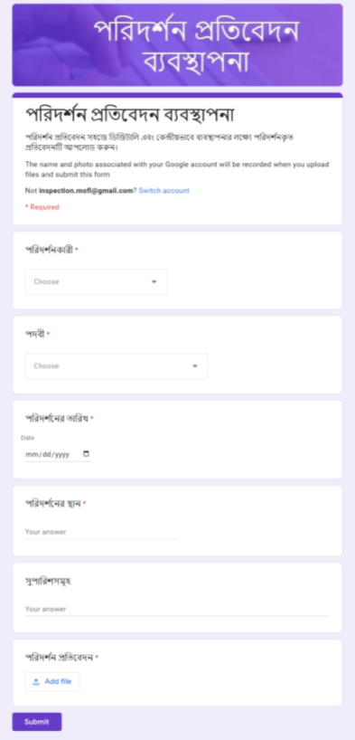

পরিদর্শনকারী অনুসারে পরিদর্শন প্রতিবেদন দেখাঃ
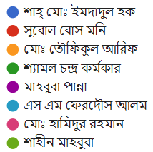
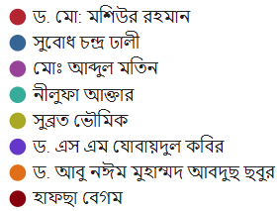
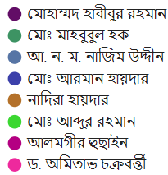
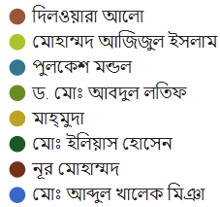
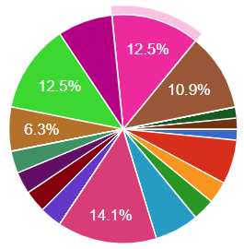

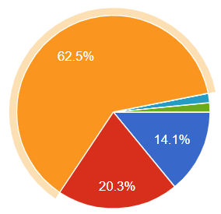
পদবী অনুসারে পরিদর্শন প্রতিবেদন দেখাঃ
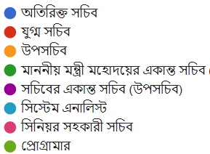

প্রত্যাশিত ফলাফল
সহজ ও ডিজিটাল পদ্ধতিতে পরিদর্শন প্রতিবেদন ব্যবস্থাপনা

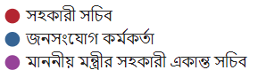

পরিদর্শনের তারিখ অনুসারে পরিদর্শন প্রতিবেদন দেখাঃ
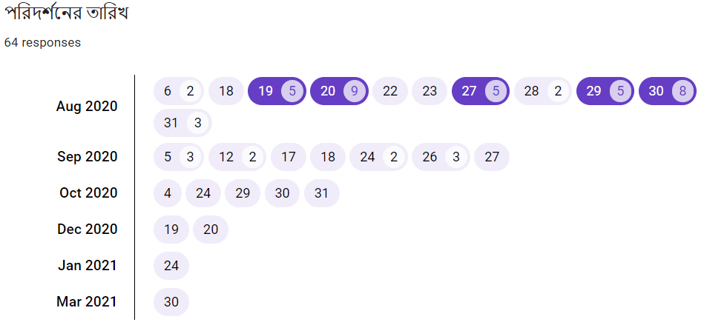

প্রত্যাশিত ফলাফল
সহজে, স্বল্প সময়ে এবং ডিজিটাল পদ্ধতিতে মৎস্য ও প্রাণিসম্পদ মন্ত্রণালয়ের পরিদর্শন প্রতিবেদনসমূহ আপলোড, সংরক্ষণ, বিভিন্ন প্রতিবেদন প্রস্তুত এবং ব্যবস্থাপনা।

পঞ্চম অধ্যায়: সেবা সহজিকরণ

সেবা সহজিকরণ প্রশিক্ষণ
প্রশিক্ষণের তারিখঃ ২২-২৩ সেপ্টেম্বর ২০২০ ইং
প্রশিক্ষণের অংশগ্রহণকারীঃ মৎস্য ও প্রাণিসম্পদ মন্ত্রণালয়ের ২৫জন কর্মকর্তা
প্রশিক্ষণের ছবিঃ-১
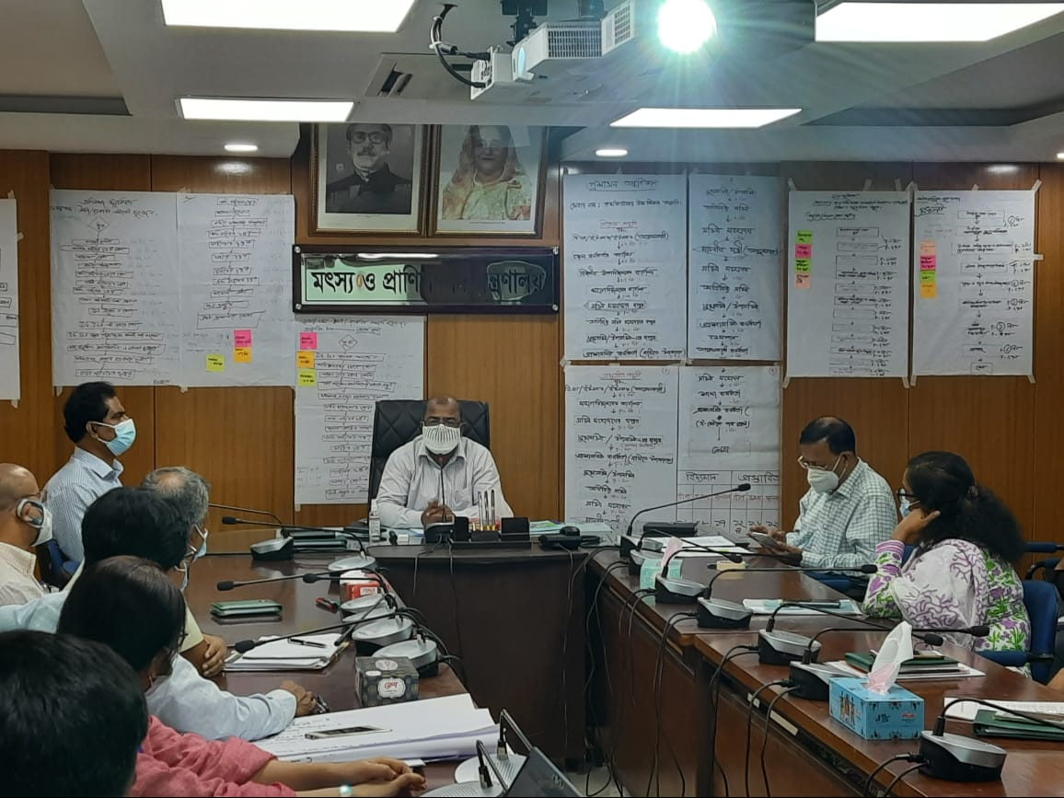

প্রশিক্ষণের ছবিঃ-২
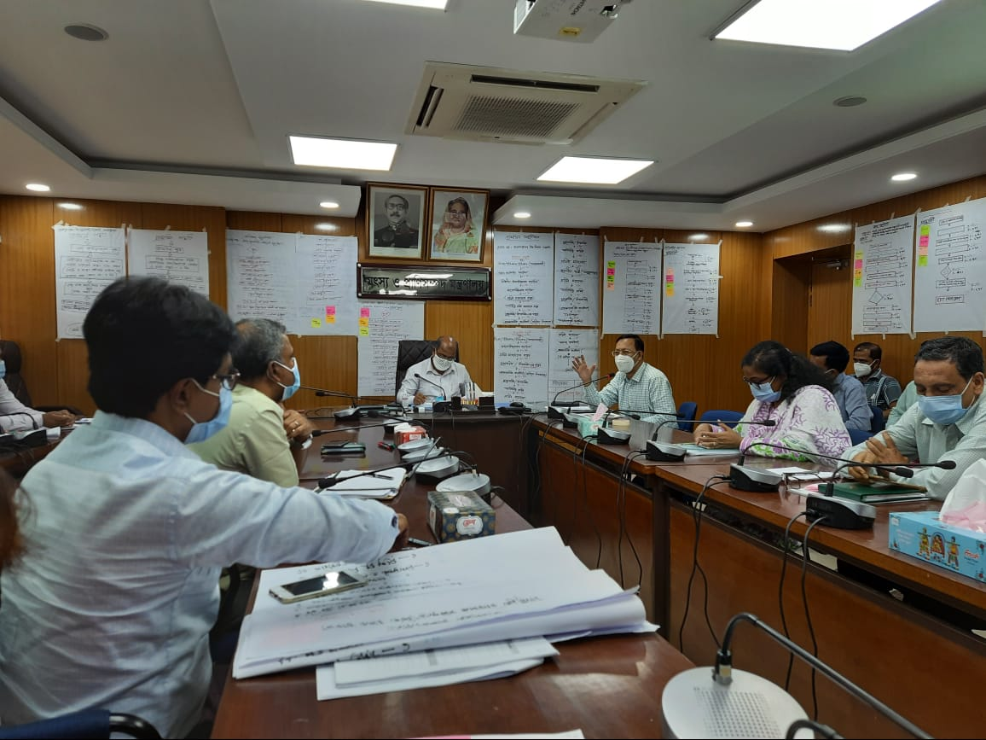

প্রশিক্ষণের ছবিঃ-৩
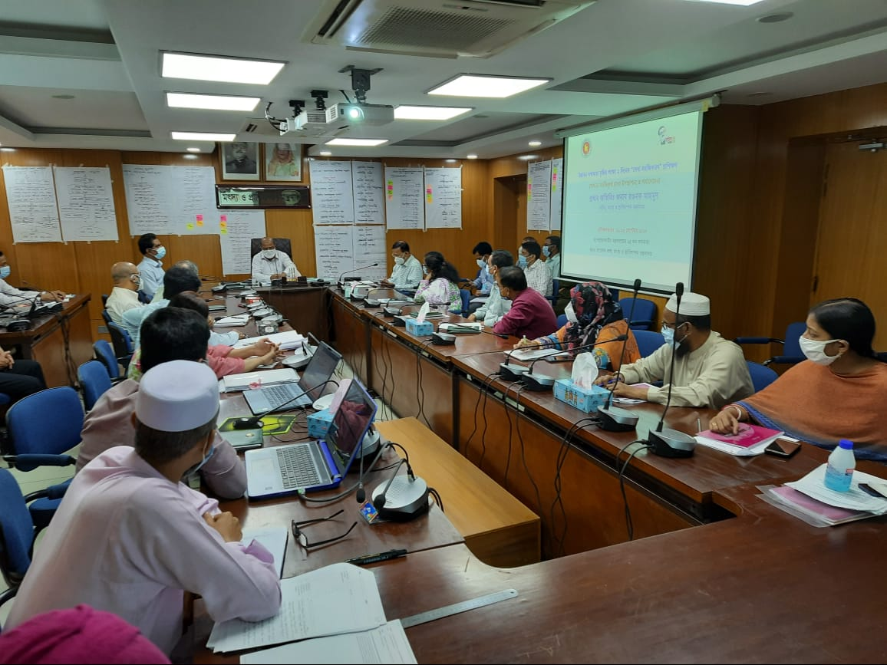

সেবার নাম - পিআরএল, লামগ্রান্ট, পেনশন ও আনুতোষিক মঞ্জুর
মন্ত্রণালয়/বিভাগের নাম: মৎস্য ও প্রাণিসম্পদ মন্ত্রণালয়
১। অফিস প্রোফাইল
ক) একনজরে অফিস
প্রতিষ্ঠানের নাম | বাংলা | মৎস্য ও প্রাণিসম্পদ মন্ত্রণালয়
 | ইংরেজি | Ministry of Fisheries and Livestock
 | সংক্ষিপ্ত | MOFL
অফিস প্রধানের পদবি | সচিব
অফিসের সংখ্যা | ১টি (প্রধান কার্যালয়)
জনবল | ১৫৩ জন
অফিসের ঠিকানা | মৎস্য ও প্রাণিসম্পদ মন্ত্রণালয়, বাংলাদেশ সচিবালয়, ঢাকা-১০০০
যোগাযোগ (ই-মেইল, ফোন, ফ্যাক্স) | ই-মেইল: secretary@mofl.gov.bd  ফোন:+৮৮-০২- ৯৫৪৫৭০০, ফ্যাক্স: +৮৮-০২- ৯৫১২২ ২০
ওয়েবসাইট | https://www.mofl.gov.bd
যাতায়াতের বর্ণনা (গুগল ম্যাপসহ) | রমনা থানার অন্তর্গত প্রেসক্লাবের পার্শ্বে বাংলাদেশ সচিবালয়ে ৬ নং ভবনের ৬ষ্ঠ তলায় মৎস্য ও প্রাণিসম্পদ মন্ত্রণালয়  ম্যাপে লিঙ্কঃ https://t.ly/ImD3  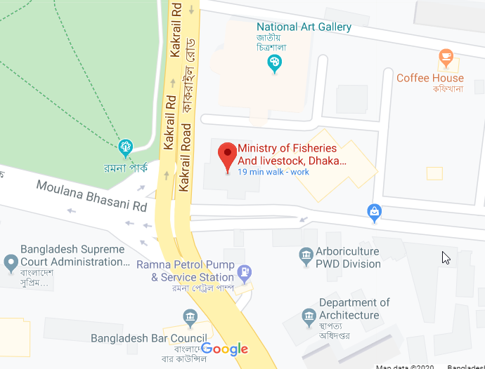

২। সেবা প্রোফাইল
ক) সেবার নাম: পিআরএল, লামগ্রান্ট, পেনশন ও আনুতোষিক মঞ্জুর

খ) সেবাটি সহজিকরণের যৌক্তিকতা
নির্দিষ্ট চাকরি জীবনের পর সরকারি কর্মকর্তা / কর্মচারীগণের পাপ্য পিআরএল, লামগ্রান্ট, অবসর সুবিধাসহ আনুতোষিক মঞ্জুরির জন্য সেবা সহজিকরণের মাধ্যমে পেনশন কেস দ্রুত নিস্পত্তির জন্য প্রক্রিয়াটি সম্পূর্ণরুপে অনলাইনে নিস্পত্তি করা আবশ্যক। এতে বয়স্ক সরকারি চাকরিজীবীদের ভোগান্তি কমবে। দ্রুত সেবা পাওয়া যাবে। সরকারি অর্থের সাশ্রয় হবে।

গ) সেবা প্রাপ্তির মৌলিক তথ্যাদিঃ
ক্র:নং | বিষয় | তথ্যাদি
১. | সেবা প্রদানকারী অফিস | মৎস্য ও প্রাণিসম্পদ মন্ত্রণালয়
২. | সেবার সংক্ষিপ্ত বিবরণ | নির্দিষ্ট চাকরি জীবনের পর সরকারি কর্মকর্তা / কর্মচারীগণের পাপ্য পিআরএল, লামগ্রান্ট, অবসর সুবিধাসহ আনুতোষিক মঞ্জুরির জন্য সেবা সহজিকরণের মাধ্যমে পেনশন কেস নিস্পত্তিকরণ।
৩. | বার্ষিক সেবা গ্রহণ কারীর সংখ্যা | ৫০ জন
৪. | সেবা প্রাপ্তির শর্তাবলী | - নির্দিষ্ট চাকরিকাল সমাপ্তকরণ।  - রাজস্বখাতে চাকরি।  - পেনশনারের মৃত্যুতে পারিবারিক পেনশন প্রাপ্তি।
৫. | দায়িত্বপ্রাপ্ত কর্মকর্তা ও কর্মচারী | বেতনগ্রেড অনুযায়ী জেলা মৎস্য কর্মকর্তা হতে সচিব মহোদয় পর্যন্ত পিআরএল, ল্যামগ্রান্ট, অবসর সুবিধা-আনুতোষিক মঞ্জুরির জন্য দায়িত্বপ্রাপ্ত।
৬. | সেবা প্রাপ্তির সময় | ১৯ দিন
৭. | সেবা প্রাপ্তিতে প্রয়োজনীয় কাগজপত্র | - কর্মকর্তাদের জন্য চাকরিবিবরণী, কর্মচারীদের জন্য সার্ভিস বই  - বয়স প্রদানের জন্য এসএসসি / জন্মসনদ  - প্রত্যাশিত শেষ বেতনপত্র  - পেনশন ফর্ম ২.৩  - সত্যায়িত ছবি।  - বৈধ উত্ত্রাধিকার – ঘোষনা পত্র  - নমুনা স্বাক্ষর ও হাতের পাঁচ আঙ্গুলের ছাপ  - না-দাবী প্রত্যায়ন পত্র।
৮. | সেবা প্রাপ্তির খরচ | ৫০০ টাকা
৯. | সেবা প্রাপ্তির জন্য যাতায়াতের সংখ্যা | বেতন গ্রেড অনুযায়ী সেবা প্রাপ্তির জন্য যাতায়াতের সংখ্যা ভিন্ন ভিন্ন।
১০. | সেবা প্রাপ্তি/ প্রদানের ক্ষেত্রে অসুবিধা/ সমস্যা/ চ্যালেঞ্জসমূহ | - নির্দিষ্ট সময়ে পত্রাতি পেতে বিলম্ব হয়।  - মঞ্জুরকারী কর্তৃপক্ষের মর্জির উপর সেবা প্রাপ্তি নির্ভর করে ফলে সেবা পেতে অহেতুক বিলম্ব হয়।  - অর্থের অপচয় হয়।

ঘ) বিদ্যমান সেবা-পদ্ধতি বিশ্লেষণ
সেবা প্রদানের ধাপ | কাযক্রম | প্রতি ধাপের সময় | সংম্পৃক্ত জনবল (জন)
১ম | জেলা মৎস্য কর্মকর্তা বরাবর আবেদনপত্র প্রেরণ / দাখিল | ১ দিন | ২ জন
২য় | বিভাগীয় মৎস্য দপ্তর বরাবর আবেদন পত্র অগ্রায়ন | ১ দিন | ২ জন
৩য় | মহাপরিচালক, মৎস্য অধিদপ্তর বরাবর আবেদন পত্র অগ্রায়ন | ৭ দিন | ৬ জন
৪র্থ | সচিব মহোদয় বরাবর আবেদন দাখিল | ১ দিন | ৪ জন
৫ম | অতিরিক্ত সচিব (মৎস্য)-এর বরাবর আবেদন প্রেরণ | ১দিন | ২ জন
৬ষ্ঠ | উপসচিব (মৎস্য-১)-এর বরাবর আবেদন প্রেরণ | ১দিন | ২ জন
৭ম | উপসচিব (মৎস্য-১) কতৃক আবেদন নথিতে উপস্থাপন | ১দিন | ২ জন
৮ম | অতিরিক্ত সচিব (মৎস্য)-এর বরাবর নথি প্রেরণ | ১দিন | ২ জন
৯ম | সচিব মহোদয় কর্তৃক সিদ্ধান্ত | ১দিন | ৩ জন
১০ম | অতিরিক্ত সচিব (মৎস্য)-এর বরাবর নথি ফেরত প্রেরণ | ১দিন | ২ জন
১১তম | উপসচিব (মৎস্য-১)-এর নিকট নথি ফেরত এবং চুড়ান্ত নিস্পত্তি | ২দিন | ২ জন

মোট ধাপঃ ১১ টি
মোট সময়ঃ ১৯ দিন
সম্পৃক্ত ব্যক্তির সংখ্যাঃ ২৯ জন

ঙ) বিদ্যমান পদ্ধতির প্রসেস ম্যাপ (Process Map)
শুরু

T: ১ দিন
P: ২ জন
জেলা মৎস্য কর্মকর্তা বরাবর আবেদনপত্র প্রেরণ / দাখিল

T: ১ দিন
P: ২ জন
বিভাগীয় মৎস্য দপ্তর বরাবর আবেদন পত্র অগ্রায়ন

T: ৭ দিন
P: ৬ জন
মহাপরিচালক, মৎস্য অধিদপ্তর বরাবর আবেদন পত্র অগ্রায়ন

মোটঃ
সময় (T): ১৯ দিন
জনবল (P): ২৯ জন
ধাপ (S): ১১ টি
T: ১ দিন
P: ২ জন
অতিরিক্ত সচিব (মৎস্য)-এর বরাবর নথি ফেরত প্রেরণ
T: ২ দিন
P: ২ জন
T: ১ দিন
P: ২ জন
T: ১ দিন
P: ৩ জন
T: ১ দিন
P: ২ জন
T: ২ দিন
P: ২ জন
T: ১ দিন
P: ২ জন
T: ১ দিন
P: ২ জন
T: ১ দিন
P: ৪ জন
না
হ্যাঁ
শেষ
উপসচিব (মৎস্য-১)-এর নিকট নথি ফেরত এবং চুড়ান্ত নিস্পত্তি
অতিরিক্ত সচিব (মৎস্য)-এর বরাবর নথি ফেরত প্রেরণ
সচিব মহোদয় কর্তৃক সিদ্ধান্ত
অতিরিক্ত সচিব (মৎস্য)-এর বরাবর নথি প্রেরণ
উপসচিব (মৎস্য-১) কতৃক আবেদন নথিতে উপস্থাপন
উপসচিব (মৎস্য-১)-এর বরাবর আবেদন প্রেরণ
অতিরিক্ত সচিব (মৎস্য)-এর বরাবর আবেদন প্রেরণ
সচিব মহোদয় বরাবর আবেদন দাখিল
চ) বিদ্যমান সমস্যা সমাধানে ক্যাটাগরিভিত্তিক প্রস্তাবনা:
ক্ষেত্র | সমস্যার বর্ণনা | সমাধানের প্রস্তাবনা
১। আবেদনপত্র, তথ্য/  উপাত্ত/ফরম/ফরমেট/  প্রত্যয়নপত্র/রিপোর্ট/  রেজিস্টার ইত্যাদি | আবেদনপত্র, তথ্য – উপাত্ত, ফরম-ফরমেট, প্রত্যয়নপত্র, রিপোর্ট প্রাপ্তির সমস্যা | ই-নথিতে আবেদন গ্রহণ ও নিষ্পত্তি
২। আবেদন দাখিল সংক্রান্ত | ম্যানুয়ালি আবেদন গ্রহণের ক্ষেত্রে আমলাতান্ত্রিক জটিলতা রয়েছে | ই-নথিতে আবেদন গ্রহণের ক্ষেত্রে এধরণের জটিলতা নেই।
৩। সেবার ধাপ | ১২টি | ৭টি
৪। নির্ভরশীলতা
৫। বিধি/আইন/প্রজ্ঞাপন
ইত্যাদি
৬। রেকর্ড/তথ্য উপাত্ত
সংরক্ষণ
৭। অন্যান্য

ছ) প্রস্তাবনা পদ্ধতিঃ
ধাপ | কার্যক্রম | সময় | সংম্পৃক্ত জনবল (জন)
১ম | উপজেলা পর্যায় হতে মহাপরিচালক, মৎস্য অধিদপ্তরের নিকট ই-নথিতে আবেদন দাখিল / প্রেরণ | ২দিন | ২জন
২য় | ই-নথিতে সচিব, মৎস্য ও প্রাণিসম্পদ মন্ত্রণালয় বরাবর আবেদন প্রেরণ | ১দিন | ১জন
৩য় | সচিব, মৎস্য ও প্রাণিসম্পদ মন্ত্রণালয় কর্তৃক ই-নথিতে উপস্থাপনের নির্দেশ | ১দিন | ২জন
৪র্থ | মৎস্য-১ অধিশাখা কর্তৃক ই-নথিতে আবেদন উপস্থাপন | ২দিন | ২জন
৫ম | অতিরিক্ত সচিব (মৎস্য)-এর নিকট উপস্থাপন | ১দিন | ২জন
৬ষ্ঠ | সচিব মহোদয় কর্তৃক সিদ্ধান্ত গ্রহণ ও নথি ফেরত প্রেরণ | ১দিন | ১জন
৭ম | মৎস্য-১ কর্তৃক নথি নিস্পত্তি | ২দিন | ২জন

মোট ধাপঃ ৭ টি
মোট সময়ঃ ১০ দিন
সম্পৃক্ত ব্যক্তির সংখ্যাঃ ১০ জন

জ) প্রস্তাবিত পদ্ধতির প্রসেস ম্যাপ (Process Map)
শুরু

উপজেলা পর্যায় হতে মহাপরিচালক, মৎস্য অধিদপ্তরের নিকট ই-নথিতে আবেদন দাখিল
T: ২ দিন
P: ২ জন

T: ১ দিন
P: ১ জন
ই-নথিতে সচিব, মৎস্য ও প্রাণিসম্পদ মন্ত্রণালয় বরাবর আবেদন প্রেরণ

T: ১ দিন
P: ১ জন
সচিব, মৎস্য ও প্রাণিসম্পদ মন্ত্রণালয় কর্তৃক ই-নথিতে উপস্থাপনের নির্দেশ

মোটঃ
সময় (T): ১০ দিন
জনবল (P): ৭ জন
ধাপ (S): ১০ টি
অতিরিক্ত সচিব (মৎস্য)-এর নিকট নথি ফেরত প্রদান
T: ১ দিন
P: ১ জন
হ্যাঁ
সচিব মহোদয় কর্তৃক সিদ্ধান্ত
উপসচিব (মৎস্য-১)-এর নিকট নথি ফেরত এবং চুড়ান্ত নিস্পত্তি
T: ২ দিন
P: ২ জন
শেষ
T: ১ দিন
P: ১ জন
না
T: ১ দিন
P: ১ জন
T: ২ দিন
P: ২ জন
অতিরিক্ত সচিব (মৎস্য)-এর নিকট উপস্থাপন
মৎস্য-১ অধিশাখা কর্তৃক ই-নথিতে আবেদন উপস্থাপন

৩। TCV (Time, Cost & Visit) অনুসারে বিদ্যমান ও প্রস্তাবিত পদ্ধতির তুলনা
 | বিদ্যমান পদ্ধতি | প্রস্তাবিত পদ্ধতি
সময় (দিন/ঘন্টা) | ১৯ দিন | ১০ দিন
খরচ | ৫০০ টাকা | নেই
যাতায়াত | ২ বার | নেই
ধাপ | ১১টি | ৭টি
জনবল | ২৯ জন | ১০ জন

ষষ্ঠ অধ্যায়: শোকেসিং-এ প্রদর্শিত উদ্ভাবনসমূহ

প্রদর্শিত উদ্ভাবনসমূহ
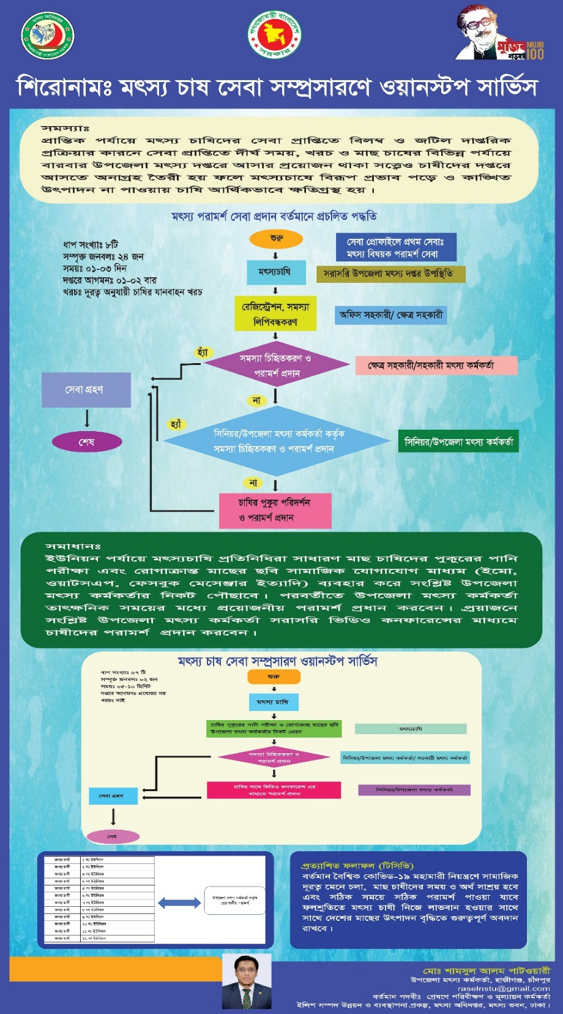
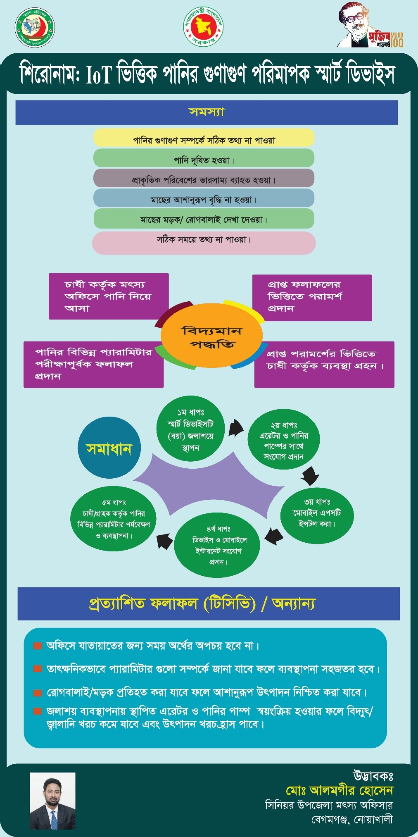
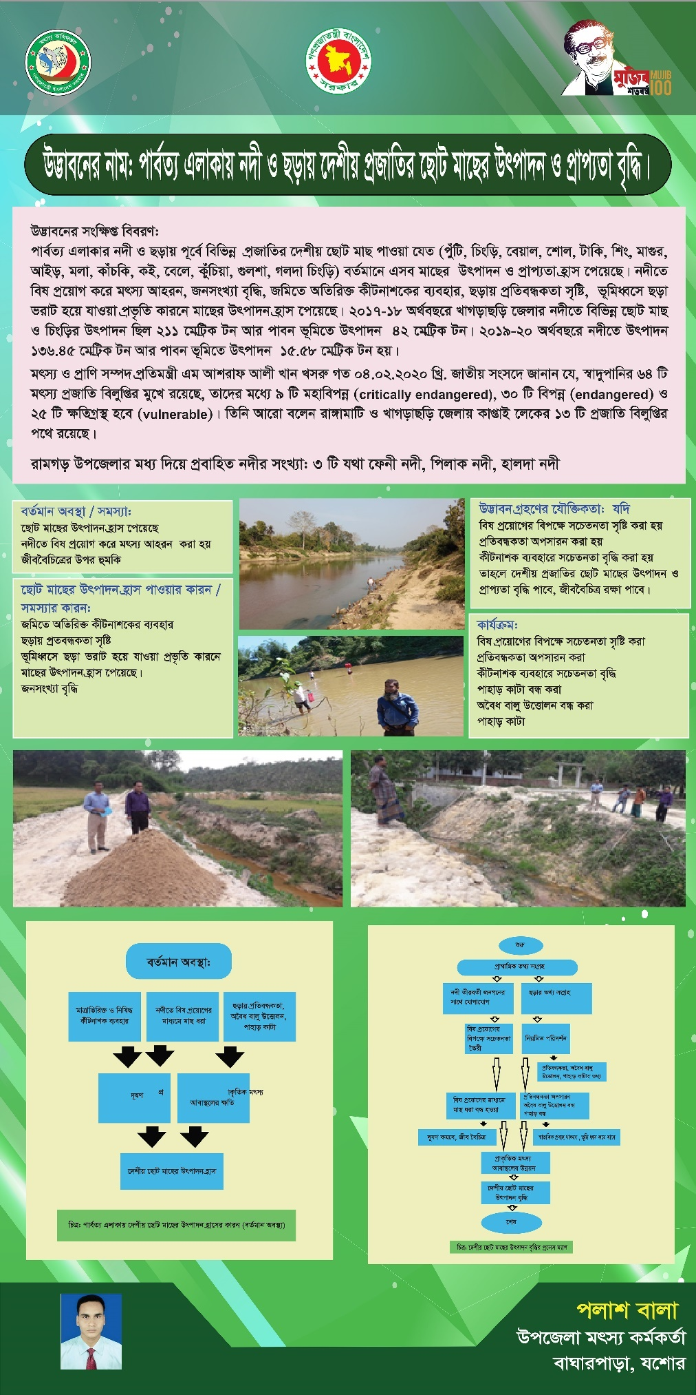
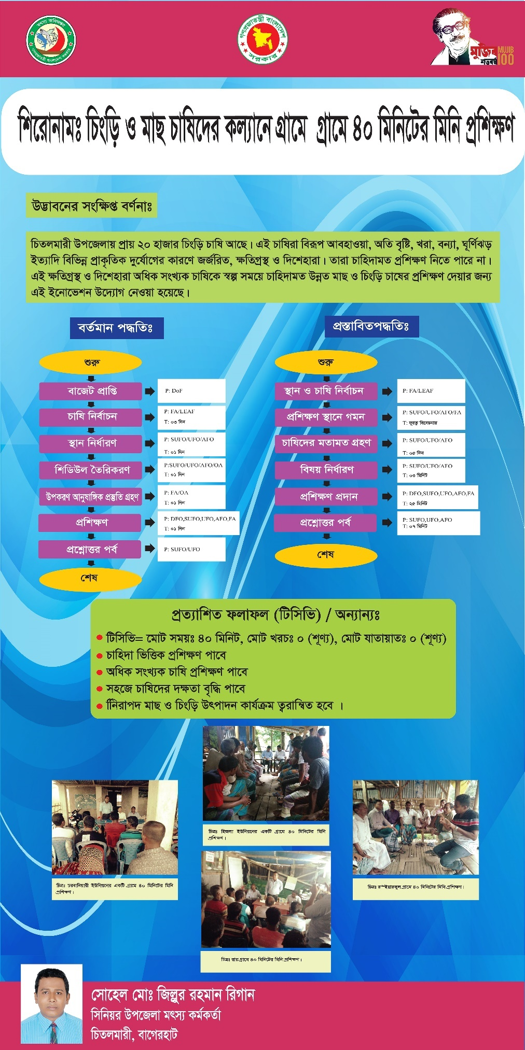
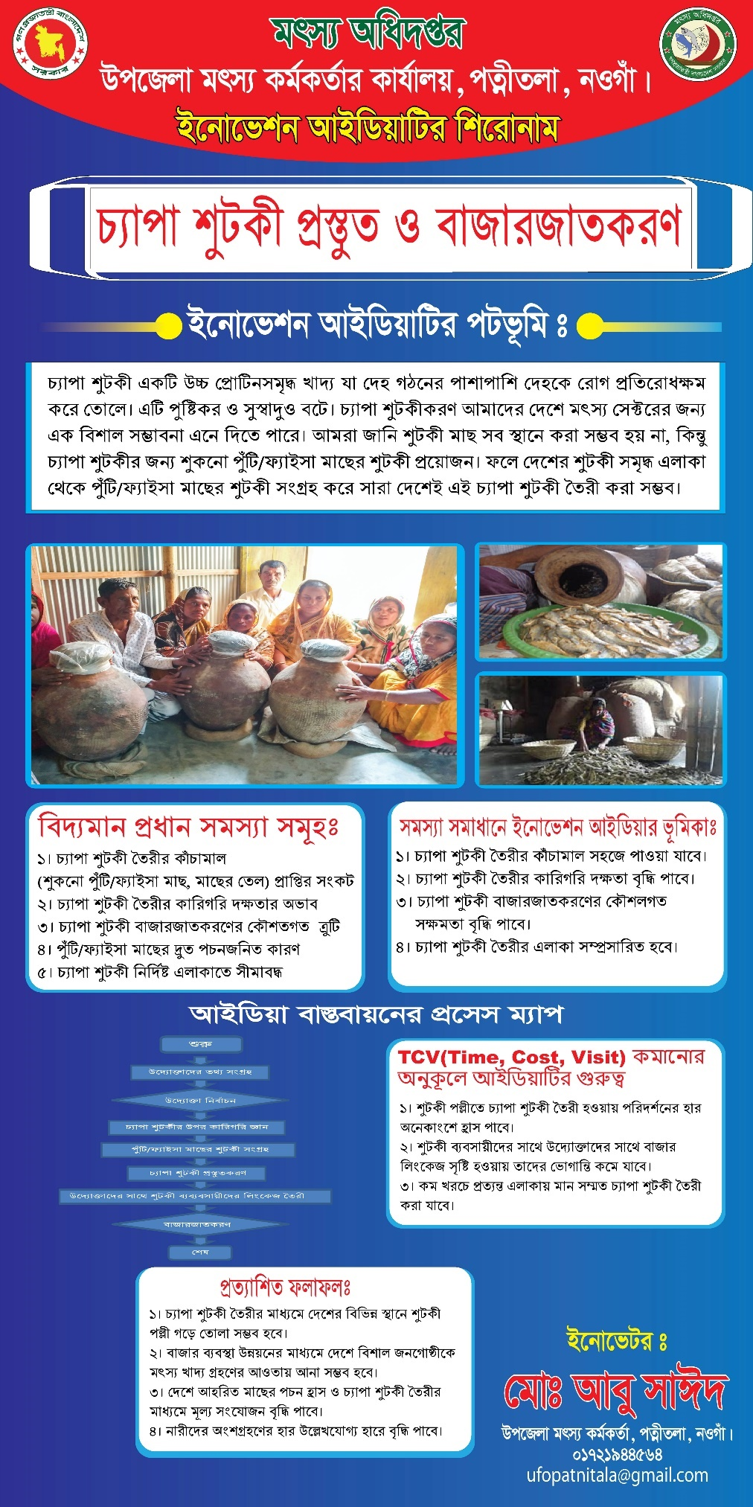
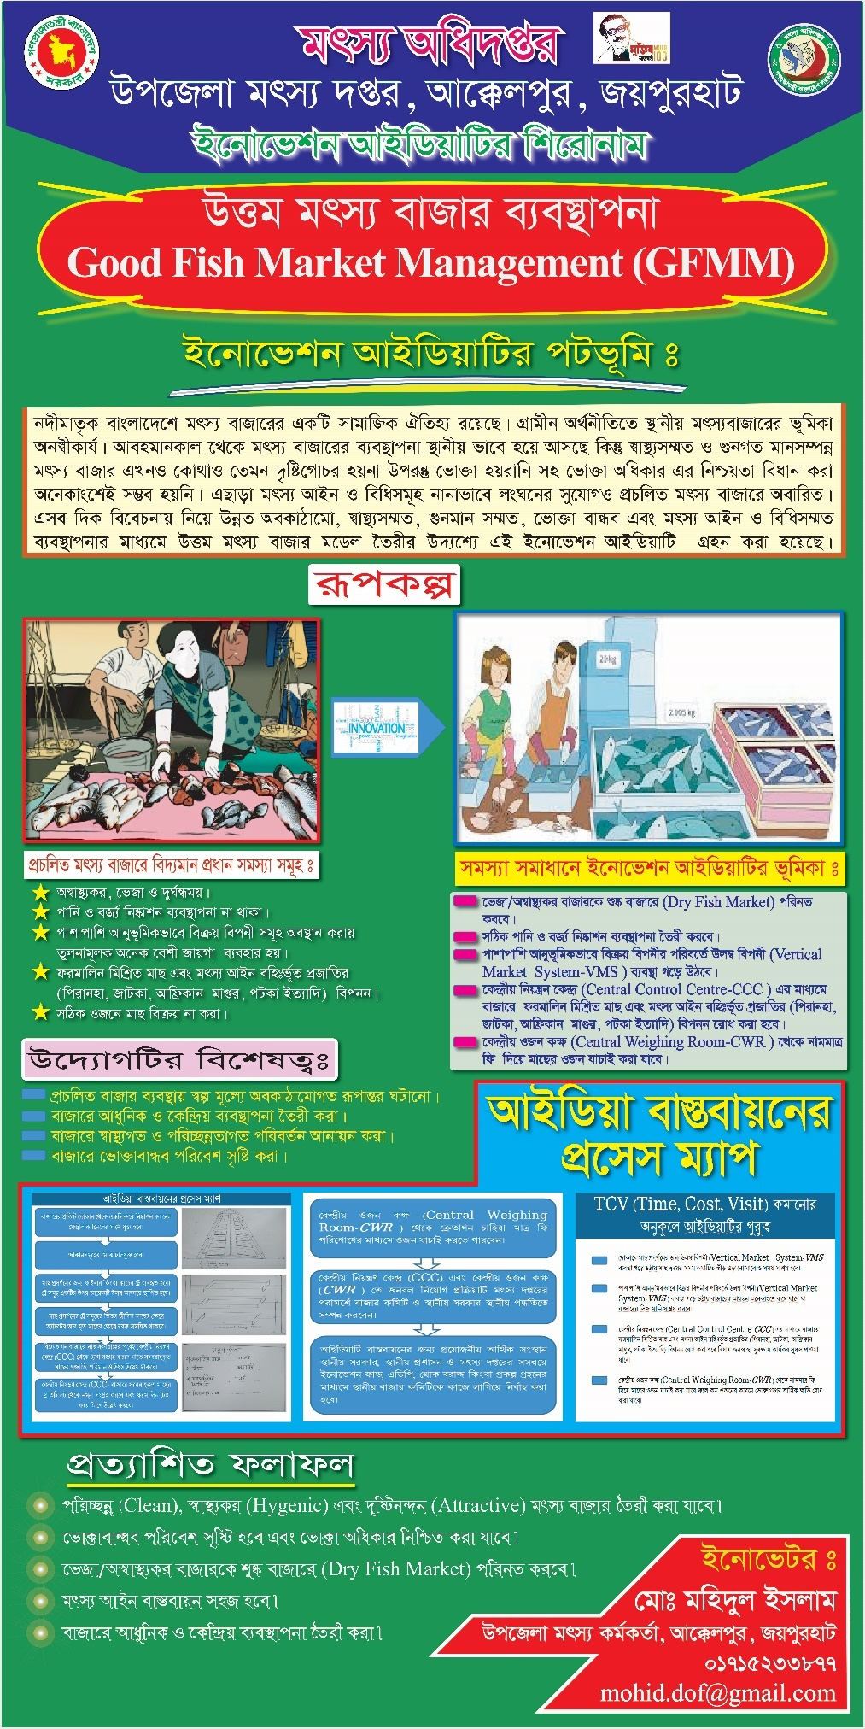
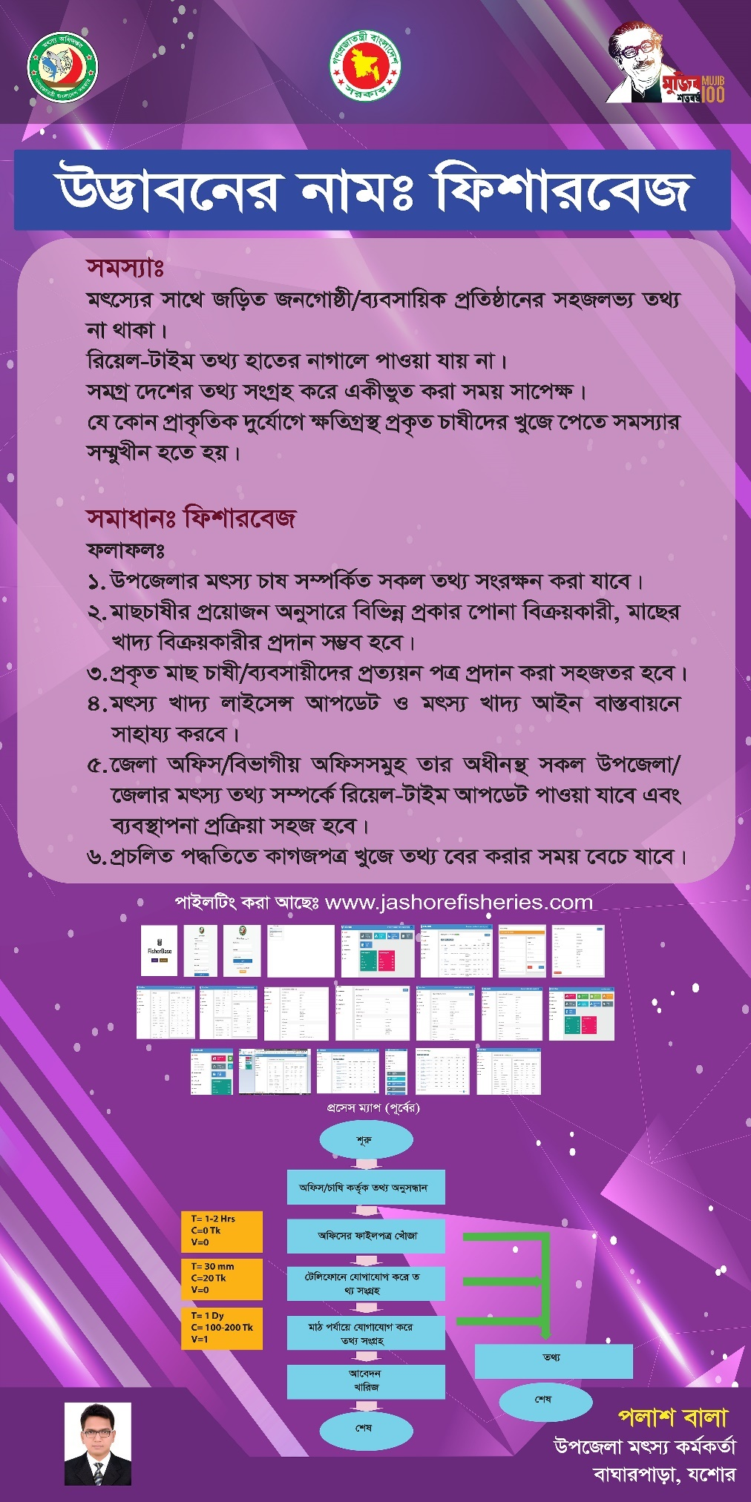
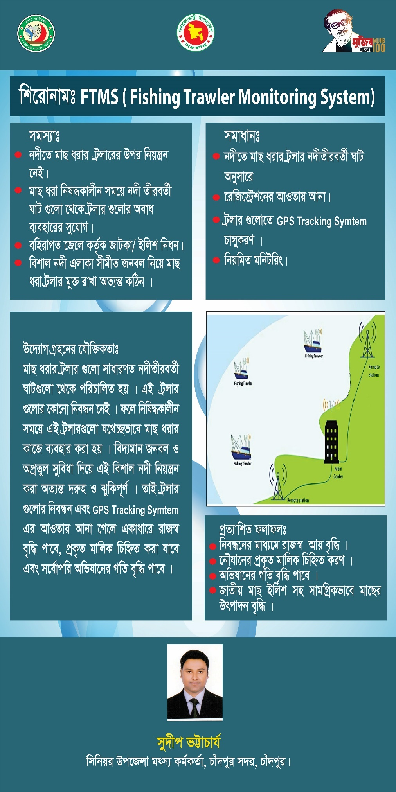
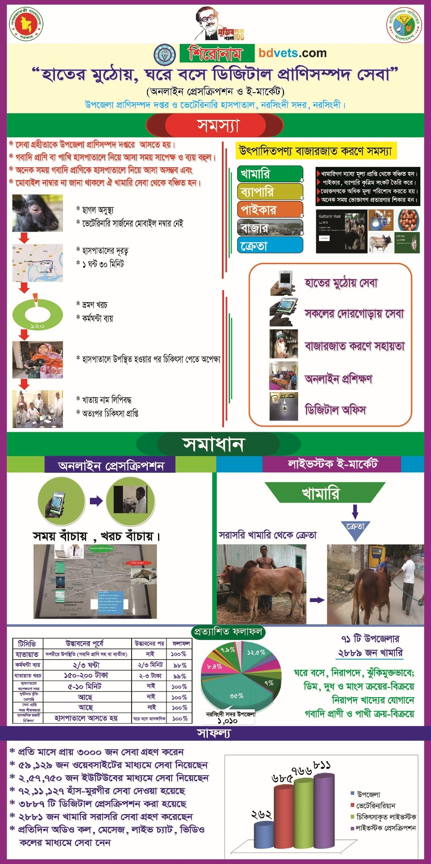
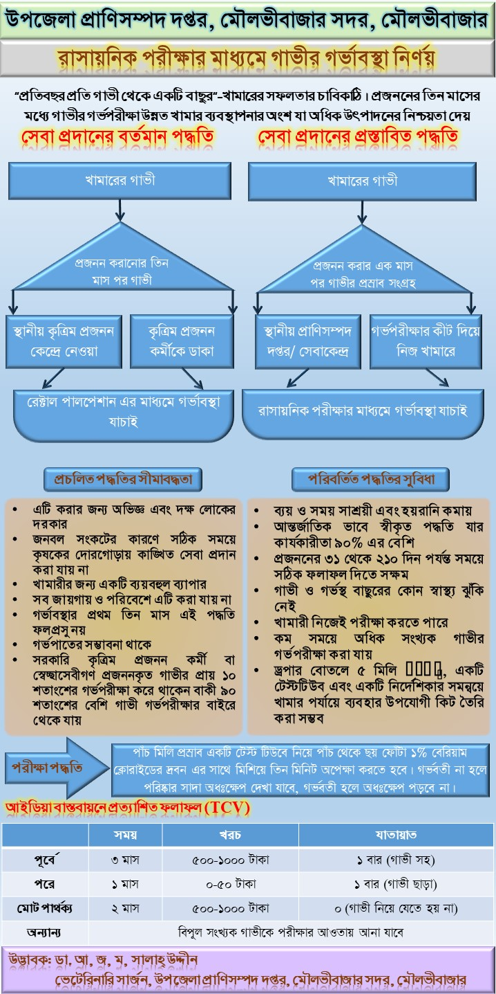
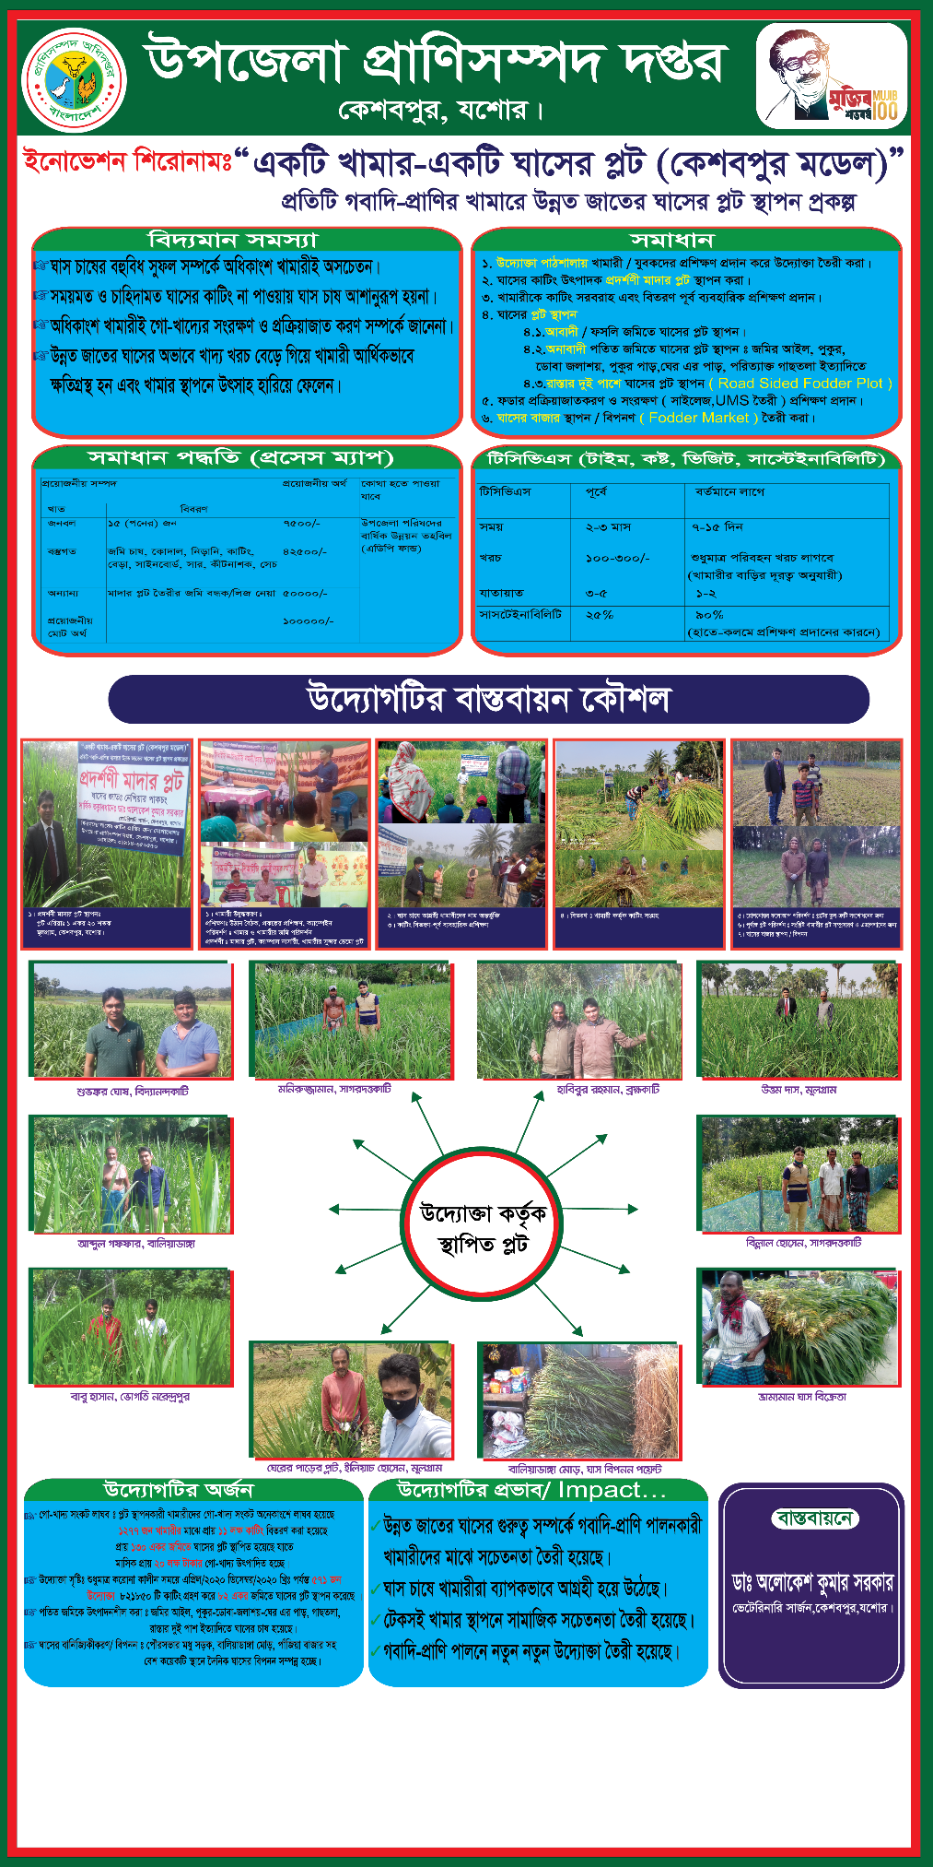
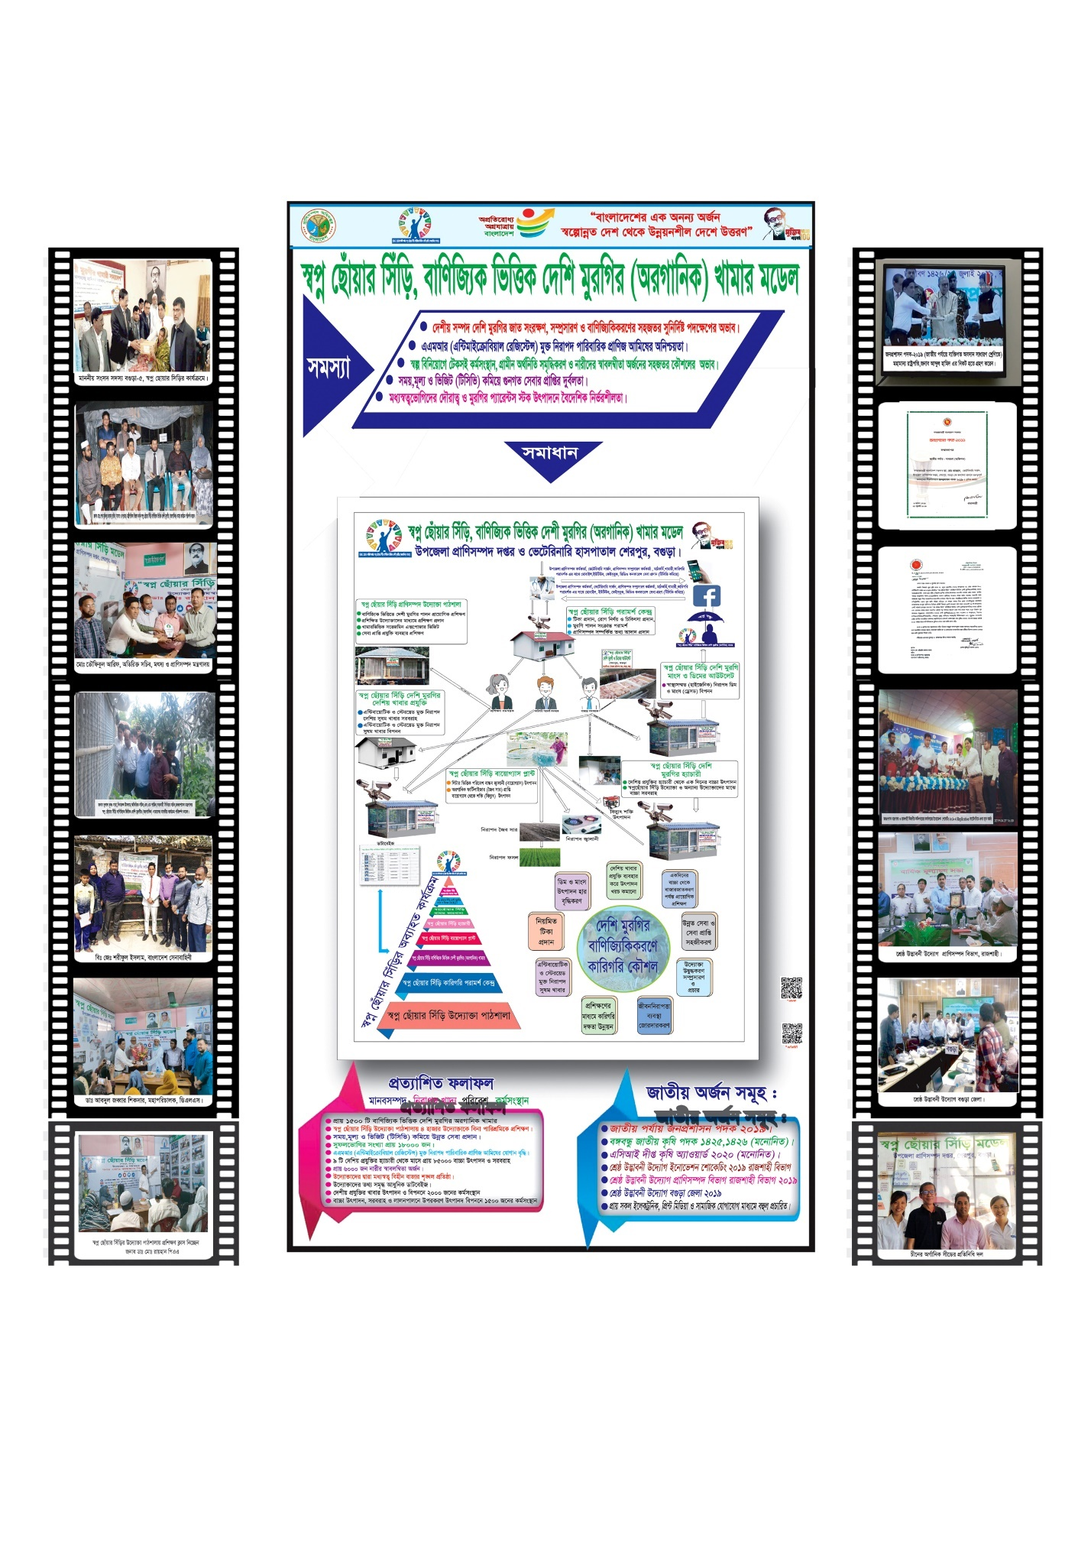
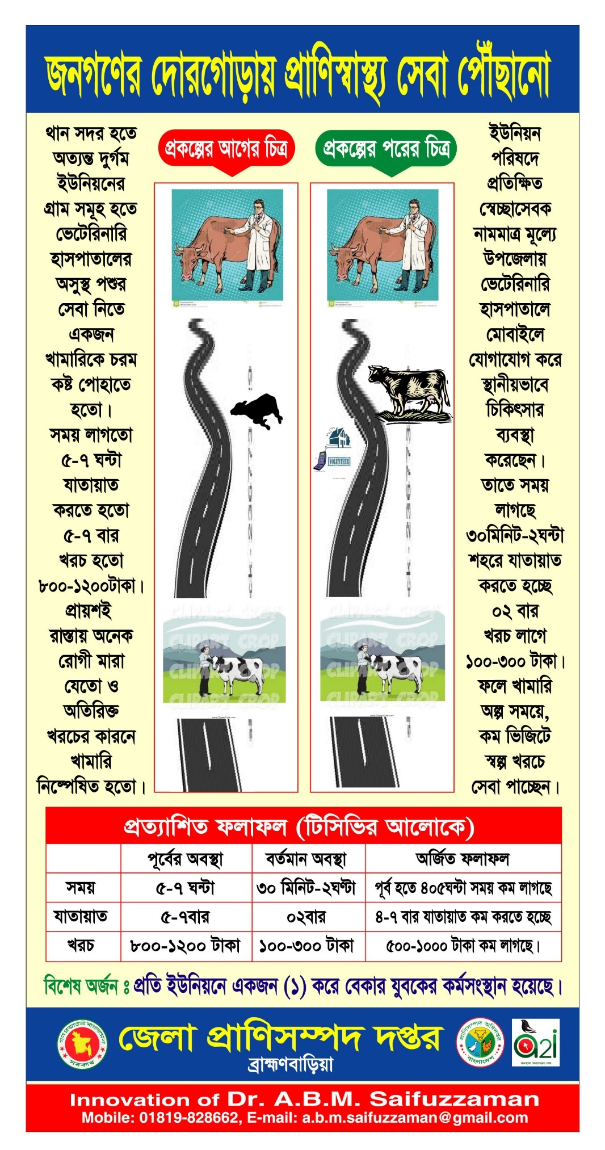
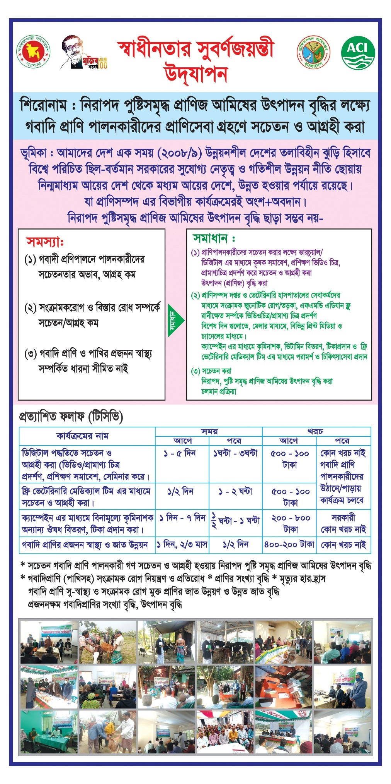
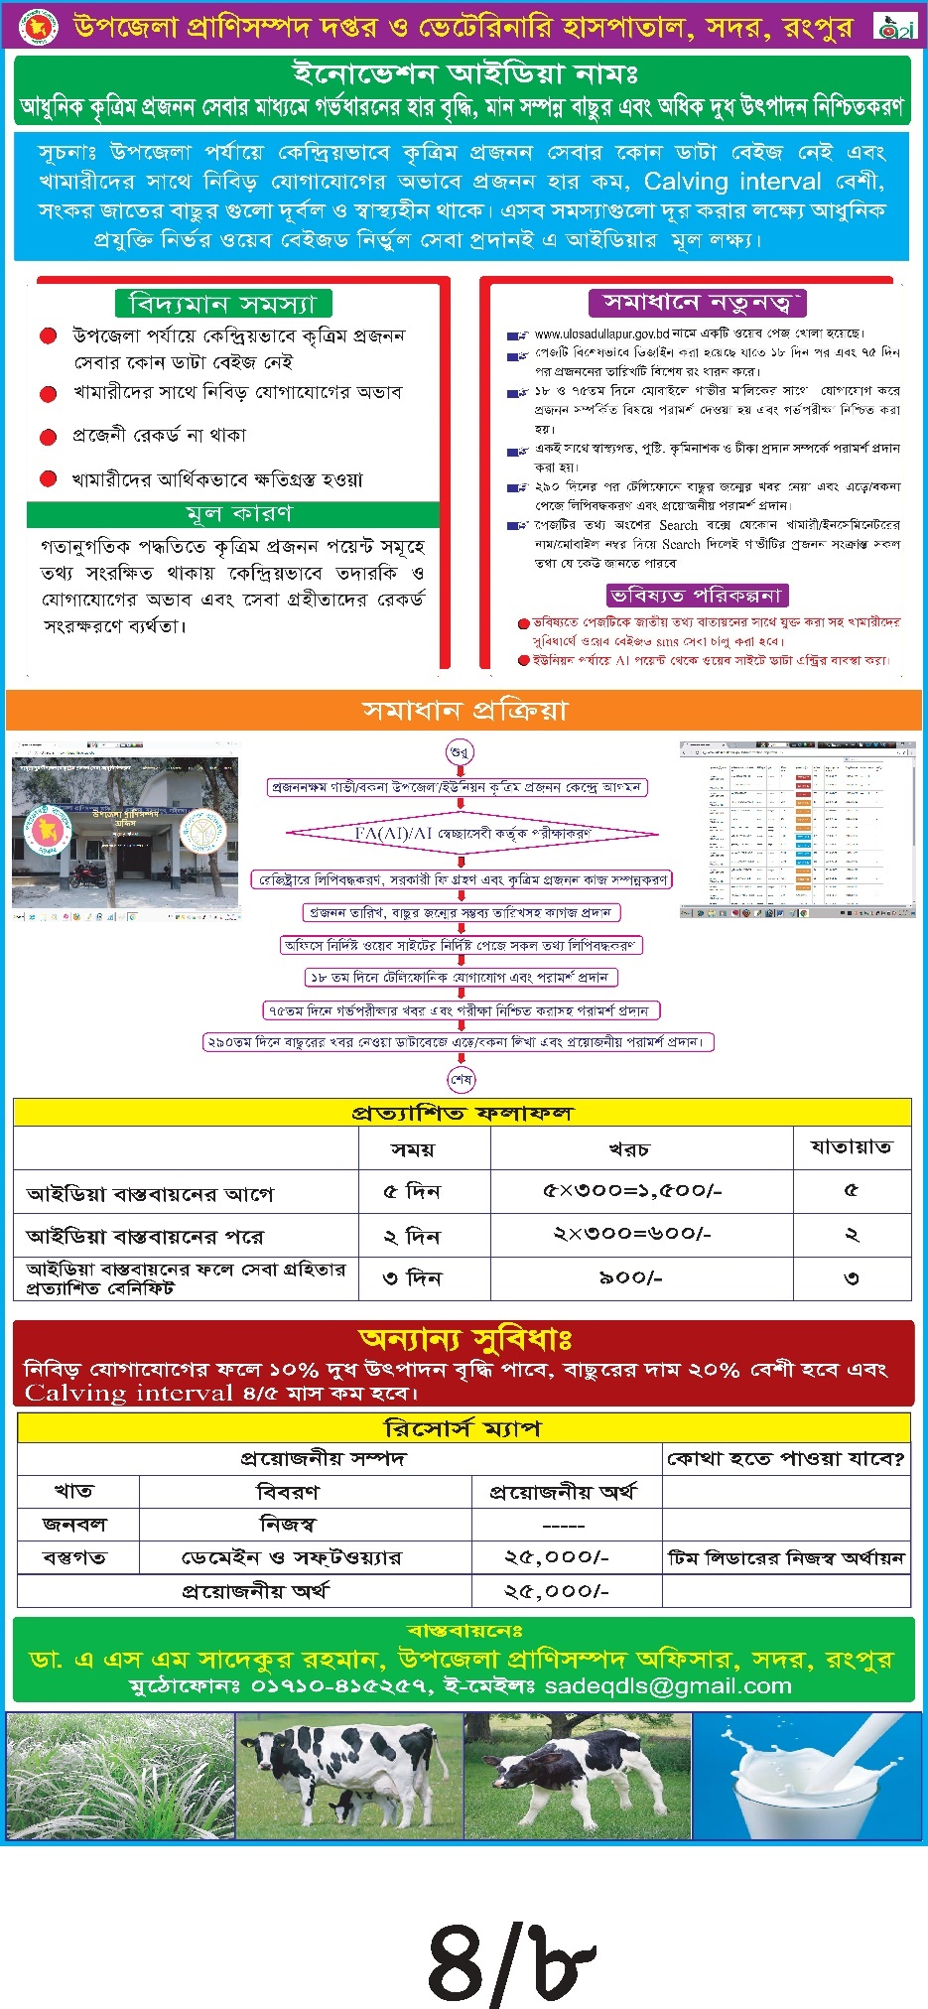
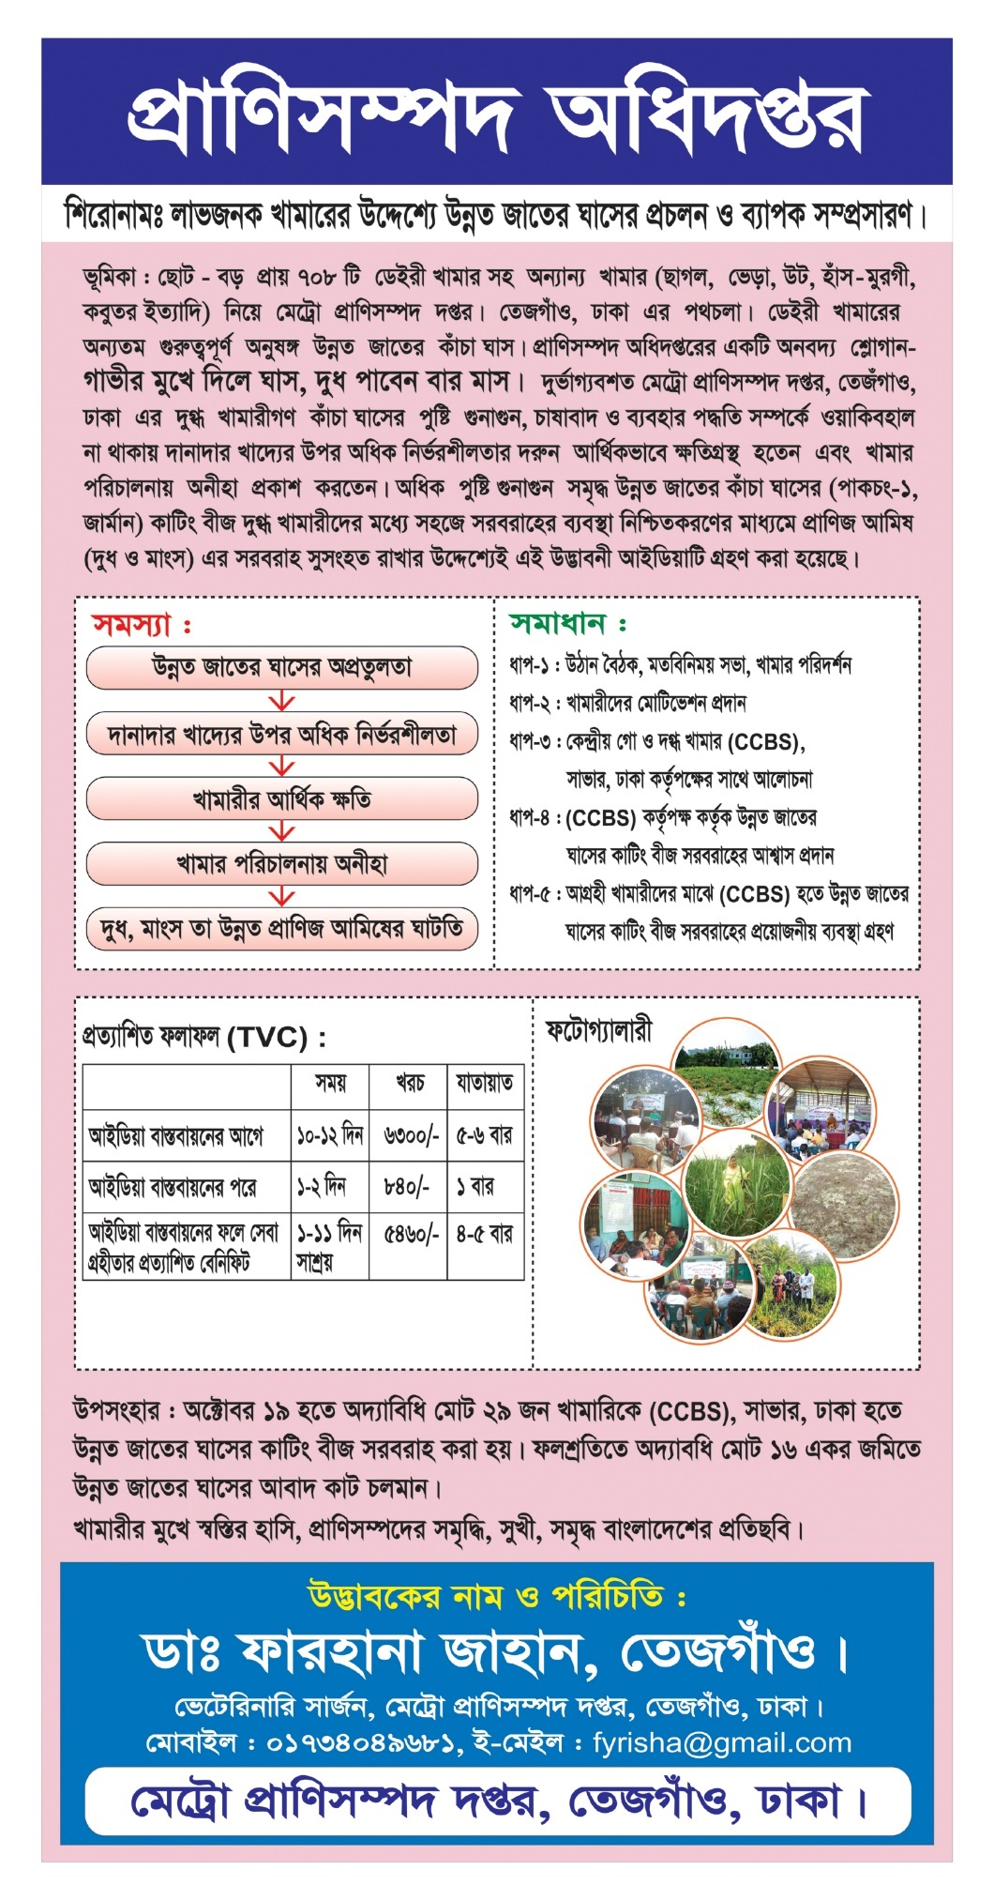
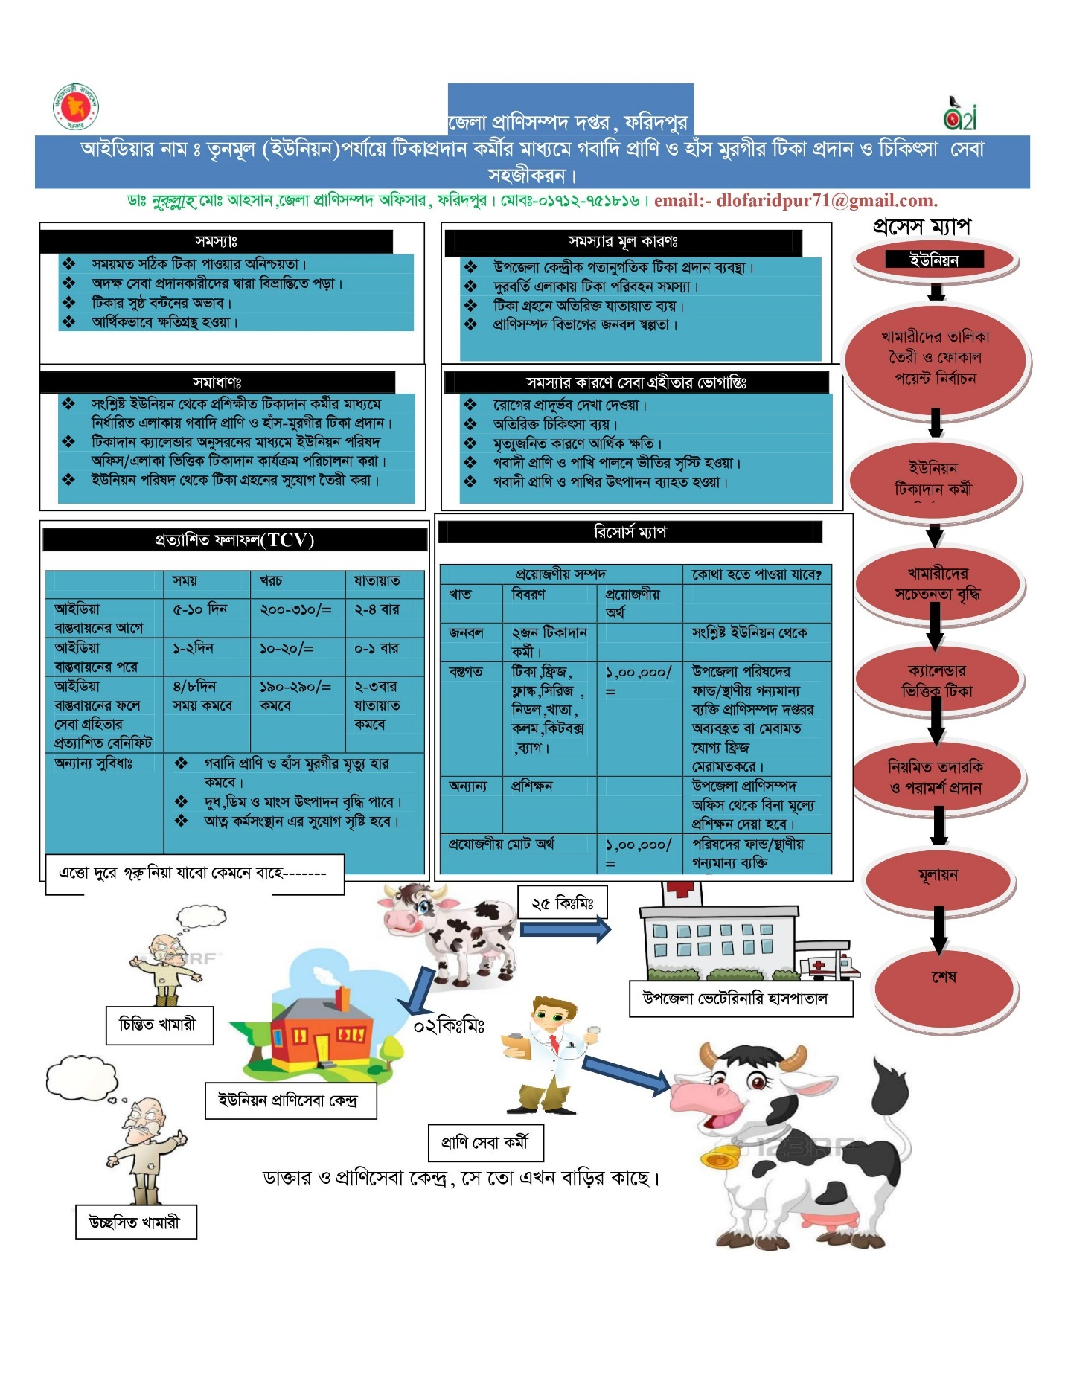

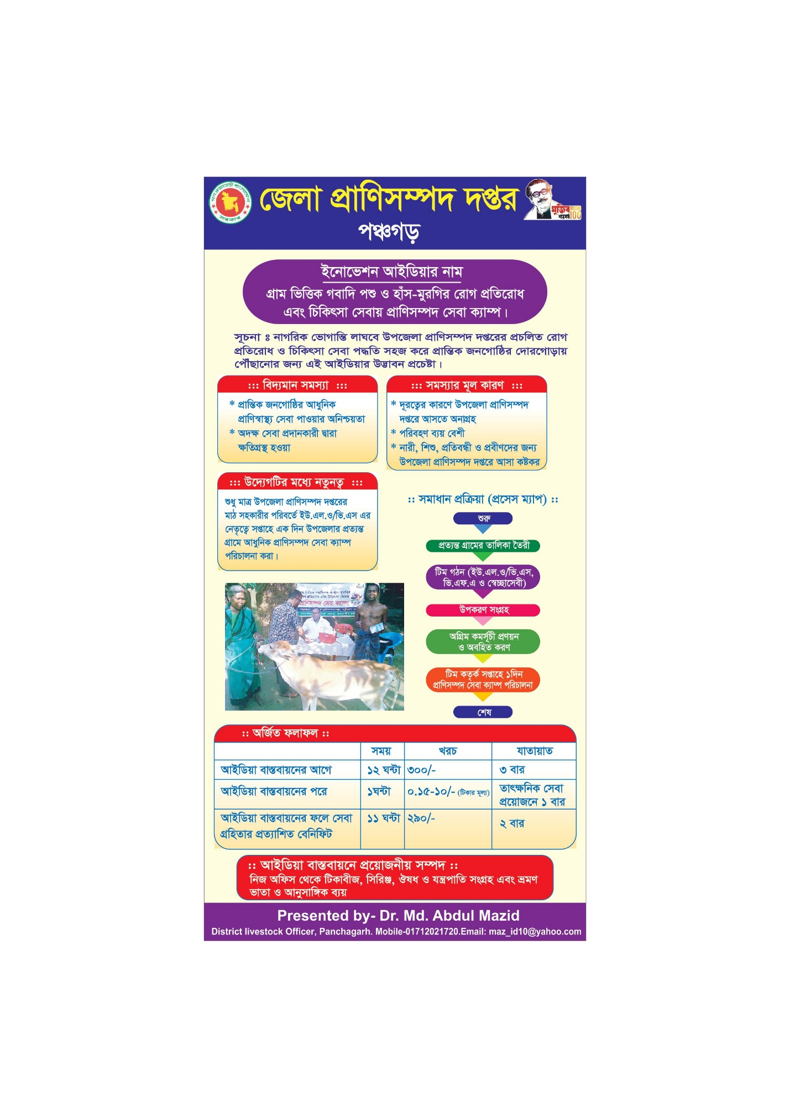
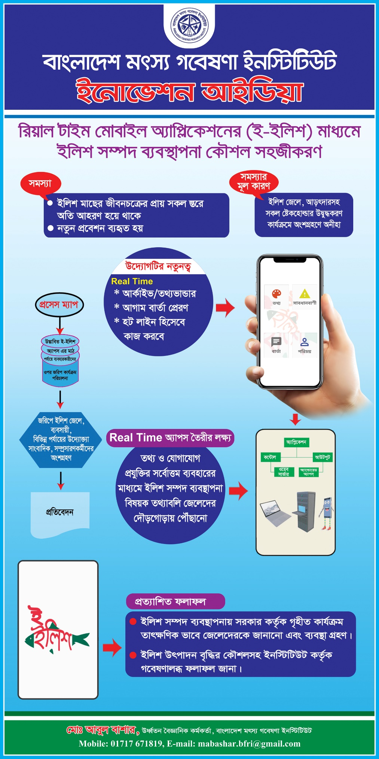
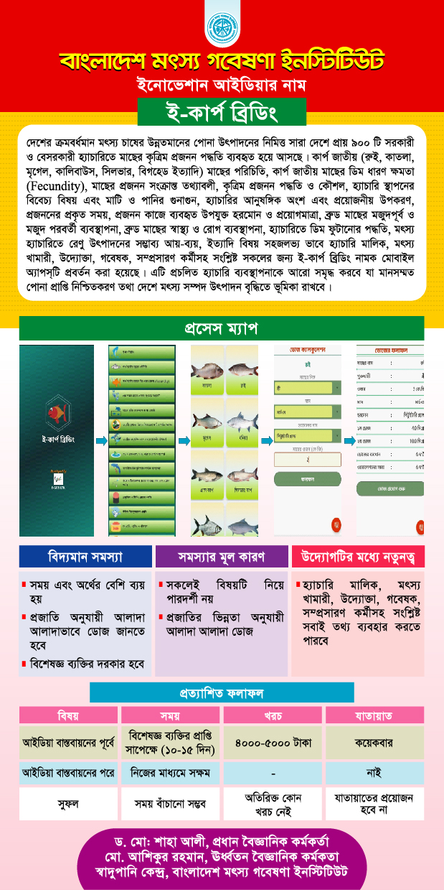
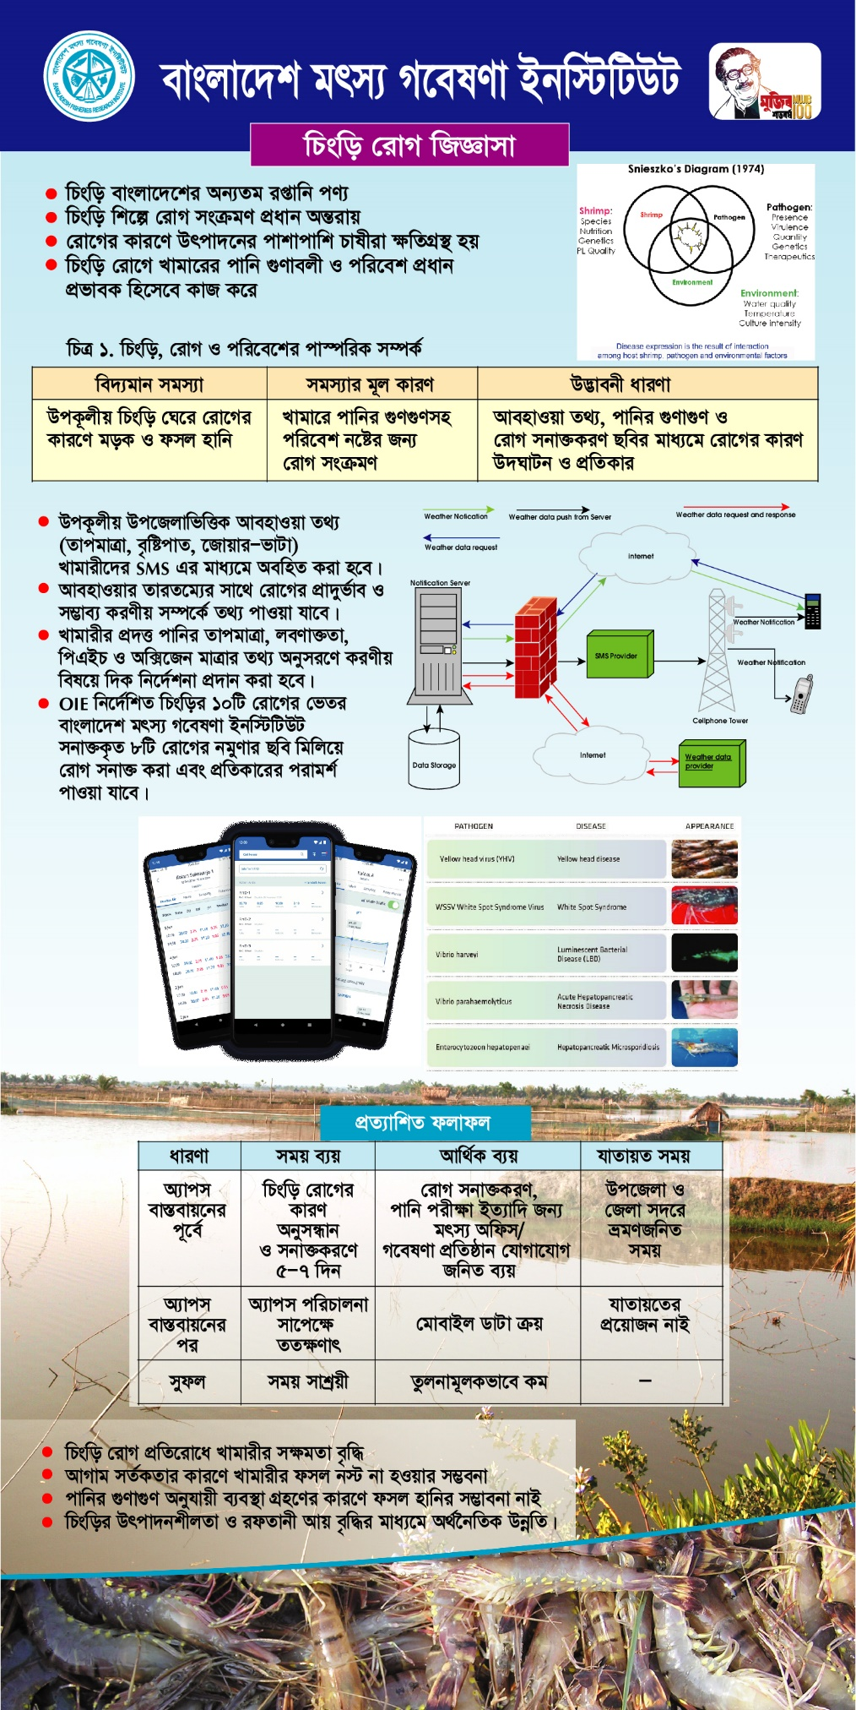
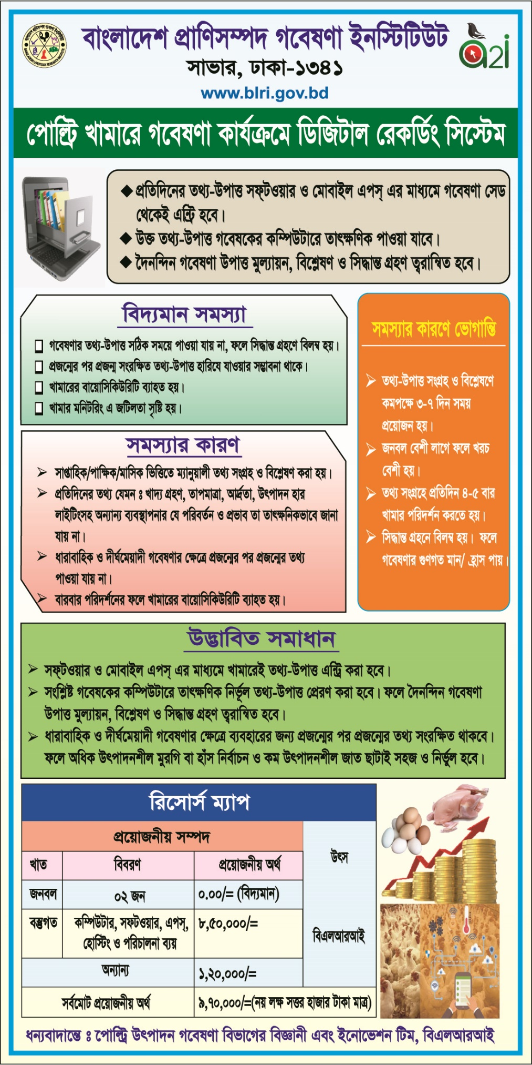
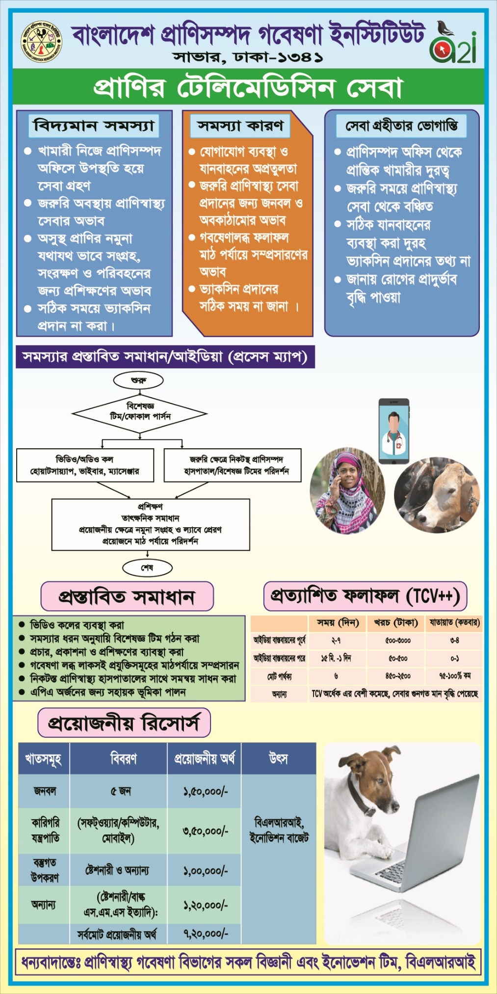
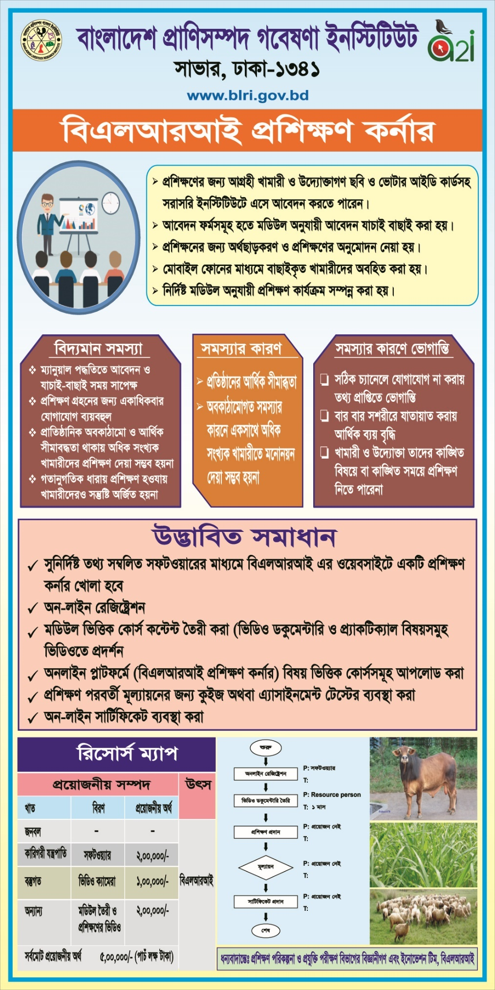
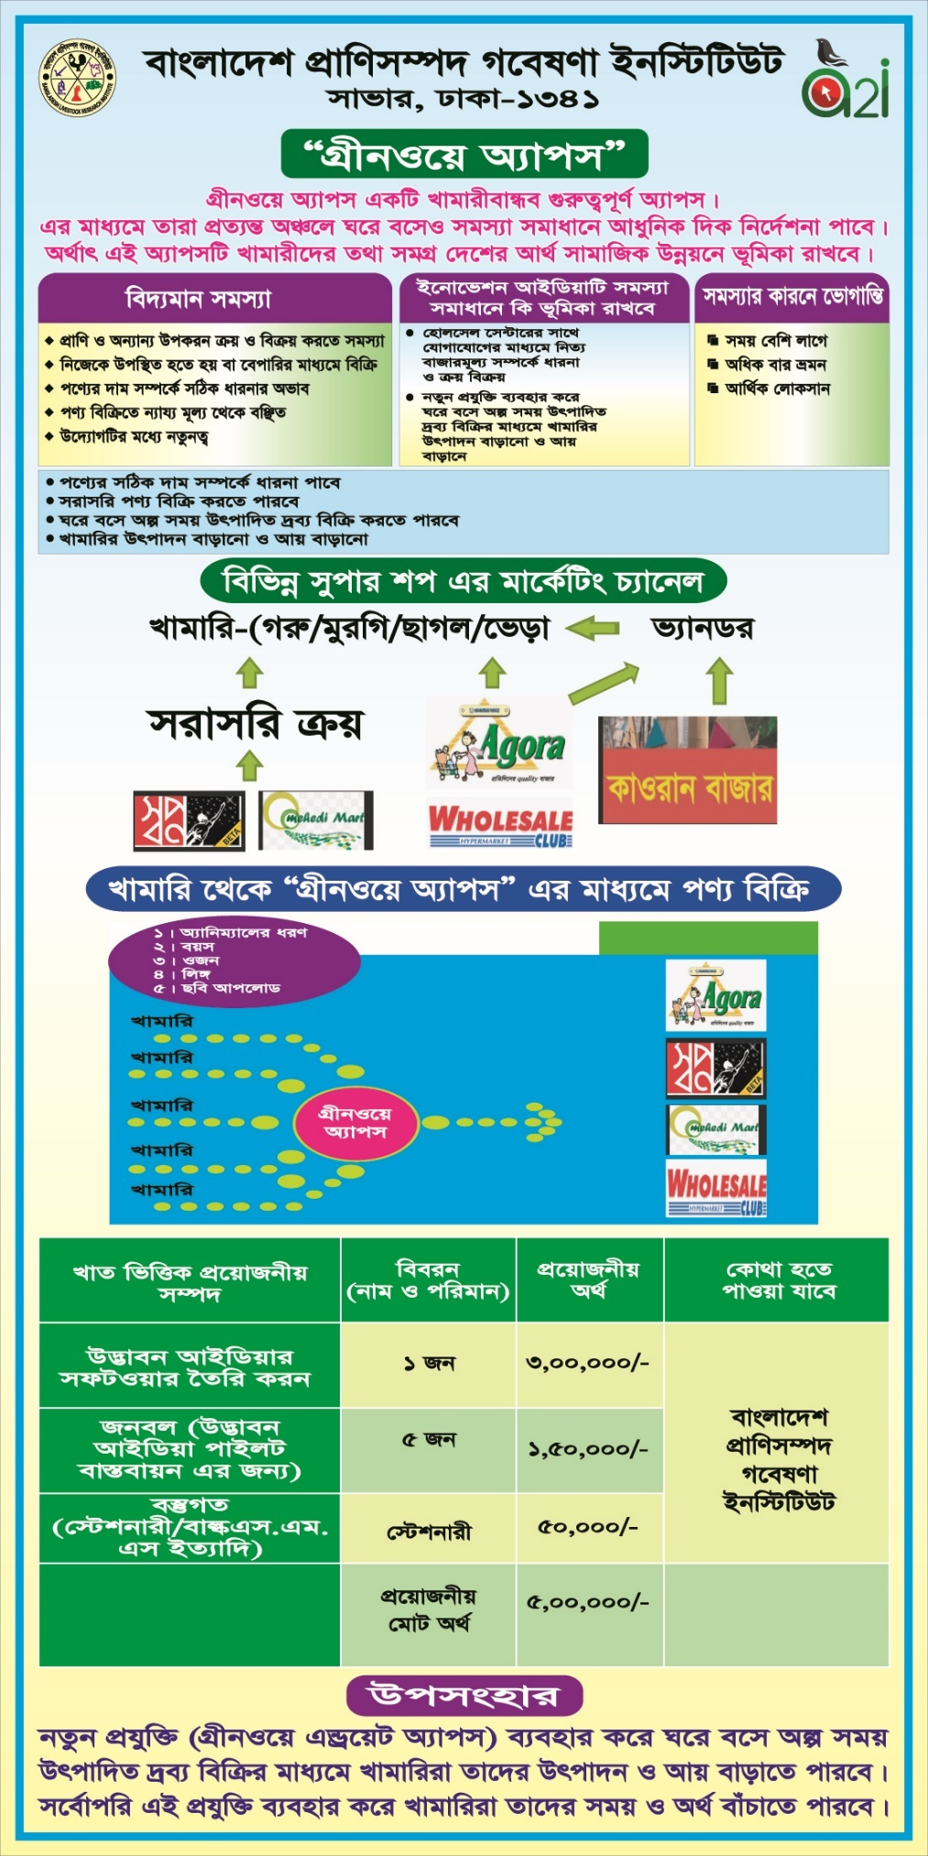
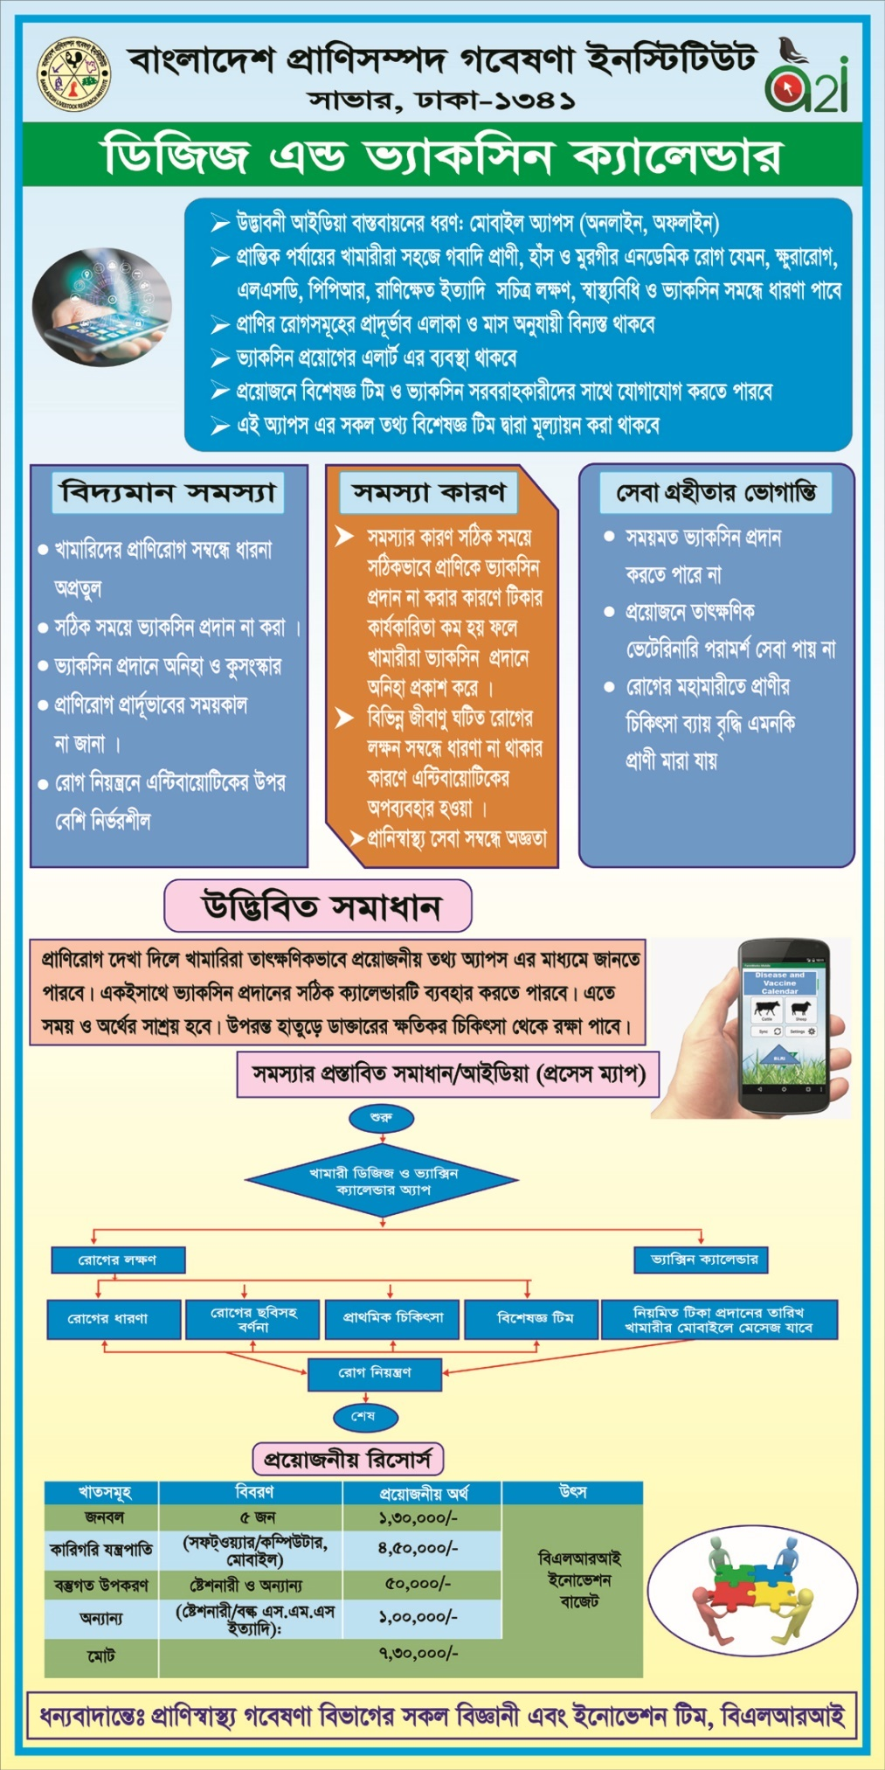
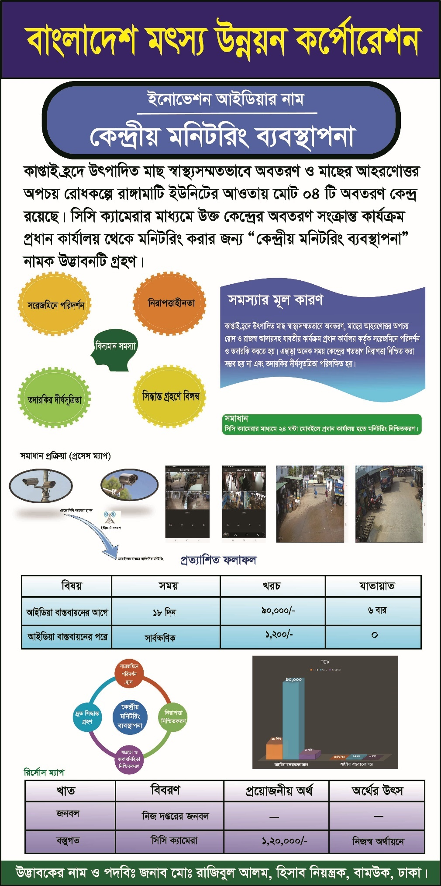
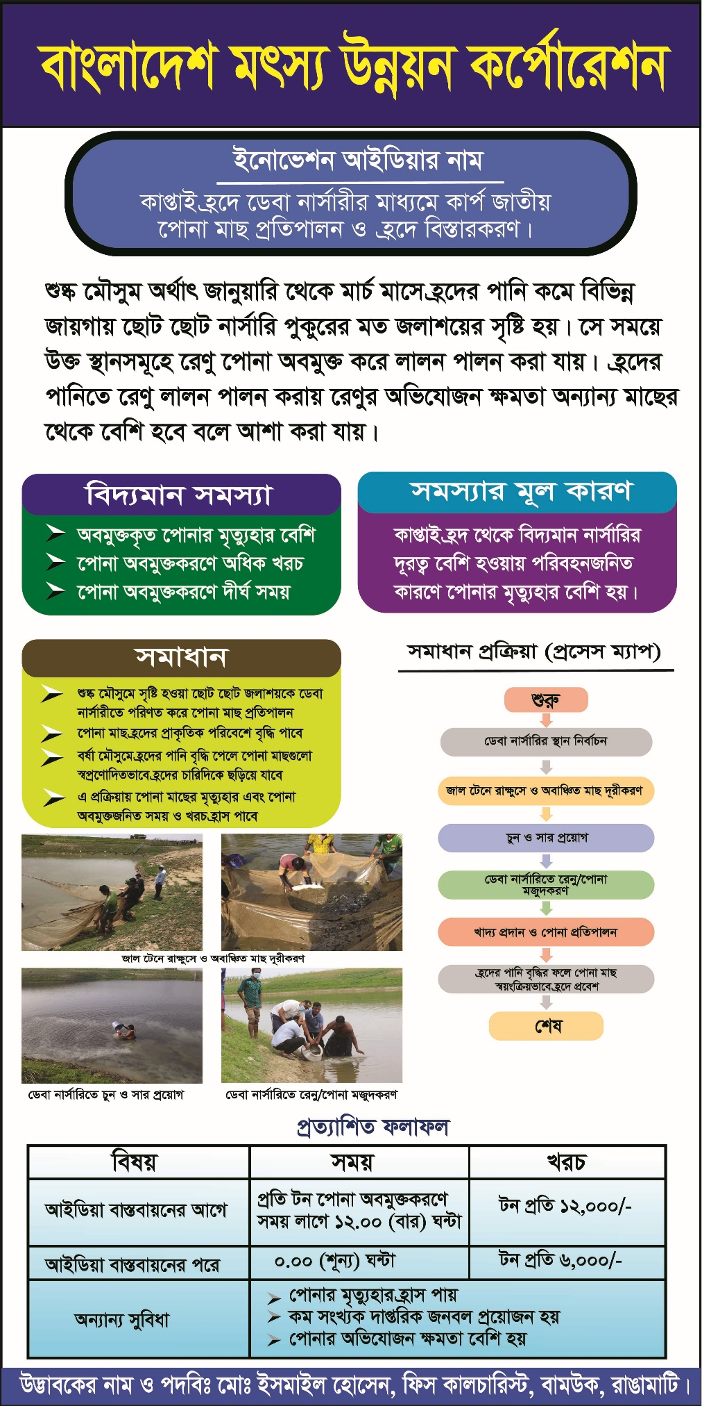
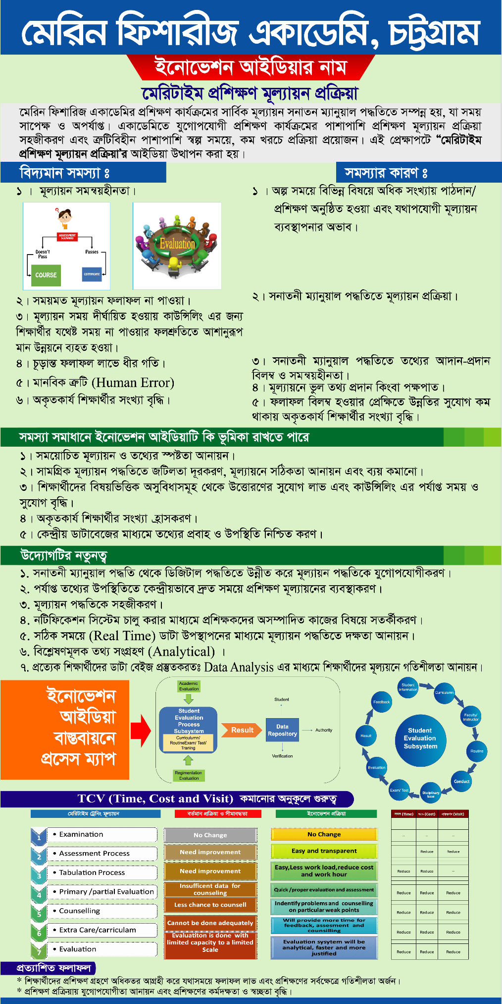
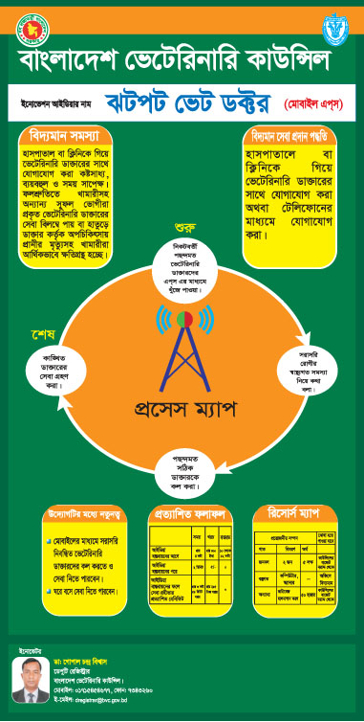

চতুর্থ অধ্যায়: উদ্ভাবনী উদ্যোগের আঊটকাম স্টাডি

Outcome Study Report: Union Livestock Centre

On
Union Livestock Centre
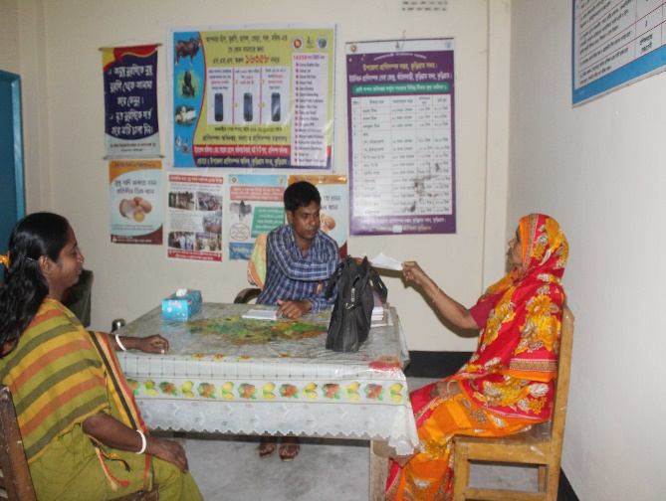

INTRODUCTION AND BACKGROUND

Livestock plays an important role in the national economy of Bangladesh with a direct contribution to agricultural GDP and total employment in the economy. The livestock sub-sector that includes poultry offers important employment and livelihood opportunities particularly for the rural poor, including the functionally landless, many of whom regard livestock as a main livelihood option.

Department of Livestock Service (DLS) remains committed to ensure livestock sectors continuous to play a significant role in overall growth of the country. As part of this, DOS provides cost-effective services like vaccination, insemination, primary care, and guidance to livestock farmers through the Upazila livestock offices. Unfortunately, these service centers can be of significant distance for many who lives in the remote areas. Due to the high cost of transportation and the stress that comes with it, many hesitate from seeking out such available services, leading to a high rate of animal deaths.

In Bangladesh, rural people rear livestock for livelihood. Rural people who are living in union level need various services such as vaccination, insemination, primary care services etc. regarding livestock farming. But they have to spend huge time, cost and visit along with lot of hassles in getting those desired services from upazila livestock office and other places as there is no service access point in union level. In this regard, Department of Livestock has brought service delivery process simplification through establishing Union Livestock Centre for reducing time, cost, visit and hassles of the citizens of rural areas while getting livestock services. Union Livestock Centre ensures the livestock services at the doorstep of rural people with ease and comfort. This innovation aligns with SDG 2 which is “Zero Hunger” and Honorable Prime Minister Sheikh Hasina Special Initiative’s “Ekti Bari Ekti Khamar” and “Naarir Khomotayon” projects.

Union Livestock Centre located at the heart of union runs by Union Parihsad. All the livestock services are being provided to the citizens by the voluntary worker. Upazila Livestock Officer is responsible for visiting the certain union livestock centre once in every week. Citizens of the particular union receive most of the services from Union Livestock centre but still they have to visit upazila livestock offices for those services which are complex and unavailable in union livestock centre.

Under the simplification process, piloting initiative has been conducted in 2014 in Jatrapur union of Kurigram Sadar upazila. From the piloting area, total 20,994 beneficiaries have taken livestock service. After successful piloting in Jatrapur, piloting initiative has been extended in Ghogadoho, Mogolbasa and Kathalbari Union in 2015 from where 28,548 beneficiaries, 20,995 beneficiaries and 30,559 beneficiaries have taken services respectively. Considering the successful piloting, Department of Livestock has replicated Union Livestock Centre in 9 unions of 9 upazilas of 9 districts of the country.
Piloting
(2014)

Jatrapur,
Kurigram Sadar,
Kurigram
- Gokarna, Nasirnagar, Brahmanbaria
- Jafarganj, Debidar, Comilla
- Bhiail, Chirirbandar, Dinajpur
- Madhyanagar, Dharmapasha, Sunamganj
- Dapunia, Mymensingh Sadar, Mymensingh
- Sombhupura, Shonargao, Narayanganj
- Panamagar, Durgapur, Netrokona
- Dehergati, Babuganj, Barishal
- Bhandarpara, Dumuria, Khulna
Replication
(2015)

Citizens from the replicated areas are being benefitted through having livestock centre at the centre of their union. It is expected to reduce their travel distance, service receiving time, travel and others cost and number of visits while getting the services. In this regard, an outcome study has been conducted to find out the effectiveness of the replication in beneficiaries life.

OBJECTIVES

The main objective of this study was to assess the effectiveness of Union Livestock centre in providing doorstep services to the rural people. Specific objectives were as follows:

- To analyze the advantages of Union Livestock centre.
- To measure the level of satisfaction on getting services from Union Livestock centre.
- To know the comparison of TCV.
- To draw out the recommendation for getting better services from Union Livestock centre.

METHODOLOGY

This study is both quantitative and qualitative in nature. Total population is 17,922 in 9 Unions where pilots have been implemented. Two stage cluster random sampling has been conducted through which 7 unions have been selected randomly from 9 unions with probability proportional to number of beneficiaries in the union. Beneficiaries have been selected randomly from each union. In total, 293 beneficiaries have been interviewed from 7 unions of 7 districts of Bangladesh. Primary data has been collected from the service recipients of union livestock centre using sample survey method following face to face interview. In terms of getting secondary data, 7 key Informant Interview (KII) have been conducted with the 7 upazila Livestock officers. In this study all the data has been collected digitally through tab using Cspro software. After that data has been analyzed through SPSS.
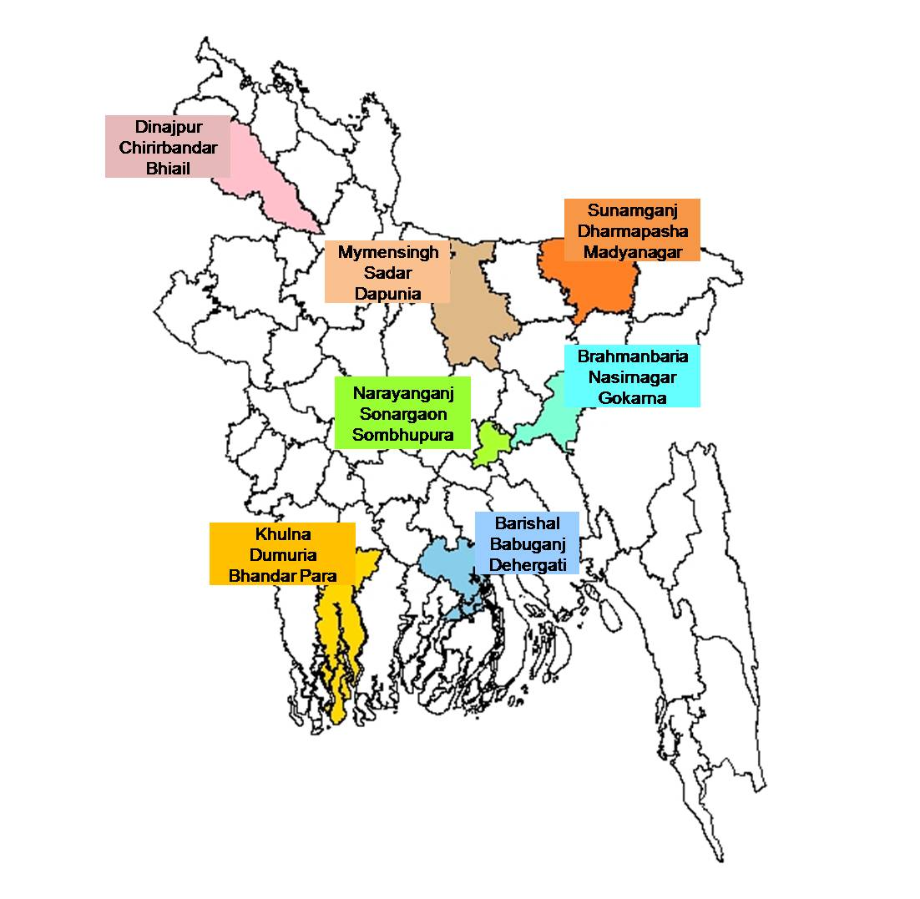
Map of the study area

Table 1: Study population and sample size
Method | Stakeholder | Sample size
Sample Survey | Citizen | 293
Key Informant Interview (KII) | Upazila Livestock Officer | 7
Total |  | 300

FINDINGS OF THE STUDY

This section represents the findings of the survey that have been gathered from the respondents of the study area.

Figure 1: Gender | Figure 2: Age
Above figure 1 shows that about 74% respondents are male and about 26% respondents are female. It implies that number of female taking service from union livestock centre is significant but the number of female beneficiaries is also noteworthy. Figure 2 shows the age of the beneficiary. About 30% respondents are within 30-39 years and about 32% respondents are from more than 49 years.

Figure 3: Occupation

Above figure 3 reveals the occupation of the respondents. Here, it is seen that about 38% respondents are livestock rarer. They mainly deal on this. Livestock is the only source of their income. About 28% respondents are farmer. Here, others are included as teacher, homemaker, day laborer, retired etc.

Figure 4: Types of cattle/poultry farming | Figure 5: Average number of cattle, poultry and duration of farming

The above figure 4 shows that about 90% respondents have personal cattle/poultry farming and on the other hand, about 10% respondents have farm based cattle farming. From the people taking services from union livestock centre, the number of personal based cattle/poultry farming owner is high (figure 5).

Figure 6: Types of livestock service

The above figure 6 shows the type of livestock services required by the citizen. It is seen that about 62% respondents have needed vaccination service for their cattle. About 50% respondents have needed artificial insemination services. About 47% respondents have required vaccination services for their poultry.

Figure 7: Places of taking livestock related services before

The above figure 7 shows the place from where respondents have taken livestock related services before the service simplification. Most of the respondents (84%) have mentioned that they have taken services from Upazila Livestocks Centre. About 10% respondents have also mentioned that they have taken insemination service from the district artificial insemination centre as this service was not available in the upazila livestock centre. About 3% respondents have mentioned that veterinarian came to their home.

Figure 8: Sources of knowing about Union Livestock Centre

Multiple responses

The above figure 8 shows the sources of knowing about union livestock centre by the respondents. About 58% respondents have mentioned that they have come to know about it by the relatives/friends/family members. As union livestock centre is situated in the heart of the union, so it is very much easy for them to be informed about it by their relatives/friends/family members. About 11% respondents have mentioned that they have come to know through miking/banner/festoon/leaflet.

Figure 9: Status of receiving necessary service/advice | Figure 10: Status of taking help of others

Figure 9 reveals the comparative status of receiving necessary service/advice by the respondents. About 55% respondents have taken necessary service/advice before simplification however, after simplification, it is seen that about 99% respondents have received this. In terms of taking help (Figure 10), about 56% respondents have to take help of others (relatives, friends, local people etc.) before simplification but about 96% respondents have revealed that they haven’t taken any help of others after simplification.

Figure 11: Status of being benefitted after simplification | Figure 12: Types of benefits
Multiple responses
Figure 11 exhibits the status of being benefitted after SPS replication. It is seen that a significant percentage of the respondents (99%) have been benefitted after simplification. In regards to the types of benefit, it is noticed that about 93% respondents have mentioned about time saving, about 85% respondents have mentioned about cost saving. About 78% respondents have revealed that now they can get timely treatment. It seems from the findings that the benefit of the respondents due to simplification is huge.

Figure 13: Status of facing problem while taking services

The above figure 13 shows the status of facing problems by the citizen while taking the service. It is seen that before simplification, 78% respondents have faced challenges. But after simplification, it is noticed that about 99% respondents have mentioned that they haven’t faced any challenges while taking the service. It seems the positive impact of the replication on citizens’ lives.

Figure 14: Comparative analysis of TCV (Average) in 2017

The above figure 14 exhibits the comparative analysis of TCV (Average) in 2017. It is seen that comparatively 31 hours (74%), about 2,292 BDT (82%) have been saved. Here, purpose of the time is travel time, information receiving time, service receiving time and waiting time and purpose of cost is travel cost, food cost, cost required for additional person and mobile bill cost. Time and cost have been decreased significantly since distance of travel has been decreased by 58%. Moreover, visit has been increased by 5 due to the increased extent of receiving instant services from ULC. It is a positive sign that now citizen are getting their desired service whenever they find it necessary as it is now in their stone’s throw.

Figure 15: Time and cost projection (Average)
Time required (hr) | Cost required (BDT)

The above figure 15 shows the projection of time and cost regarding taking services from union livestock centre. Projection shows that time and cost will become under zero. But for this some factors will be needed to consider for making this projection visible. Such as:
- Establish 2/3 centres in each union according to the number of beneficiaries.
- More promotional activities.
- Include services which are not available currently.
- Ensure the regular presence of veterinarian.
- Increase service quality.
- Ensure more volunteer for providing door to door service.

Figure 16: Status of increase in production of cattle/poultry, income and socio-economic status | Figure 17: Types of changes in socio-economic status

The figure 16 shows the status of increase in production of cattle/poultry, income and socio-economic status of the respondents by using time and money saved by taking services from Union livestock centre instead of upazila livestock centre. In terms of production, about 90% respondents have mentioned that their production has been increased to 3-4 on an average. Regarding income, 98% respondents have mentioned that their income has been increased to 10 thousand-50 thousand BDT on an average and in terms of socio-economic status, about 98% respondents have revealed about their increased socio-economic status. On the other hand, figure 17 shows the types of changes in socio-economic status. About 76% respondents have mentioned that their income level has been increased. About 64% respondents have mentioned that their standard of living has been increased. Along with that their social status has been enhanced (19%) and they have become well-reputed (16%).

Figure 18: Issue-wise level of satisfaction after the simplification

In regard to satisfaction, above figure 18 shows the various issue-wise level of satisfaction of the respondents. Here, it is seen that most of the respondents are satisfied with the issues such as behavior of officers, number of visits, cost, time, types and quality of services. However, 8% respondents have found who are dissatisfied with the office environment since it is not infrastructural well-equipped. In terms of the availability of the service, half of the respondents are found highly satisfied.

Figure 19: Level of satisfaction after simplification (Overall)

The above figure 19 shows the overall level of satisfaction of the respondents in getting services from union livestock centre. Here it is seen that a significant percentage of respondents are found highly satisfied (42%) and about 53% respondents are found satisfied. People are so much satisfied with the services from union livestock centre that their number of visits has been increased positively due to instant service taking.

Figure 20: Number of people informed by the respondent

The figure 20 exhibits the number of people who have been informed by the beneficiaries who have taken service already. It is seen that about 35% respondents have informed 6-10 persons. It is mentionable that about 7% respondents have informed more than 20 persons. It refers that beneficiaries are playing a vital role in spreading out the innovation in his/her community and increasing its’ publicity.

Figure 21: Recommendation from the beneficiary for the development of Union Livestock Centre

Multiple responses
The figure reveals the recommendations drawn out from the beneficiary for the development of Union Livestock centre. About 70% respondents have suggested that treatment facilities should be improved. About 65% respondents have recommended to ensure regular presence of the veterinarians. About 47% respondents have suggested to develop the infrastructure of the livestock centre. It seems from the mentioned above proactive suggestions that citizens are eager to take services from this centre and they are very much concerned about its development.

Case Study
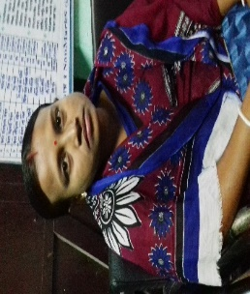
“The union livestock center has been a blessing for me and my family. Before, it used to take me over 6 hours to take the animals to the Upazila livestock center! Traveling that far, for that long, with the animals was unbearable. I had to travel more than 30km just to visit the livestock officer! But now, I have a union center that is less than a km away! I normally never went till I faced any major issues with the animals, just because of the hassles of the trip, but now I can easily reach out to the union volunteers before things get too bad for the animals. ULC gave me the comfort to be more proactive in taking care of my animals in a way I was never able to do before. My income has increased by BDT 1,000,000 since I started using the ULC! But more importantly, I have a peace of mind and better care for my animals. Frustration finally gave away to happiness and comfort.” - Sapna Mondol

RECOMMENDATIONS

Simplification in livestock service delivery process led rural citizen to get easy access to livestock services but there are also some sort of hassles throughout the process that citizen have to face. Therefore, to reduce the challenges, recommendations have been drawn out to get better livestock service centres in alignment with the achievement of sustainable development goal. Major recommendations are:

For existing implementation area:

- Ensure the regular presence of veterinarian in each Union Livestock Centre.
- Develop payment mechanism for the volunteers.
- Facilitate proper equipment in each centre.
- Increase manpower for providing better and quick service.
- Arrange regular training for the service providers.
- Develop infrastructure of the Union Livestock centre.

For new set up:

- Improved service delivery process need to be assured for achieving Sustainable Development Goals (SDGs).
- Specific payment model should be established for sustaining the service providers and take mechanism for enhancing their quality.
- Ensure promotional activities for the publicity of Union Livestock Centre.
- Ensure doorstep service for both personal and farm based beneficiaries for reducing TCV.
- Maintain separate business model for both farm based and personal based livestock service provider.
- Ensure development model through specifying responsibilities of officers/veterinarians.

CONCLUSIONS

Department of Livestock is trying heart and soul to ensure doorstep livestock services service to its recipient in the easiest way. They have established Union Livestock centre which is a remarkable step by which citizens are getting benefitted enormously. Though there are still some challenges such as absence of veterinarian, lack of medicines in the centre, lack of equipment and infrastructure, lack of publicity etc. To reduce these challenges, some suggestions have been provided by the beneficiaries such as presence of veterinarian, proper equipment, manpower, infrastructure etc. It is expected that if DLS considers the suggestions, it will be possible to ensure sustainable service delivery to the rural beneficiary through union livestock centre along with creating potential for achieving SDG and Vision-2021.

Commitment Reached by DLS following the Outcome Findings Sharing Session by a2i:

- The most remote regions within the country will receive precedence for establishment of the new Union Livestock Centres.

- 40 new Union Livestock Centres will be established by 2018.

‘Fish Advice’ Application:

Journey towards Changing Life
Department of Fisheries (DoF)
Government of the People’s Republic of Bangladesh

Introduction

Bangladesh is country surrounded by hundreds of rivers and endowed with vast water resources. The climate of Bangladesh is unique for aquaculture and fisheries resources management. The world’s largest flooded wetland, the Bengal Delta, and the three main river systems that flow from the Himalayas into the Bay of Bengal contribute to Bangladesh having the third greatest aquatic fish biodiversity in Asia. Bangladesh’s fish farmers represent almost 7% of the world’s inland fish production. The fisheries sector makes important contributions to the country’s food security, nutritional status and economic growth through income generation, employment, and foreign exchange. At present the Fisheries Sector in Bangladesh represents as one of the most productive and dynamic sectors in the country. About 1.25 million people are directly involved in Fisheries sector in Bangladesh. Over 12 million additional rural people indirectly bear their livelihoods from fisheries related activities. Among rural dwellers, four out of five are dependent to some extent on fisheries resources. The coastal and marine zone of Bangladesh is one of the richest ecosystems of the world, having high biological diversity. The country is rich in fishery resources, including 260 freshwater fish species, 475 marine fish species, 24 freshwater shrimp species, 36 marine shrimp species, and other important species. The newly-settled maritime boundary with neighboring states, Myanmar and India has huge potential for marine fisheries in artisanal, industrial and coastal sub-sectors. More than 17 million people, including about 1.4 million women depend on fisheries sector for their livelihood by fishing, fish farming, fish handling, processing etc.
Bangladesh is one of the world’s leading inland fisheries producers and has a huge water resource all over the country in the form of small ponds, ditches, lakes, canals, small and large rivers, and estuaries covering about 4.34 million hectares. The fisheries sector in Bangladesh is broadly divided into four sub-sectors- inland capture, inland culture, mariculture (artisanal fish farmers) and marine industrial fish farmers. Freshwater aquaculture involves pond aquaculture especially the polyculture of native and exotic species. The country also has a coastal area of 2.30 million hectares and a coastline of 714 km along with the Bay of Bengal, which supports large artisanal and coastal fish farmers. Bangladesh is considered one of the most suitable countries in the world for farming of freshwater prawn.
A great portion of the people of Bangladesh is directly or indirectly engaged with fisheries in different suitable areas of fish farming. The fish farmers used to face different types of challenges to get the information centering fish cultivation. In recent years, a wide range of changes affecting fish farmers have taken place, including very large increases in fish production from all forms of aquaculture, declines in most capture fisheries, encroachment and degradation of natural resources, rapid urbanization, infrastructure investments that have negatively impacted fish farmers.
For instances, farmers had no source of getting fisheries related scientific advice but Upazila fisheries office. This Upazila fisheries office is far distant from most of the firm and individual fish farmers. Far distance to travel and often waiting for the fisheries officials consequently more time and cost to spend. Otherwise the fish farmer called the fisheries officials to visit his/her firm and doing nothing rather waiting for fisheries officers visiting for advice. Even the fish farmers didn’t know where to get the solution of problem. The fish farmers used to take advice from local sources; other fish farmers, fish feed and medicine sellers or dwellers. The advice is based on the previous experiences not based on scientific fish farming knowledge. Such old-aged fish cultivation or farming led the production of firm into the least. Sometimes they had to face a great amount of loss only for lack of scientific suggestion.
So, the technological application in fish cultivation was necessary to face the challenges centering this sector. In this regard, the DoF has initiated the app for solving the problems centering the fisheries practice. Fish Advice (FA) contains several scientific suggestion and guideline. It also contains with still picture of the issues such as photo of fish diseases, water problem, pond mud, enemy species, etc. The people have been greatly benefited by using the app as they can avail doorstep service of information, they have been able to increase the production of the fish. They also can avail the service at low cost and their both annual income and annul fish production have significantly increased. Specially, the amount of fish production in last one year has been increased for those fish farmers that have taken the benefits of suing the app. Now, the respondents can get the information of fisheries with very short time, cost and visit and the service has made them satisfied. Most of the respondents have been found as the highly satisfied and satisfied with getting the service. They have mentioned various reasons behind their satisfaction. The respondents have been satisfied as the information can be availed easily, with less cost as well as quickly different problems can be solved. As the time, cost and visit for availing the service have reduced the respondents are utilizing surplus money and saved time for familial tasks, in business purpose, for daily works, for educational purposes and also for seeking other jobs.

Literature review

Fisheries and aquaculture sector have emerged as the second most important contributors in export earnings of Bangladesh. It is the second largest export industry in Bangladesh and produces 2.5 percent of the global production of shrimp. Though rice is the most widely produced agricultural crop in Bangladesh, fisheries has a unique feature for its role in providing an important source of animal protein and essential elements for the population. In 2010-2011, some 5.5 million people were directly involved in fisheries as the main source of earning (Ghose B, 2014).
Fisheries and aquaculture are playing vital role in the world by providing 142 million tons of fish for human becomes the source of income and livelihood for 45 million people through direct employment and provides more than 180 million employment opportunities as a whole in the global fish industry. Globally, fish provides 20 percent of animal protein to the 2.9 billion people. Yearly availability of fish in developing countries is 16 kg per person per annum compared to world average 18 kg per capita. Growth of aquaculture is rising from a share of 4 percent in 1970 to 38 percent in 2009. So, employment in aquaculture is increasing at a faster rate than world population growth and now accounts for one-quarter of the total number of workers are directly involved in the fisheries sector (FAO, 2012).
With the increasing demand for fish and the decline in capture fish production, small indigenous species (SIS) farming in Bangladesh is becoming more intensive (Ahmed et al., 2007).
Bangladesh continues to be the fourth largest fish producer in the world for Inland water fish capture. FAO predicts Bangladesh to be the first of the four countries, followed by Thailand, India, and China, to experience the highest growth rate in terms of fish production by the year 2022 (World Fisheries and Aquaculture, 2014).
Fish is the primary source of animal protein for Bangladeshi population, especially for poor rural households. Fishes are the major source of animal protein providing 80% of the animal protein intake and 7% of total protein supplies. Rice and fish constitute such an important part of Bangladeshi food culture that it has become a popular proverb- “mache bhate bangali” which means “fish and rice make a Bengal (Ghose B. 2014).
Technology necessary for marine fish breeding, culture, management and conservation are limited. Many of the evolved technologies are required modification and standardization suited to more challenging agro ecological zones for balancing the ecological niches. Research focusing fish-culture and management in closed floodplains under unfavorable environments, development of stress and extreme heat and cold tolerant varieties are essential. Scientists must determine variables responsible for yield gap at fish culturist level (BRAC, 2013).
Bangladesh is endowed with vast marine, coastal and inland water resources having great fisheries production potential, contributing 3.69% to the Gross Domestic Product (GDP) of the country and almost one-fourth (22.60%) to the agricultural GDP. Fish supplements about 60% of our daily animal protein intake. More than 17 million people including about 1.4 million women depend on fisheries sector for their livelihoods by fishing, farming, fish handling, processing, etc. Different survey revealed that more than 80% of labors engaged in fish processing industries are women and creating more employment opportunities to the country people (Bangladesh Delta Plan 2100).
Fish trade is a significant source of foreign currency earnings for Bangladesh and delivers benefits at both the macro and microeconomic levels. Fish is the third largest contributor to Bangladesh’s export earnings and it is growing annually by 5-8 percent. Revenue from traditional exports of non-fish agricultural products are gradually being outpaced by fishery products. Now, fish has become the most important primary commodity that Bangladesh exports (Moni N N & Khan N N, 2014).

Rationale of the Study

It is seen that most of the cases, fish farming related people go to the Upazila fisheries office which is the only source of scientific advice and which is provided manually. So, most of the firm people and the fish farmers need to go to the Upazila fisheries office that was far from their residence. The respondents used to go there by travelling long distance, paying much money and spending a lot of time. Beside these, the taken service by the respondents from the local source was not scientific resulting the often leads. So, the fish farmers had to usually face different types of problems while availing the service from the Upazila fisheries office. For reducing these problems the DoF has initiated the FA app from April 2016 and the respondents have been greatly benefitted by using this app. So, this study has been conducted to demonstrate the coverage of receiving online app solution among the target people. The study will also be helpful to assess the benefits of fish farmers received through the ‘FA App’ and to find out future action after a review.

Objectives of the Study

The main objective of the study was to analyze the benefits of cost achieved through introducing the service. The specific objectives of the study were:
- To explore the overall benefits of the ‘FA App’.
- To identify the satisfaction level (technical, knowledge, elements etc.) of the service receivers
- To compare the reduced time, cost and visit with earlier status.
- To demonstrate the coverage of getting benefit from the app and suggesting probable strategy.

Limitations of the Study

Though the study has been completed but there are still some of opportunities by which further studies in future can be initiated for successful. The researchers faced some challenges such:
- Conducting the study within limited timeframe and human resources.
- Appropriate and accurate information were limitedly available in Google play as most of the respondents have collected the app from others.
- To identify the satisfaction level (technical, knowledge, elements etc.) of the service receivers.

Research Methodology

The study population was all of the fish farmers of Bangladesh who use FA App. Data was collected both from primary and secondary sources. Analyzing the secondary sources was one the key aspects of the study. In this regard, a number of relevant peer reviewed journals published articles, international and national publications on fisheries have been reviewed. Some books, policy papers, empirical documents, different websites and relevant reports were also reviewed to improve the conceptual understanding and identification of the issues, and the development of data collection tools those were secondary sources of information.
Primary Data was collected from 10 districts. Snowball sampling technique was used for reaching the respondents and 118 respondents provided information based on their experience. In this regard, 103 fish farmers and 5 authority level respondents (from Dhaka, Mymensingh, Barisal, Comilla and Chanpur) have been selected to collect data over phone, through online survey using SurveyMonkey platform, nonetheless, findings sharing & data validation workshop was also organized. A central level workshop was arranged with participation of 10 different category of people- DoF official, innovators, UDC representative and fish farmers participated in the workshop those were qualitative information that supplemented the quantitative findings.
Collected quantitative data was analyzed using SPSS. Then validated data was checked through logical and range checks. A number of tests were developed for checking the internal consistency and quality of data. Analysis was done through mean and percentages for the relevant variables using SPSS and MS excel. The qualitative information was incorporated to complement the fulfillment of perfection of the study.

2. Findings of the Study

2.1 Demographic and general information
This section briefly explains about the characteristics of the respondents including gender, education level etc.
Figure 1: Gender of Respondents

Farmers informed that their family members including wife, mother, daughter, sister & other family members accompany them for this job therefore, more female are indirectly involved.

The figure 1 shows that the gender of the respondents study. About 96% male and 4% female have been found who are engaged in fisheries. Engagement of female in the profession indicates women’s economic empowerment and it is clear that App is helpful for them to practice fisheries and they can overcome the challenges centering this profession.
FIGURE 2: Age Range of the Respondents

The figure 2 shows that about 52% of the respondents aged within 30 years. About one-third (33%) of the respondents have been found aged between 31 years to 40 years. So, it is observed that the young people are being engaged with fisheries. The involvement of young mostly with this profession points to technological contribution to dynamic aspect of fisheries.
Figure 3: Living Areas
The figure 3 shows most of the respondents (78%) are engaged in the fisheries usually live in the rural areas comparing to urban.
Figure 4: Educational Status 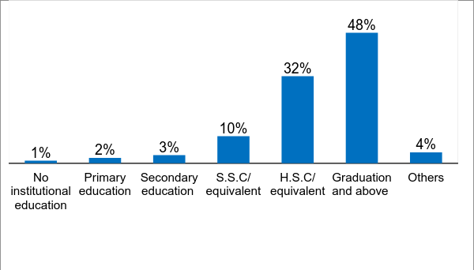
Educated people quickly adapt new technology and they are getting interest to be involved with this profession, thereby, number of farmers is also increasing day by day

The figure 4 describes about the educational status of the respondents. About 48% of the respondents have been found with having graduation and post-graduation degree. So, the Involvement of much educated people with this sort of profession indicates a breakthrough in social discourse.

2.2 Pre-scenario of using FA App:
This section briefs respondents’ condition before introducing the app including parameter like Time, Cost & Visit.
Figure 5: Involvement in Fisheries 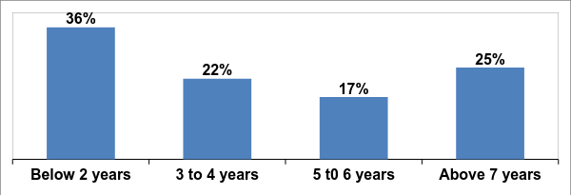
The figure 5 shows that a significant portion of the respondents has recently been involved in fishery activities. In this regard, about 36% of the respondents have been found that are engaged in fisheries for last 2 years. About one-fourth (25%) of the respondents have been found that are involved since above half of a decade.
Figure 6: Sustainability between ‘Rural & Urban’ Areas in Fisheries Practice
The figure 6 shows that the fish farming are more sustainable in rural areas comparing to the urban. About 28% of the respondents have been found those are practicing fisheries in rural areas for 2 years. In contrast, only 8% are from urban areas. On the other hand, about 8% of the respondents of rural areas have been sustained with this profession since last 7 years.
Figure 7: Respondents’ Realization about Fisheries Information
As the practice of fisheries is dependent on different types of information so the respondents need to be touched with getting this necessary information. And the figure 7 demonstrates that almost all of the respondents have mentioned the necessity to get information of fisheries.
Figure 8: Types of Necessary Information
The figure 8 describes that the respondents have necessity of different type of fisheries information. About 74% of the respondents have mentioned that they need information for knowing about the technique of fish cultivation.
Figure 9: Time Required Previously
The figure 9 shows that about 68% of the respondents needed 30 minutes to get the information about fisheries and about 15% of the respondents had to spend more 60 minutes.
Figure 10: Cost Required Previously

The figure 10 demonstrates that about 54% of the respondents had to spend BDT from 20 to 40 to avail the information. Even above 80 BDT was spent to avail the service.
Figure 11: Visit Required Previously
The figure 11 reveals the number of visits that were required to avail the information before initiating the app. Though about 64% of the respondents could avail the information visiting first time but the rest of the respondents had to make 2 or more visits.
Figure 12: Challenges Faced By the Respondents to Avail the Information
The figure 12 shows that about half of the respondents (41%) faced challenges while availing the information when there was not a single service like this app.
Figure 13: Type of Challenges while Availing the INFORMATION
The figure 13 describes details about nature of challenges faced by the respondents while collecting the information before initiating the FA app. About one-fourth (27%) of the respondents have mentioned that the service was far from their home and there was problem in understanding about the information. Beside this there were challenge like lack of reliable information and necessity of much time.

2.3 Knowledge regarding FA app:
This section highlights the condition regarding the knowledge level of the potential users.
Figure 14: Sources of Knowing about ‘FA App”
The figure 14 shows that the respondents had known about the FA through different types of sources for the first time. Almost all the respondents (87%) had known about the FA from Upazila fisheries office.
Figure 15: Using the FA App after Knowing

The figure 15 shows that most of the respondents (84%) become the users of the ‘FA application’ when they have known about its uses. As most of the respondents have started using this FA it may be said that it will become popular among the people.
Figure 16: Sources of Collecting ‘FA App”
The figure 16 shows that the respondents have collected the app from different sources. Almost respondents have collected the app from Upazila fisheries office. The other sources of collecting app by the respondents are District Unnayan fair, Google play store/online and others (youth development training center and Dweller of providing fish food). It indicates that DoF & Fish Farmers are supplementary & complementary to each other for using the App.
Figure 17: Inspiring Others to Use ‘FA App”
The figure 17 shows that about 78% of the respondents have inspired others to use the ‘FA app’. It is inspirable that users are motivating others for getting the benefit of this app.
Figure 18: Inspiring Number of Persons to Use ‘FA App’
The figure 18 shows that the respondents who are the users of ‘FA app’ have tried to inspire others for suing this app. About 61% of the respondents have inspired around 6 to use this app. Even more than 20 people were inspired by the users.
Figure 19: Using the ‘FA App’
The figure 19 demonstrates that about 65% of the respondents have been using the ‘FA app’ since last 1 to 6 months whether about 29% of the respondents have been using it from 7 months to 1 year. A portion of the respondents have been identified that is using it above year.
Figure 20: Reasons for not using the ‘FA App’
From the figure 15 we know that only 16% of the respondents have not used the ‘FA App’ in spite of being informed about it. Whereas, the Figure 20 specifies the reasons that they have not become the users of it. About 56% of them have mentioned that they had lack of knowledge about the app. Lack of sufficient publicity seemed one of the reasons on what intervention is needed as the respondents mentioned.
2.4 Benefits of ‘FA App’:
This section will state about the outcome level impact of using the app.
Figure 21: Benefits Received

The figure 21 shows that about 97% of the respondents have received benefits from the app. So, it may be mentioned that about entire population have been the beneficiaries of this technological advantage.
Figure 22: Type of Benefit
The figure 22 shows the nature of benefit users have been receiving currently. It indicates that the production of fish as well as income are increased and users can avail doorstep service of information & immediate service with low cost by using the app.
Figure 23: Increased Annual Fish Production
The figure 23 shows that about 85% of the respondents have informed that the annual fish production increased after using the app. So the respondents have been benefitted as the annual fish increased.
Figure 24: Amount of Increased Fish Production
The figure 24 shows that about 66% of the respondents have mentioned that the fish increased 50 kg than the previous period. Even above 150 kg fish production increased which is good for country’s economy.
Figure 25: Change in Annual Income
The figure 25 demonstrates that the annual income of the respondents has also increased while the respondents have started using the ‘FA App’. The annual income has increased in the case of about 86% of the respondents.

2.4.1 Case Study 1: ‘FA’ impacted on annual income and fish cultivation
Sarwar Azom Majumder (48) has been involved with fisheries profession from more than 6 years. He is one of the beneficiaries of FA App has been using this since last 2 years. It is necessary to know about the technique of fish cultivation, to prevent the various types of diseases of fish and to increase the production of fish. Upazila Fisheries Office was the only dependable source for Sarawar to collect information for fish cultivation. But, it needed to cross 4 kilometers, took 15-30 minutes and frequent visits for receiving the services. When he started using the App then time, cost and visit have significantly been reduced and getting the information for fish cultivation become very easy. The use of FA App has positively impacted in the annual earning and fish production of Sarwar. Now, he can utilize surplus time and cost in familial purposes. 2 years earlier, he could accumulate about BDT 500,000 annually by cultivating fishes. Now, it has reached up to BDT 1,000,000 as well as the fish production has increased up to 800 kilograms. Sarwar’s satisfaction level is very high regarding the uses of this App and he has also encouraged around 50 fish farmers to use this App and to know about the technological knowhow as well as to take the advantages from the app. His social dignity has increased in recent times. In this relation, Sarwar has encouraged 10 youths to take training for fish cultivation.
2.5 Post-scenario: Time, Cost & Visit required at present time:
This section briefs respondents’ condition after using the app including parameter like Time, Cost & Visit.
Figure 26: Required Time Currently
Now, the users can avail the information within very short span of time. Figure 26 shows that about 78% of the respondents need to spend just 5 minutes to avail the necessary fisheries information. On the other hand, a few portion of the respondents need to spend above 10 minutes to avail the service by using the ‘FA App’.

Figure 27: Required Cost Currently

In the Figure 10 it was seen that the respondents had to pay BDT 20 to above BDT 80 to avail the information. But, the figure 27 shows that the app has kept a great advantage in getting the service without any cost for the respondents. In this regard, about 67% of the respondents have attained the information without any payment. The cost for attaining the information has almost been limited within BDT 20. About 22% of the respondents need to pay BDT 1to 20 for availing the information. Only 11% of the respondents have to pay more than BDT 20.
Figure 28: Required Visit Currently
The figure 28 shows that about 96% of the respondents need avail the information visiting only 1 kilometer. Whereas only 4% needs to visit above 1 kilometer.

Figure 29: Comparative Analysis of Time, Cost & Visit between Before And After
Total time save
277 days
Total cost save
BDT 1M+
Total visit save
146K (km)
The figure 29 shows the reduced time, cost and visit comparing to the previous time to avail information. The figure demonstrates that a very significant time, cost and visit have reduced. This has been possible for using the ‘FA App’ by the respondents. About 90%, 80% and 98% of time, cost and visit has reduced after initiating the app. So, this is a tremendous effect of ‘FA App’ by which the respondents are now getting the information within very short time, with low cost and within very short span of time. Though authority level informed that this app can solve instant difficulties, however, farmers need to meet the fisheries officer at Upazila level if it needs more in-depth solution.
2.6 Satisfaction of respondents by using the FA App:
This section illustrates regarding satisfaction level of the users and reasons even reasons if not satisfied and utilization of surplus Time, Cost & Visit saved by using this app.

Figure 30: Level of SATISFACTION
Reasons of not satisfaction
- No information on facing natural calamity
- No information on new disease
- No smooth communication mechanism with Officer
- No information on advanced method 0f fish cultivation

The Figure 30 shows that about 34% and 60% of the respondents are highly satisfied and respectively satisfied by getting the information using the app. So, the respondents have been satisfied using the app as they have faced some problems in getting the information centering the fish cultivation.
Figure 31: Reasons of Satisfaction 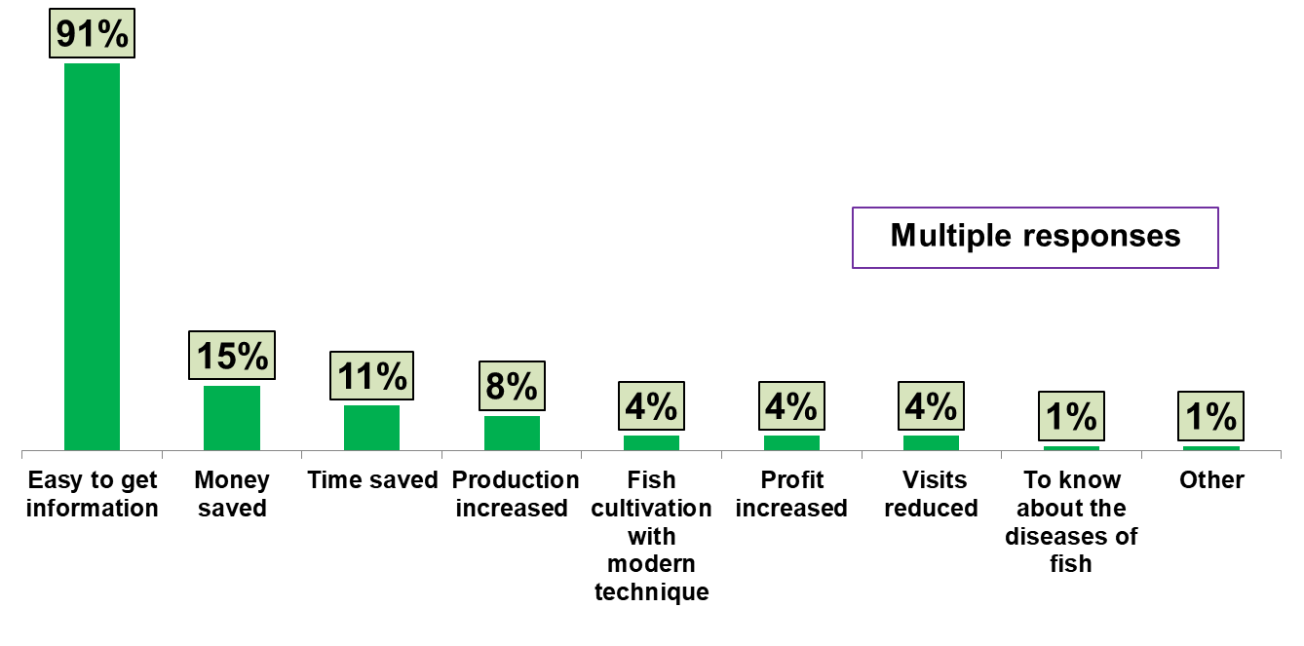
The respondents have been satisfied for some specific reasons with getting the information from the present service. The Figure 31 shows that about 58% of the respondents have been satisfied as the information can be availed easily. About 15% and 12% have mentioned that the information can be availed with less cost as well as quickly. On the other hand, about 11% of the respondents have identified the less time needed, easy to find necessary information, different problems can be solved and fish production has increased as the reasons of their satisfaction for getting the service.
Figure 32: Utilizing the ‘Surplus Time’ Saved By Using the ‘FA App’
The Figure 32 shows that about 64% of the respondents have mentioned that they utilized the time for familial tasks whether about 33% of the respondents used the time in business purposes, daily works and for educational purposes. On the other hand, a very few portion of the respondents have used the surplus time for seeking jobs.
Figure 33: Utilizing the ‘Surplus Money’ Saved By Using the ‘FA App’
The figure 33 shows that the respondents have also utilized the surplus money for different purposes. About 64% of the respondents have used this surplus money for familial purposes. On the other hand, about 30% and 23% of the respondents have used this surplus money for business and daily works.

3 Coverage of FA App
The following section delivers a projection of using this app that includes motivation of users, total coverage till 2021 and projected saving of Time, Cost & Visit till 2021.

3.1 Status of motivators & users
Figure 34 demonstrates that Google Play is the most reliable source of downloading ‘the App’ and the number is 27,500 since April 2016 to August 2017. As 78% inspired others for using this app and based on it we may state that 21,450 people played role as motivators in last one year and 1,67,922 (1 Lac 67 Thousand Nine Hundred Twenty Two) people have been motivated in last 7 months. From qualitative method we found that a single farmer motivated 50/60 people in last one year.
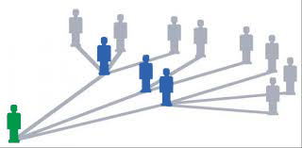
Figure 34: ‘FA App’ Expansion Status
27,500 downloaded the ‘App’
from
21,450
Motivators found
1, 67,922 been motivated
In last 7 months
About 50/60 persons are inspired by a single farmer who use FA app- informed by farmers

3.2 Outcome of the App-Future Aspect
Figure 35 states that a large portion of people will be motivated through authority by 2021. The number seems highest in Comilla and Barisal as projected data shows that the coverage will be 80.2K and 53.2K respectively. Chandpur District is a bit in backward position in this aspect.
Figure 35: Bringing Respondents under ‘FA App COVERAGE’ – A Projection
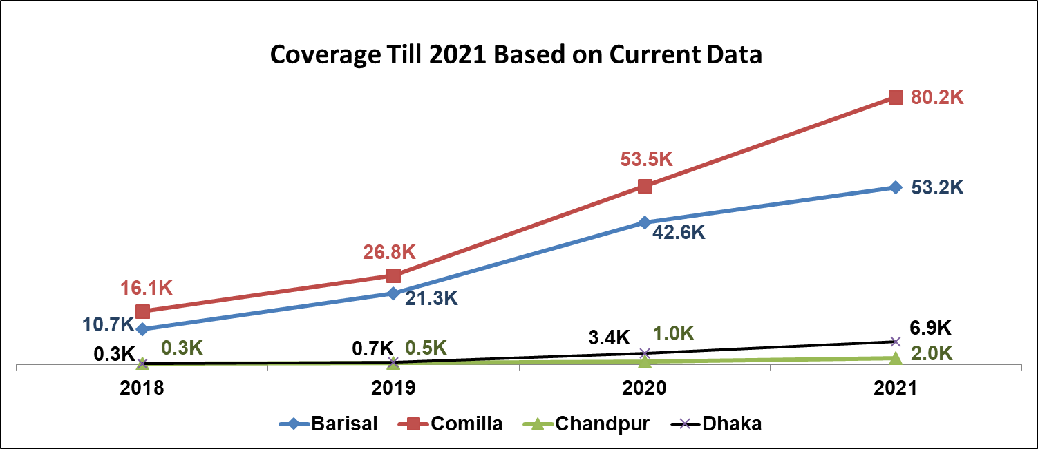
* K= Thousand

Figure 36: ‘FA App’ User Status- A Projection
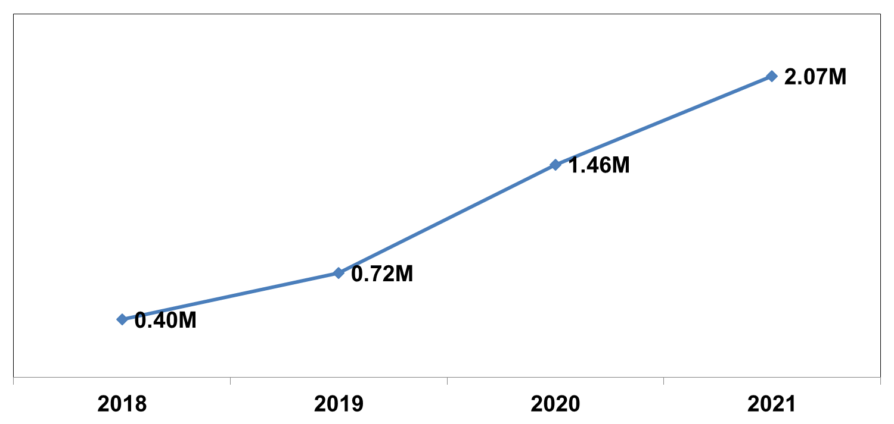
* M= Million

Figure 36 shows upward trend of increasing rate of FA App users, for instance, in 2021 the user number will be 2.07 million which is very inspiring.

3.3 Status of Time, Cost & Visit
Figure 37 demonstrates that depending on the findings it can be projected that from 2018 to 2021 users can save their time from 8.9K days to 46.0K days, in case of cost, they can save BDT 21.1M to 109.8M and for visiting this will be 0.21M KM to 1.10M KM. So gradually by 2021 the users can save time, cost & visit by using this app which is significantly positive.

Figure 37: Projection of Time, Cost & Visit Save
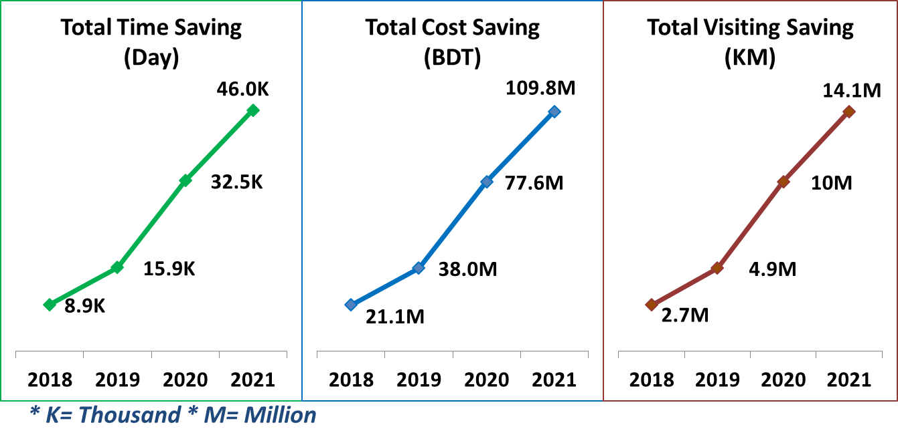

4 Discussion, Recommendations and Concluding remarks

4.1 Discussion
As most of the respondents are engaged in the fisheries usually live in the rural areas comparing urban. The fisheries practice is more sustainable in urban areas than the rural areas has been revealed in the study. Engagement of female in the profession indicates the women economic empowerment and it is clear that App is helpful for them to practice fisheries and overcome the challenges centering this profession. Because farmers informed that their family members including mother, daughter, sister & other family members accompany them for this job, therefore, more female are indirectly involved.
The involvement of young mostly with this profession points to technological contribution to dynamic aspect of fisheries. Despite this impressive growth, the characteristics of aquaculture in Bangladesh (technical, economic, and in terms of environmental performance and producer behavior) remain low understood. This is due in part to the rapidity of change and development in the sector, and to the diversity of specialized production technologies that have emerged in response to local comparative advantages in different regions of the country. Research on the technical characteristics of aquaculture production, the socio-economic characteristics of aquaculture producers, and the broader impacts of the activity on communities and the environment in Bangladesh have focused on a limited number of technologies. However, these production systems now account for only a small fraction of Bangladesh’s total aquaculture output. As the practice of fisheries is dependent on different types of information so the respondents needs to be touched with getting these information.
In this regard, the respondents had the necessity of information regarding fish to know about the technique of fish cultivation, to know the way of preventing diseases, to increase the production, to know about food and to know about the medicine for removing fish diseases for cultivation. But the respondents had to spend significant time, cost and visit to receive the fisheries information. Beside this, the respondents used to face different types of challenges to avail the information from Upazila fisheries office which was the only source of collecting the information. The major challenges were problem in understanding about the service and crossing long distance. Beside these, unavailability of information in due time, lack of reliable information and necessity of much time were also the other problems.
A technical support for availing the information was very much needed for the respondents and the respondents started knowing about the app from Upazila fisheries office, district fisheries office, District Unnayan fair, fish farmers, fish medicine seller, Dweller and youth development training center. Most of the respondents have collected the app from Upazila fisheries office. The respondents have also collected the app from district fisheries office, district Unnayan fair, Google play store/online, youth development training center and Dweller of providing fish food. In last one year, the tendency to use the FA App has increased significantly and the respondents have also been able to encourage the other fish farmers to use the app for getting the easy information by using the app. Furthermore, a very positive trend is visible from the projection analysis that indicates that users will be benefitted and demand for this app in future will be dramatically increased.

Case study 2: Encouraging the fish farmers to utilize technological knowhow

“Sahedul Rahman a presidential award winner for fish cultivation has been engaged in this sector last 14 years. He is one of the beneficiaries of FA App and can save a lot of time by using it. Before being initiated with the App he used to go to ‘Upazila Fisheries Office’ for taking necessary advices for fish cultivation. The ‘Upazila fisheries office’ was 15 kilometers far from his home.. It took about 40 minutes and cost above BDT 100 to reach at ‘Upazila fisheries office’ for collecting the information. The necessity information was not available as well as other challenges prevailed. Now, the problems have been solved by using the App. He needs no travel and cost but can avail the information within 3 to 5 minutes. He can use the saved time to invest in business purpose, fish, production, making fish food, and to communicate with client to export or import his production. The use of App has impacted the annual fish cultivation and increased his income also”.
As the fish farmers have started using the app and become benefitted; they are trying to encourage the others to be beneficiary from this app. It has become regular for the people to have the intention to convert the natural pond into commercial pond through cultivating the fishes. The number of fish farmers have been increasing day by day and fisheries is being taken as the second profession by the people of the selected areas. The time, cost and visit from both side (from fish farmers and the official of DoF) has reduced than the previous time. In the earlier period, the fish farmers used to face the case of loses but some of them have capable to recover the financial loss. The social dignity of the fish farmer has amplified as the income centering the fish cultivation has amplified than the previous time. In the recent time, it has seen that the female entrepreneurs have increased as they have received centering the app.

4.2 Recommendations

Some recommendations have been accumulated from the study. The accumulated recommendations would be very useful for the Government, private-sector entrepreneurs, investors and zone level entrepreneurs to solve the problems centering the fisheries sector by using the ‘FA app’ as well as to make the app popular. If the recommendations are taken into consideration then the people related with fisheries sector, including fish farmers and service providers of DoF and FA app users will be immensely benefitted. The recommendations are described as follows:
- Publicity, motivational activities, training, meetings and seminars on the app can be increased so that entire citizen can receive the benefit from this app, disseminating information by SMS and advertisement on TV channels can be effective for the fish farmers;
- Picture of different diseases of fishes could be attached in the app so that the fish farmers can identify the diseases easily;
- More advanced and modern technique containing necessary information and keeping feedback options will be helpful to increase fish cultivation;
- A ‘FA’ online monitoring platform can be introduced in which the mobile number of the users, name of the frequent used content, location of the users will be saved in central data base for future analytics;
- A free helpline for phone calling may be introduced for users for instant service’;
- Adequate printed materials for disseminating knowledge of fisheries, enough manpower and sufficient logistics can be ensured for providing service to the people could be ensured by DoF;
- UDCs could be linked with the using of the app, bill-board & posters can be hanged in the different important places;
- Desktop or laptop version and audio & video option can be added into it;
- Feed Conversion Ratio (FCR) can be added in the app so that the fish farmers can measure the assessment of providing actual feeding to the fishes

4.3 Conclusion

Bangladeshi fish farmers have apple scope of development to strengthen the national economy. In this regard, the Govt. departments, development partners and researchers have been working to implement the different formulated strategies to ensure the participatory approach for bringing the positive outputs. The fish farmers of Bangladesh represent a remarkable natural resource, with an intimate connection with the life and well-being of the country and its people. The newly introduced mobile application ‘FA’ has been endowed with scientific suggestions and guidelines. DoF has initiated this app for reducing the hassle of the people and to get the information of fisheries in a smooth way. The FA has reduced the earlier required time, cost and visit as well removed the different challenges in fish cultivation. The study has suggested some significant recommendations which should be taken into condensation for making the app more popular and effective for the mass people. If this happens then more fish farmers might be benefited and the publicity of the app would be more stretched. Finally, it can be concluded that the FA app has the bet utility to be used in a greater level and the concerned stakeholders have the equal opportunity to ensure the better uses of this app in meeting the needs of the millions of people for whom fish farming are an essential livelihood issue. As the FA has partially reduced the hassle of cultivation fishing by using it. But the fish farmers have to go at ‘Upazila or District fisheries office’ if they want to get the in-depth service in this regard.

References:

Belton, B., Karim, M., Thilsted, S., Collis, W., & Phillips, M. (2011). Review of aquaculture and fish consumption in Bangladesh.
Ahmed, N. (2007). Economics of aquaculture feeding practices: Bangladesh, FAO Fisheries Technical Paper.
Islam, M. M., Rahman, M. H., & Rahman, M. M. (2011). Training Manual on improved carp/carp-shing poly culture in pond and dyke cropping. The World Fish Center Working Papers.
Impact Evaluation of Aquaculture Interventions in Bangladesh (2008), Ministry of Foreign Affairs of Denmark.
Ghose B (2014) Fisheries and Aquaculture in Bangladesh: Challenges and Opportunities. Ann Aquac Res 1(1): 1001.
Chowdhury, M. H., & Maharjan, K. L. (2001). Increasing Efficiency of Pond Fish Production in Rural Bangladesh.
A comparative TCV + Study on Fisheries Advice Technique (2016), Access to Information (a2i) Programme & UNDP Bangladesh.
Allison E. H & Badjek M.C (2004). Fisheries Co-Management in Inland Waters: A Review of International Experience. Department for International Development (DFID) and Food and Agricultural Organization of United Nations.
Bangladesh: “Delta Plan 2100 Formulation Project Fisheries Baseline Study” General Economic Division, Planning Commission, Government of Bangladesh. (2015)
A Study on Sector-based Need Assessment of Business Promotion Council – Fisheries Products; Bangladesh Foreign Trade Institute (2015).
Fishing for Food Security; The Importance of Wild Fisheries food Security and Nutrition (2016); USAID.
Moni N N. & Khan N N. (2014); Fish Cultivation as a Livelihood Option for Small Scale Farmers – Study in Southwestern Region of Bangladesh; Khulna University, Bangladesh.
Aquaculture technologies in Bangladesh: An assessment of technical and economic performance and producer behavior; (2015), World Fish.

Annex 1: Questionnaire of Study
‘Fish Advice’ Application: An Outcome Level Study
(The collected information will be used only for research purpose and the personal information of the respondents will be kept confidential)

Number of question |  |  |  |  | Type of data collection |  |  |  |  |  |  |  |  |  |  |  |  |  |  |  |  | District code |  |  |  |  |  |  |  |  |  |  |  |  |  |  |  |  |  |  |  |  | Division code
 |  |  |  |  | 1=Manual 2=Tab
 |  |  |  |  | Type of data collection |  |  |  |  |  |  |  |  |  |  |  |  |  |  |  |  | Mobile no |  |  |  |  |  |  |  |  |  |  |  |  |  |  |  |  |  |  |  |  | Date
Name of data collector |  |  |  |  | 1=Manual 2=Tab
Name of data enterer
Section A : Primary Information about Respondents
A1 |  | Name of Respondents
A2 |  | Age ( Year)
A3 |  | Gender |  |  |  |  |  |  |  |  | 1 = Male |  |  |  |  |  |  |  |  |  |  |  |  |  | 2= Female |  |  |  |  |  |  |  |  |  |  |  |  |  | 3= Others (mention please)
A4 |  | Ethnicity |  |  |  |  |  |  |  |  | 1= Bengali |  |  |  |  |  |  |  |  |  |  |  |  | 2= Others (mention please)
A5 |  | Religion |  | 1= Islam |  |  |  |  |  | 2=Hindu |  |  |  |  |  |  |  | 3=Buddhist |  |  |  |  |  |  |  | 4 = Christian |  |  |  |  |  |  |  |  |  |  |  |  |  |  |  | 99 = Others (mention please)
A6 |  | Phone Number
A7 |  | Educational qualification |  |  |  | 1 = No institutional education  2 = Primary education (1-5 class)  3 = Secondary education (6-9 class)  4 = S.S.C/ equivalent  5= H.S.C/ equivalent  6 = Graduation/ equivalent  7 = Post-graduation/ equivalent |  |  |  |  |  |  |  |  |  |  |  |  |  |  |  |  |  |  |  |  |  |  |  |  | 7 = Post-graduation/ equivalent  8=PhD  9 = Diploma (S.S.C)  10 = Diploma (H.S.C)  11 = Others (mention please)
A8 |  | Union
A9 |  | Upazila
A10 |  | District
A11 |  | Type of the area |  |  |  |  |  | 1 = Urban |  |  |  |  |  |  |  |  |  |  |  |  |  |  |  |  |  |  |  |  |  | 2 = Rural
Section B: Questions on Fisheries Advice & TCV
B1 | How many days have you been involved in fisheries? |  |  |  |  |  |  |  |  |  |  |  |  | 1 = 1 Year  2 = 2 Years  3 = 3 Years  4 = 4 Years |  |  |  |  |  |  |  |  |  |  |  |  |  |  | 5 = 5 Years  6 = 6 Years  7 = More than 6 years (mention please)
B2 | Do you need any information or advice of fisheries? |  |  |  |  |  |  |  |  |  |  |  |  |  |  |  |  |  |  |  |  |  |  |  |  |  |  |  |  |  |  |  |  |  |  |  | 1 = Yes |  |  |  |  |  |  |  |  |  | 2 = No
B3 | In this case which information or advices are necessary for you? (Multiple responses) |  |  |  |  |  |  |  | 1 = To prevent the diseases of fish  2 = To increase the production  3 = To know the technique of fishing |  |  |  |  |  |  |  |  |  |  |  |  |  |  |  |  |  |  |  |  |  |  |  |  | 4 = To know about the food of fish  5 = To know about the medicine of fish  6 = Others (please specify)….
B4 | Before using the ‘FA app’ from where you used to collect the information of fisheries? |  |  |  |  |  |  |  | 1 = District fisheries office  2 = Upazila fisheries office  4= Seller of the fish medicine |  |  |  |  |  |  |  |  |  |  |  |  |  |  |  |  |  |  |  |  |  |  |  |  | 5 = Dweller (provides food of the fish)  6 = Other fish farmers  7 = Others (mention please)
B5 | How much distance was needed to travel from your home to collect the fisheries information? |  |  |  |  |  |  |  |  |  |  |  |  |  |  |  |  |  |  |  |  |  | Kilometer:
B6 | How much time was needed to collect the information |  |  |  |  |  |  |  |  |  |  |  |  |  |  |  |  |  |  |  |  |  | Minutes: hours:
B7 | How many times you visited to avail the service on average? |  |  |  |  |  | 1 = 1 time  2 = 2 times  3 = 3 times |  |  |  |  |  |  |  |  |  |  |  |  |  |  |  |  |  |  |  |  |  |  |  |  |  |  |  |  |  |  |  |  |  | 4 = 4 times  5 = 5 times  6 = Above 5 times
B8 | How much average duration you needed to receive the information? |  |  |  |  |  | 1 = Less than 15 minutes  2 = 15-30 minutes  3 = 31-60 minutes |  |  |  |  |  |  |  |  |  |  |  |  |  |  |  |  |  |  |  |  |  |  |  |  |  |  |  |  |  |  |  |  |  | 4 = 1-1.30 hours  5 = 1.30-2.00 hours  6 = More than 2 hours
B9 | How much cost was required for availing the information? |  |  |  |  |  |  |  |  |  |  |  |  |  |  |  |  |  |  | Sector of cost |  |  |  |  |  |  |  |  |  |  |  |  |  |  |  |  |  |  |  |  |  |  |  |  | BDT
 |  |  |  |  |  |  |  |  |  |  |  |  |  |  |  |  |  |  |  | Transport cost
 |  |  |  |  |  |  |  |  |  |  |  |  |  |  |  |  |  |  |  | Middleman
 |  |  |  |  |  |  |  |  |  |  |  |  |  |  |  |  |  |  |  | Others
 |  |  |  |  |  |  |  |  |  |  |  |  |  |  |  |  |  |  |  | Total
B10 | Have you faced any challenges for availing the information? |  |  |  |  |  |  |  |  |  |  |  |  |  |  |  |  |  |  | 1 = Yes |  |  |  |  |  |  |  |  |  |  |  |  |  |  |  |  |  |  |  |  |  |  |  |  | 2 = No
B11 | If yes, what types of challenges have you faced? ( multiple responses) |  |  |  |  |  |  |  |  |  |  |  |  |  |  |  | 1 = problem in understanding  2 = old technique  3= lack of accurate information |  |  |  |  |  |  |  |  |  |  |  |  |  |  |  |  |  |  |  |  |  |  | 4 = long distance home  5 = information is not available in due time  6 = others
B12 | Do you know about mobile app ‘FA’? |  |  |  |  |  |  |  |  |  |  |  |  |  |  |  | 1 = Yes |  |  |  |  |  |  |  |  |  |  |  |  |  |  |  |  |  |  |  |  |  |  | 2 = No
B13 | Has the visit reduced by using the ‘FA” app? |  |  |  |  |  |  |  |  |  |  |  |  |  |  |  | 1 = Yes |  |  |  |  |  |  |  |  |  |  |  |  |  |  |  |  |  |  |  |  |  |  | 2 = No
B14 | How far away do you need to go to avail the information? |  |  |  |  |  |  |  |  |  |  |  |  |  |  |  | Kilometer:
B15 | How much time is needed for you to avail the information? |  |  |  |  |  |  |  |  |  |  |  |  |  |  |  | Minutes: Hour:
B16 | In this case, what amount of money is required to avail the information? |  |  |  |  |  |  |  |  |  |  |  |  |  |  |  | BDT-------
B17 | How do you utilize the ‘surplus time’ saved by using the ‘FA app’? (multiple answers are applicable) |  |  |  |  |  |  |  |  |  |  |  |  |  |  |  |  |  | 1 = familial purposes  2 = for business purposes  3 = health purposes  4 = for professional purposes |  |  |  |  |  |  |  |  |  |  |  |  |  |  |  |  |  |  |  |  | 5 = for regular tasks  6 = for educational purposes  7 = in recreation  8 = others (mention please)
B18 | How do you utilize the ‘surplus money’ saved by using the ‘FA app’? (multiple answers are applicable) |  |  |  |  |  |  |  |  |  |  |  |  |  |  |  |  |  | 1 = familial purposes  2 = for business purposes  3 = health purposes  4 = for professional purposes |  |  |  |  |  |  |  |  |  |  |  |  |  |  |  |  |  |  |  |  | 5 = for regular tasks  6 = for educational purposes  7 = in recreation  8 = others (mention please)
Section C: Information about Using of Mobile App ‘FA’
C1 |  |  | From where you firstly knew about mobile app ‘FA’? (multiple answers are applicable) |  |  |  |  |  |  |  |  |  | 1 = District fisheries office  2 = Upazila fisheries office  3= Seller of the fish medicine |  |  |  |  |  |  |  |  |  |  |  |  |  |  |  |  |  |  |  |  |  |  | 4 = Dweller (provides food of the fish)  6 = Other fish farmers  7 = Others
C2 |  |  | From where you firstly collected the mobile app ‘FA’? (multiple answers are applicable) |  |  |  |  |  |  |  |  | 1 = Online / Google play store  2 = District fisheries office  3 = Upazila fisheries office |  |  |  |  |  |  |  |  |  |  |  |  |  |  |  |  |  |  |  |  | 4= Seller of the fish medicine  5 = Dweller (Food of the fish)  6 = Other farmers  7 = Others
C3 |  |  | Have you inspired others to use mobile app (FA)? |  |  |  |  |  |  |  |  |  |  |  |  |  |  |  |  |  | 1 = Yes |  |  |  |  |  |  |  |  |  |  |  |  |  | 2 = No
C4 |  |  | If yes, how many numbers of people have been inspired by you?
C5 |  |  | From how many days are you using of this mobile app (FA)? |  |  |  |  |  |  |  |  |  |  |  |  |  |  |  |  |  | Months: …......... Year:
C6 |  |  | Have you received any benefits by using the mobile app (FA)? |  |  |  |  |  |  |  |  |  |  |  |  |  |  |  |  |  | 1 = Yes |  |  |  |  |  |  |  |  |  |  |  |  |  |  |  |  | 2 = No
C7 |  |  | If yes, what types of benefits have you received (multiple answers are applicable) |  |  |  |  |  |  |  |  |  |  |  |  | 1 = Fish production has increased  2 = service at doorstep  3 = no cost |  |  |  |  |  |  |  |  |  |  |  |  |  |  |  | 4 = immediate service  5 = income has increased  6 = others
C8 |  |  | Do you think that the production of fish has increased after using the mobile app (FA)? |  |  |  |  |  |  |  |  |  |  |  |  |  |  |  |  |  |  |  |  |  |  |  |  | 1 = Yes |  |  |  |  |  |  |  |  |  |  |  | 2 = No
C9 |  |  | If yes, how much amount of production has increased? |  |  |  |  |  |  |  |  |  |  |  |  |  |  |  |  |  |  |  |  |  |  |  |  | ….....(Kg/every month)
C10 |  |  | Do you think that annual income has increased after using the mobile app (FA)? |  |  |  |  |  |  |  |  |  |  |  |  |  |  |  |  |  |  |  |  |  |  |  |  | 1 = Yes |  |  |  |  |  |  |  |  |  |  |  | 2 = No
C11 |  |  | If yes, how much annual income has increased? |  |  |  |  |  |  |  |  |  |  |  | Previous  profit |  |  |  |  |  |  |  |  |  |  |  | Current profit |  |  |  |  |  |  |  |  |  |  |  |  |  |  |  |  |  |  | Increase/  decrease
C12 |  |  | Are you satisfied by using this app (FA)? |  |  |  |  |  |  |  |  |  |  |  | 1= Highly satisfied  2 = Satisfied  3 = Moderately satisfied |  |  |  |  |  |  |  |  |  |  |  |  |  |  |  |  |  |  |  |  |  |  |  |  |  |  |  |  | 4 = Dissatisfied  5= Highly dissatisfied
C13 |  |  | If satisfied, then specify the reasons
C14 |  |  | If dissatisfied, then specify the reasons
C15 |  |  | Give your suggestions for ensuring the better uses FA app?

- সমাপ্ত -

Fishing for Food Security; The Importance of Wild Fisheries food Security and Nutrition (2016); http://pdf.usaid.gov/pdf.docs/PA00M1T3.pdf ; (accessed on 02 August 2017).
A Study on Sector-based Need Assessment of Business Promotion Council–Fisheries Products (2015); http://www.bfti.org.bd/pdf/Fisherypdf ; (accessed on 01 August, 2017).
Fisheries and Aquaculture in Bangladesh: Challenges and Opportunities (2014); https://www.jscimedcentral.com/Aquaculture/aquaculture-1-1001.pdf; (accessed on 02 August 2017).
A comparative TCV + Study on Fisheries Advice Technique (2016), Access to Information (a2i) Programme, Prime Minister’s Office. http://a2i.pmo.gov.bd/resources/studies/ (accessed on 03 October 2017).
Bogra, Comilla, Feni, Jessore, Moulavibazar, Mymensingh, Chanpur, Noakhali, Rajshahi, Barisal.
Aquaculture technologies in Bangladesh: An assessment of technical and economic performance and producer behavior; (2015) http://pubs.iclarm.net/resource.centre/2015-52.pdf ; (accessed on 4 August, 2017).

